LOCATION – SITUATION – RECOMMENDATION
Case studies for the SBNRC
Location:
7 miles south of Norman, Nebraska
Farmer Cooperator: Kevin Raun 308 830-1077
Current Crop: Corn under center pivot irrigation
Previous Crop: Soybeans
Row Spacing: 30 inches
40.403717, -98.795221 (enter value in Google Map) or +40° 24' 13.38", -98° 47' 42.80"
Situation:
Planting date: April 22, 2009
Sensing date: June 15, 2009
Cumulative GDD: 690
Estimated Yield Potential (YP0): >300 bu/ac
Response Index: 1
N Rich NDVI: 0.83 ± 0.03
Farmer NDVI: 0.84 ± 0.02
N Rich side NDVI: 0.86 ± 0.02
Farmer side NDVI: 0.86 ± 0.02
In general there were higher readings in the Farmer practice than the N Rich strip, but not significant. The N Rich Strip had 190 lbs N/ac preplant, and the Farmer Practice had 90 lbs N/ac preplant. This corn field is without question some of the very best corn in Nebraska (perfect stand, plants 6-7 inches apart, homogenous emergence, etc.).
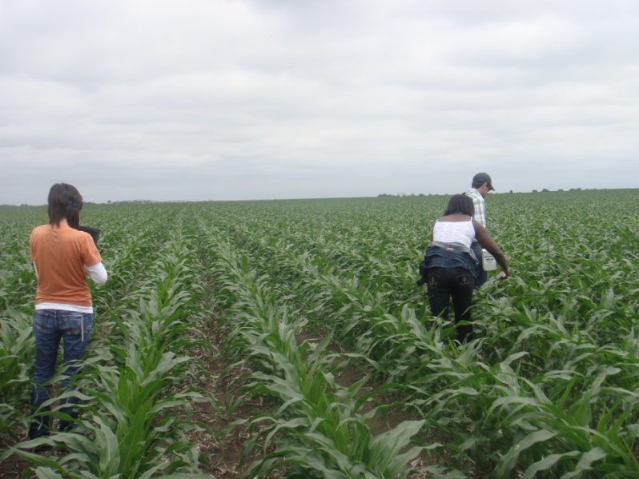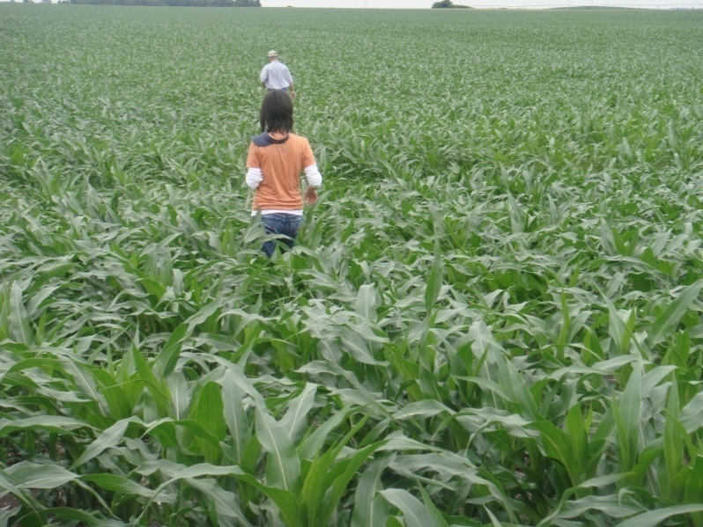
Corn field looking north, near Norman, Nebraska.
Recommendation:
NDVI readings and cumulative GDD resulted in an estimated yield potential of >300 bu/ac. Response Index was 1.0 indicating no need for added N. Because YP0 was so high, our recommendation was to apply the full amount topdress (90 lbs N/ac), so as to avoid any yield loss risk. They have had almost perfect growing conditions since planting, it had been cool, and they have received timely rains.
Lesson learned: both the upper and lower leaves at V8 exhibited dark green hue’s with absolutely no firing whatsoever in the lower leaves. This was a bit surprising as the lower leaf almost always reveals something. This may in part be due to having been in soybeans the previous year.

Outcome:
To review, the previous crop was soybeans. Coop applied 100# 11-52-0 with 100# 12-0-0-24S in Feb or March. I applied 95# N via NH3 in early April to the N-rich strip. I applied approximately 10# N via starter fertilizer at planting to the entire field. Coop applied 65#N to the entire field via 32% with broadcast herbicide application after planting. I applied 70#N via 32% with sidedress applicator to all the field except the N-rich strip and 24 rows next to the N-rich strip. The three treatments, N-rich strip 195#N total pre plant, 100#N pre plant no side dress, and side dress
70# plus 100# pre plant. The north half of the field received a 3 inch fast rain which washed the field considerably before the corn came up.
Harvested the strips on the 7th of December. The plots were equal size. The gps monitor had them at 4.08 acres each. The yields were
948.86 for the N-rich strip, 232.6 bu/ac
797.86 for the no side dress strip, 195.6 bu/ac
932 bushels for the 70# side dress strip. 228.4 bu/ac
The majority of his corn this year was in the 225-245 range.
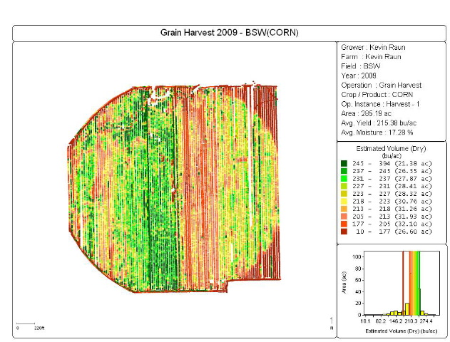
Location:
Iowa/Minnesota Border Town: Armstrong, IA
Farmer Cooperator: Dick Gerhardt
Current Crop: Corn (3rd continuous)
Previous Crop: Corn
Row Spacing: 30 inches
43.482757, -94.507356 (enter value in Google Map)
Situation:
Planting date: April 18, 2009
Sensing date: July 6, 2009
Cumulative GDD: 960
N Rich NDVI: 0.795
Farmer NDVI: 0.801
Estimated Yield Potential (YP0): >250 bu/ac
Response Index: 1
Higher readings in the Farmer practice than the N Rich strip. Readings taken with the hand held sensor. The N Rich Strip had 200 lbs N/ac preplant, and the Farmer Practice had 100 lbs N/ac as manure, plus 38.5 lbs N/ac sidedress at the 4 leaf stage. This corn field has received timely rains and the rain has come lightly. Dick has put down N preplant and has sidedressed once at the 4 leaf stage. Currently the corn is at the 12-13 leaf stage.
Recommendation:
The decision is whether or not to apply 30 additional pounds of N/ac. Because soil temperatures are now rising, with 4-5 percent organic matter, and because rainfall has been light and consistent, the recommendation was to not apply more N since added N mineralization is expected and the sidedress N from V4 should still be present. Also, N uptake by V12 was not different in the N Rich and Farmer practice at this stage (indicative from NDVI values), and by this growth stage, the corn plant has taken up almost 70% of the total N. If there had been slight NDVI differences at this late growth stage, more N would have been recommended, but there were not. There are no signs of lower leaf decay anywhere in the field suggesting sufficient N to date. On July 8, field received another 1” of gentle rain. Expect tasseling within 2 weeks. Will check FP yields against NRS at harvest to evaluate decision. Would be major victory to hit high yield potential with only 140 lbs of N on 3rd year continuous corn.
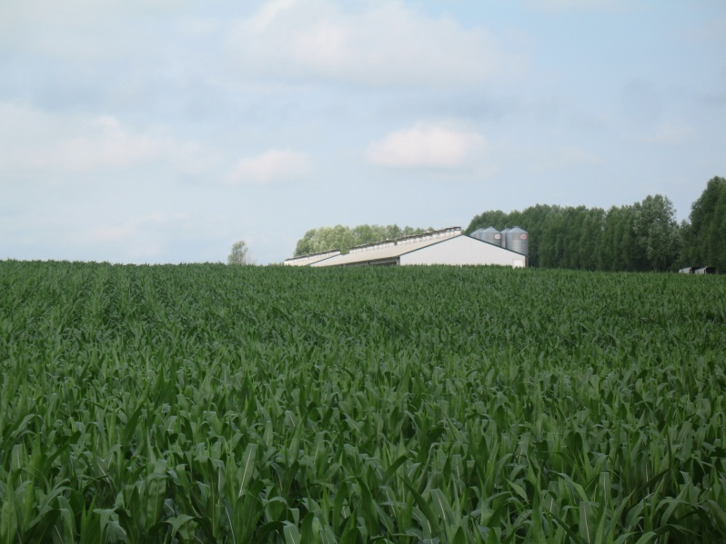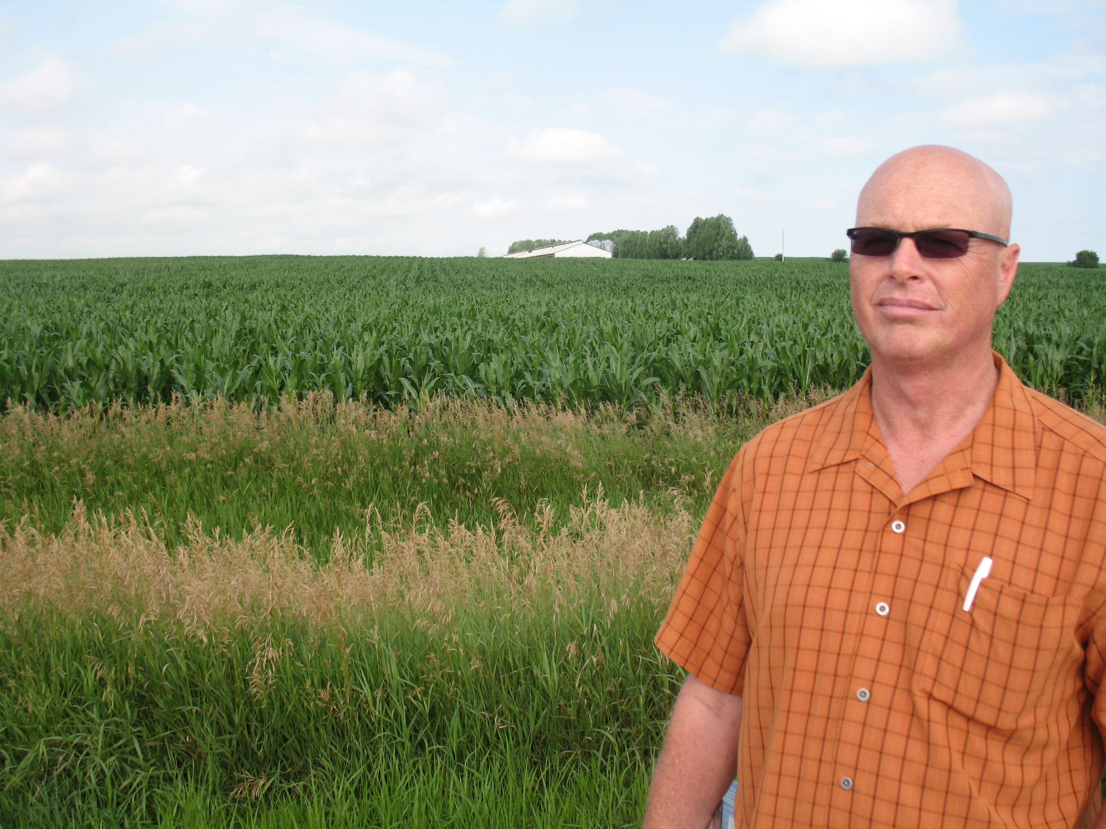
Lindell Farm near Armstrong, IA. The N Rich strip is the first 24 rows to the left of the hog barn. Dick Gerhardt standing in field drainage way.

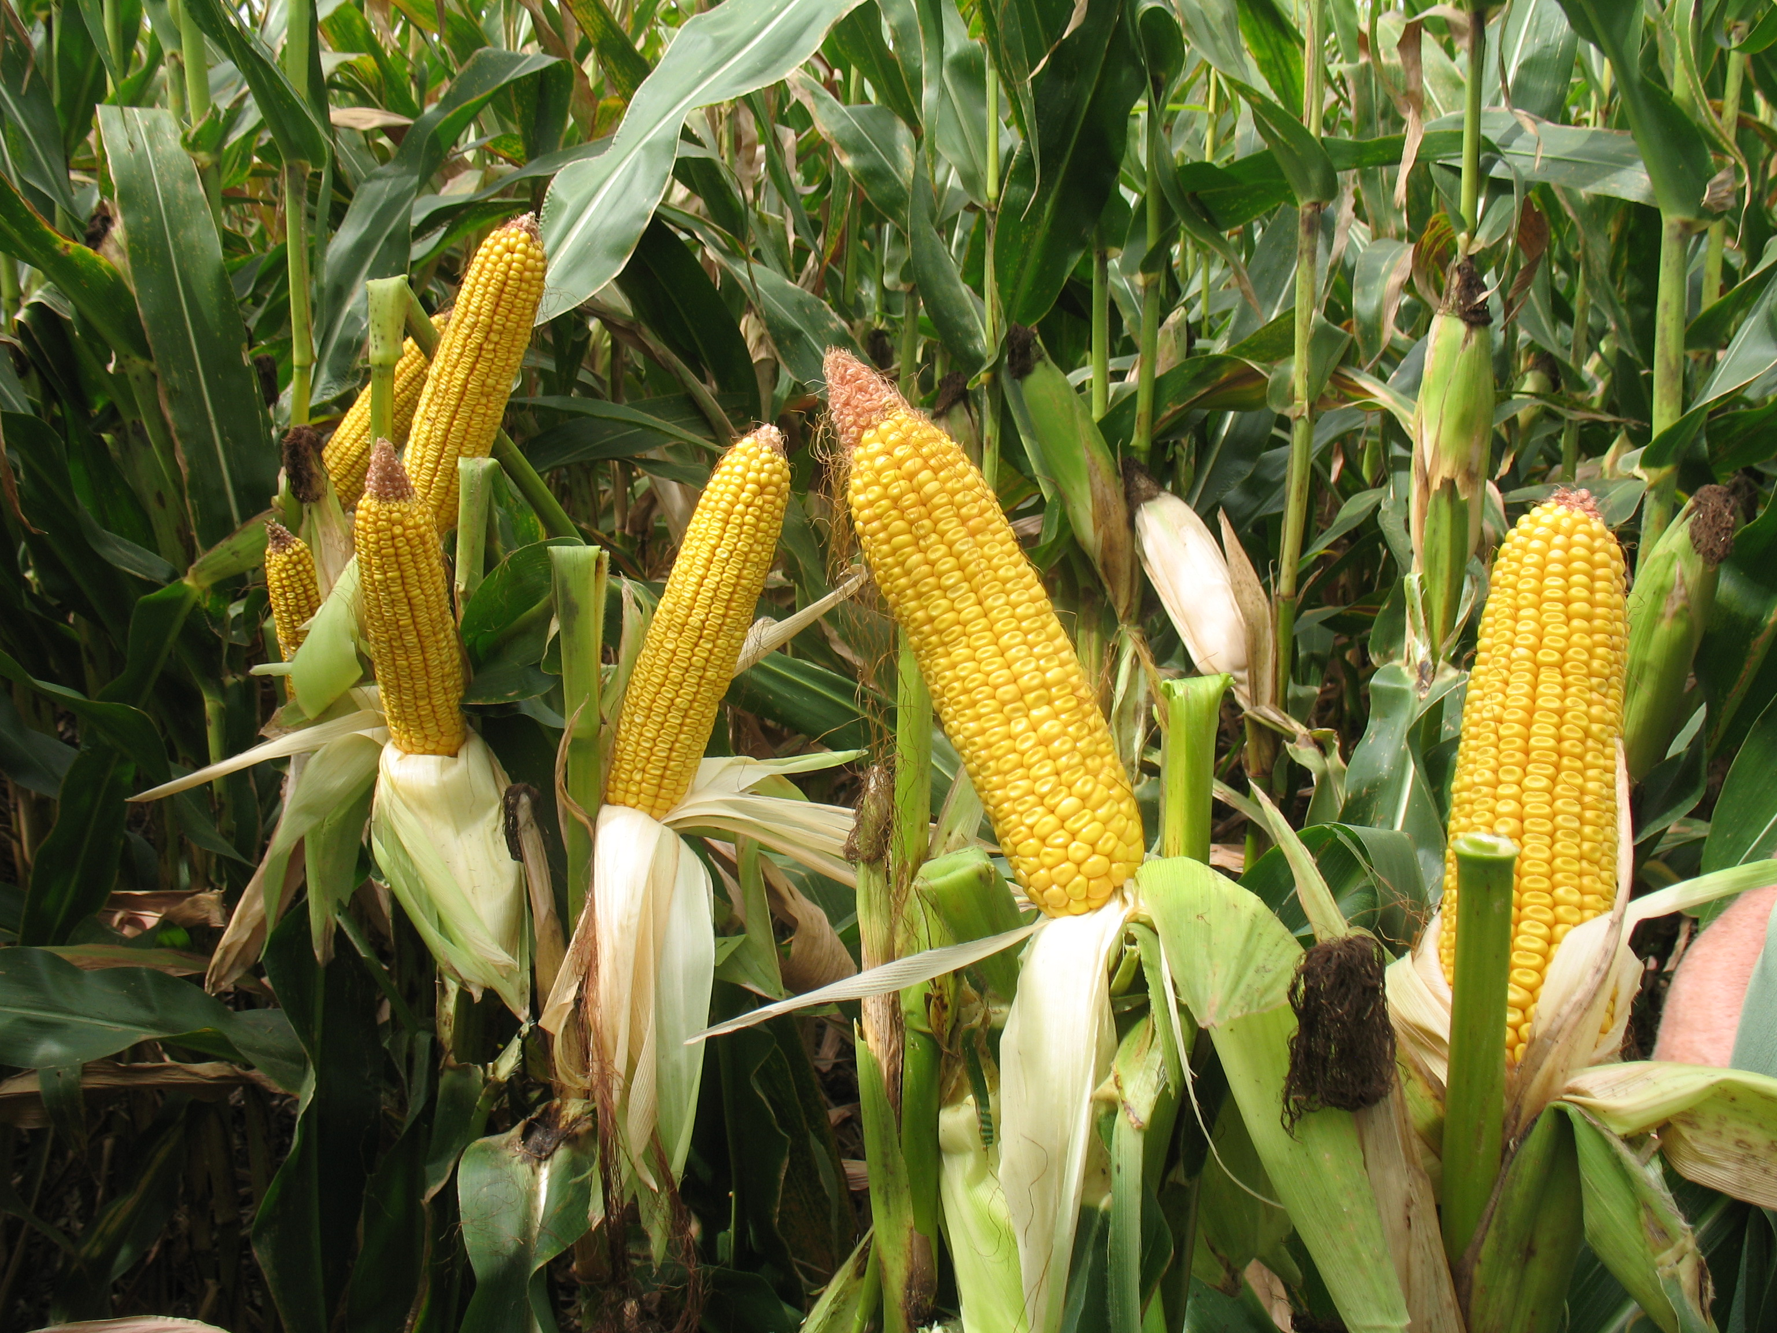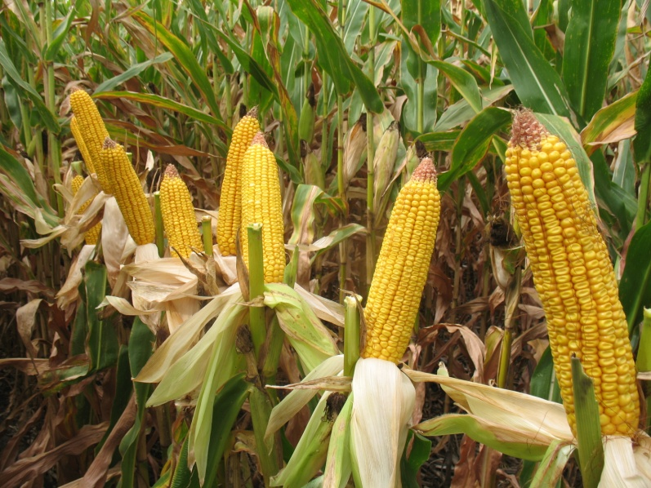
Lindell Farm, Nitrogen Rich Strip (left) and farmer practice (right)
September 14, 2009. BTW, I took a quick trip this afternoon to my brother’s field that we are tracking to get some visual checks during the maturing process. I have attached some pictures. Two pics are labeled NRS (N Rich Strip 200 lbs), two pics are labeled FP (farmer practice 135lbs), and the last two show the previous crop old corn stalks as this is a 3rd year strip till field. I took my 75 year old father along to make sure there was no bias, but we could not account for any noticeable differences in ear size or quality from the two areas. Thought you might want to add these to the case study. On average, 16 rows/ear (range 14-18) and about 36-42 kernels per row. Milk line is at 50%. The NRS stalks do appear a little greener in the photos. Jrg

Outcome:
Unusually cool and dry August and September. Corn had trouble reaching full maturity as did all of the upper Midwest (low GDUs). Test weights were affected by the cool conditions resulting in ~52 lb/bu corn. Poor end of season conditions kept corn from achieving its full sensor predicted yield potential. The decision to not make a final nitrogen application resulted in a net gain of $15.45 per acre over the N rich strip of 200lbs.
Treatment | Avg Profit | Avg Yield | Total N-rate (lbs/ac)
SBNRC | $ 681.45 | 181 | 133
N-Rich | $ 666.00 | 184 | 200
Difference | $ 15.45 | 201.62 | 60.2

Location:
Nebraska: Stanton County, 68779
Farmer Cooperator: Dan Davidson 402-968-0942 or 402-649-5919
Current Crop: Corn no-tilled into cover crop of rye
Previous Crop: Corn
Row Spacing: 30 inches
41.8119010 -97.2523298 (enter value in Google Map)
Situation:
Planting date: May 20, 2009
Sensing date: July 10, 2009
Cumulative GDD: 930
N Rich 200 lbs/ac NDVI: 0.68 cv = 5.9
N Rich 140 lbs/ac NDVI: 0.70 cv = 7.4
Farmer NDVI: 0.617
Bare Soil NDVI: 0.171
Estimated Yield Potential (YP): 156 bu/ac (with N), 116 bu/ac (no N)
Response Index: 1.31
Plants population: 23,681/ac or 4.3±0.383/m
Two N rich strips were established in the field, one with 140 and another with 200 lbs of N/ac and the farmer practice consisted of a pre-plant application of 70 lbs of N/ac. The NDVI values for the N rich strip with 140 lbs/ac was slightly higher than the NDVI value from the strip with 200 lbs/ac and both were higher than the farmer practice. The average of both N rich strips was used to make the recommendation (NDVI=0.69). A stand count revealed an average of 4.3±0.383 plants/m and plant population of 23,681.5 plants/ac (58,493.31 plants/ha). This corn field received about 11 inches of rain from planting to sensing date.
Recommendation:
Using the values collected with the GreenSeeker sensor, OSU recommended and additional 52lbs of N on top of the pre-plant rate of 70 lbs of N, making the total N rate 122 lb N/ac. This comes on the heels of having a robust response index (1.3) indicating that a 30% increase in yield would be attainable with the application of added N. This makes sense considering that the potential yield predicted was 156 bu/ac. Some important additional observations were that this was a no-till system in a corn on corn rotation for the past several years. The 2009 corn was no-tilled into a cover crop of rye. After corn was planted, millet was then burnt down using glyphosate. The stand for the most part was fairly uniform with exceptions in the old terrace channels on the side hills and some of the topographically low depressions where topsoil and water has accumulated resulting in a taller stand. Additionally this field was non-irrigated in a region of north central Nebraska where water is often a limiting factor without supplemental irrigation.

Outcome:
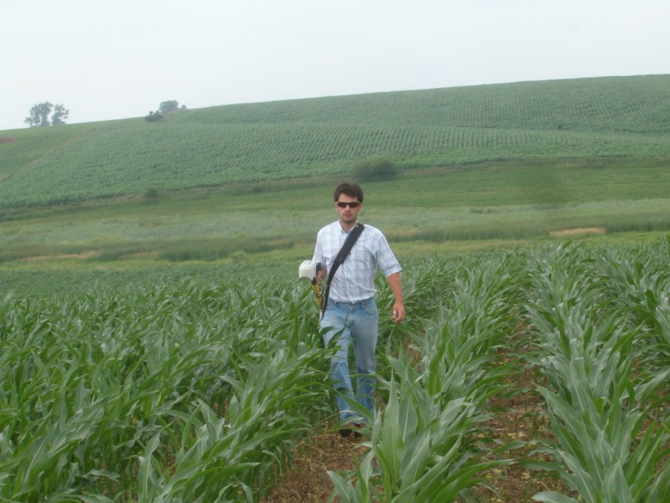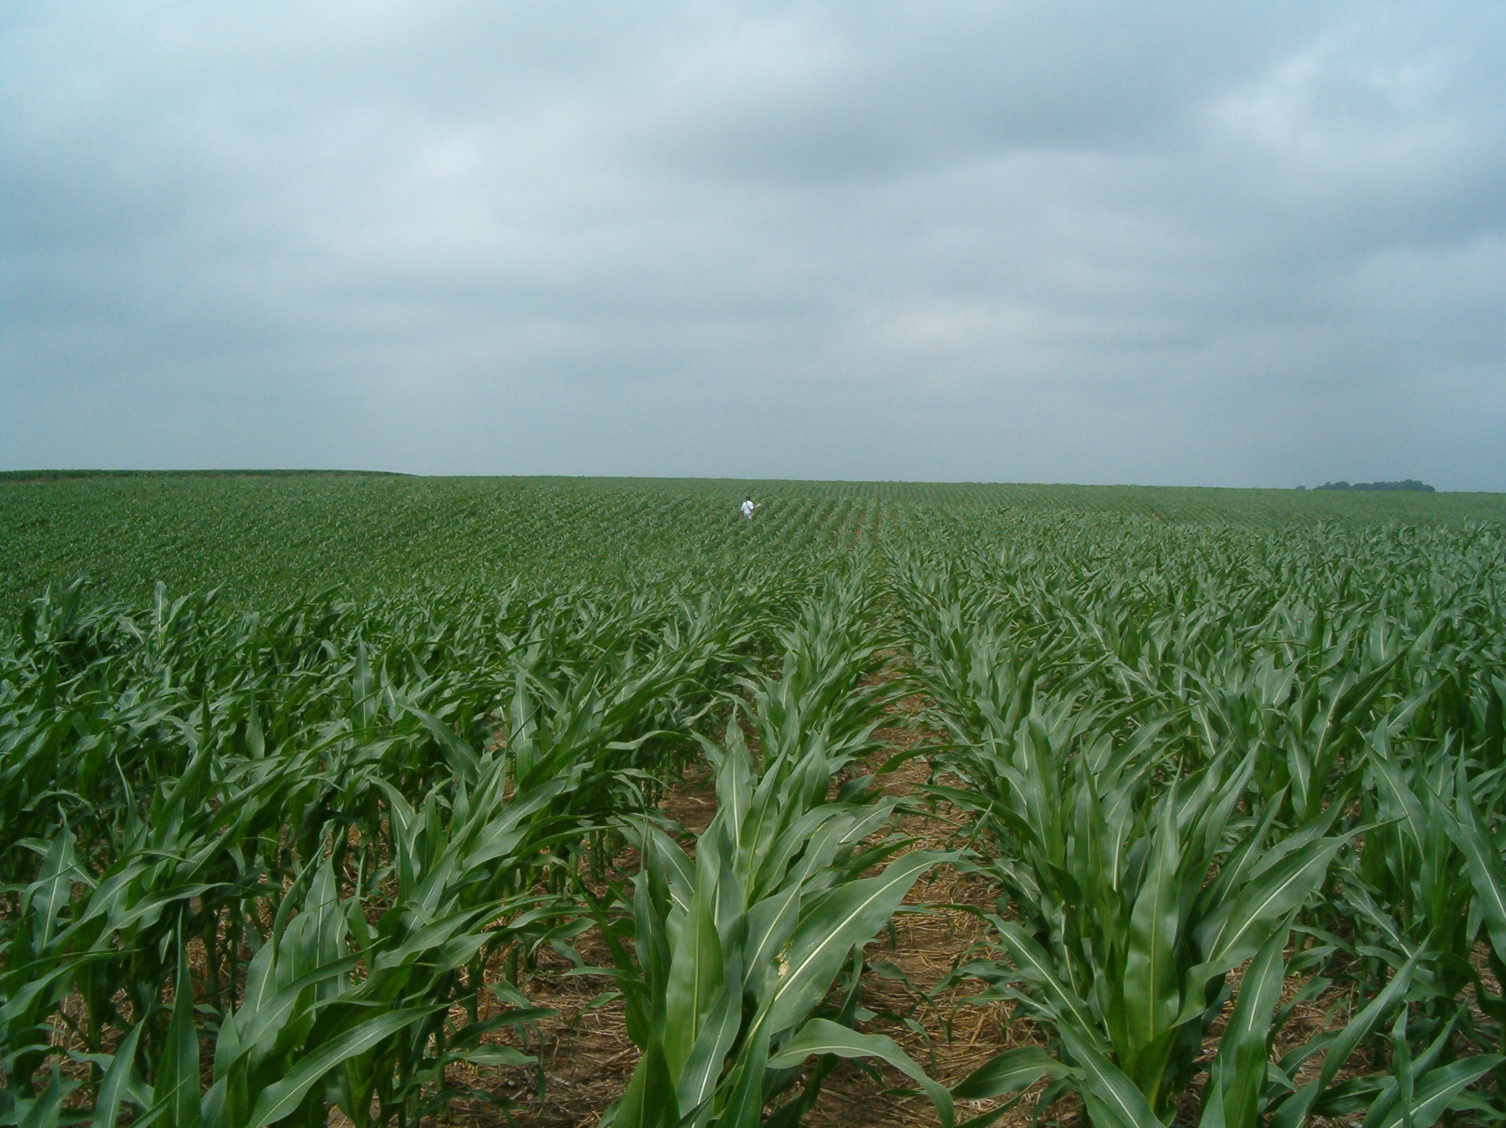
Dan Davidson farm, Stanton County, Nebraska

70 lb pre plant N rate averaged <100 bu/acre
210 lb N/ac N Rich Strip rate averaged 160 bu/acre
All the other sidedress N rates averaged around 145-150 bu/acre
The Greenseeker rep at 52 lb N/ac was no different than the PSNT with about 85 lbs N/ac.
Grower comment: “Seems that it worked”

Location:
St Charles County Missouri, Part of the 09 large scale implementation of sensor based Tech
Farmer Cooperator: Ross and Rich Boschert
Current Crop: Corn
Previous Crop: Soybeans 60 bu
Lat 38°53'17.74"N, Lon -98° 47' 42.80"
Situation:
Planting date: April 17th, 2009
Sensing date: June 12th, 2009
Cumulative GDD: 909
Physiological Growth Stage V-11 to V-12
N Rich NDVI: 0.917 ± 0.03 = 350lbs/N
Farmer NDVI: 0.907 ± 0.02
The N-Rich strip had slightly higher NDVI values, however it was not apparent at all with the naked eye except for a slight difference in height. Additionally the farmer practice had only 30 lbs/N while the N-Rich strip had 350lbs/N. The previous year they had 60 bu/ac soybeans on a soil with 3+ % O.M.
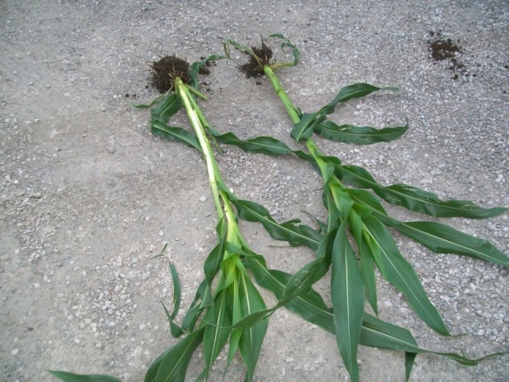
350 lbs/ac right, 28 lbs/ac pre-plant left note: no visual difference

Recommendation:
We recommended 52 lbs of additional sidedress N using the SBNRC recommendation. Yield potentials were predicted to be high (possibly 220 for field averages).
Outcome:
The farmer practice did have the highest yield, however, when figuring gross profit using $4.00/bu corn and $0.35 lb N, the SBNRC flat rate had the highest gross profit. The RT-200 VRT Treatment yielded substantially lower and produced a lower gross profit than the farmer practice; unfortunately, there were a couple of the sensors that were reading negative values which probably influenced the outcome. Results are presented in the table below.
Treatment | Avg Profit | Avg Yield | Total N-rate (lbs/ac)
Farmer Practice | 825.92 | 223.98 | 200
SBNRC Flat Rate | 835.21 | 215.80 | 80
RT-200 VRT | 785.40 | 201.62 | 60.2
N-Rich | 777.23 | 224.93 | 350

Location:
St Charles County Missouri, Part of the 09 large scale implementation of sensor based Tech
Farmer Cooperator: Wehmeyer Grain Farms
Current Crop: Corn
Previous Crop: Corn 200 bu/ac
Lat, 38°50'8.91"N Lon, 90°28'14.95"W
Situation:
Planting date: April 24th, 2009
Sensing date: June 13th, 2009
Cumulative GDD: 847
Physiological Growth Stage V-9
N Rich NDVI: 0.892 @ 350/lbs
farmer NDVI: 0.872 @ 15/lbs
The N-Rich strip had slightly higher NDVI values, however it was not apparent visually, except for a slight difference in height. Additionally the farmer practice had only 50lbs/N while the N-Rich strip had 420lbs/N. A good N response at this location was expected considering it was 3rd year corn on corn with very little pre-plant N. However it was a very moist spring and early summer and a soil with 2% organic matter.
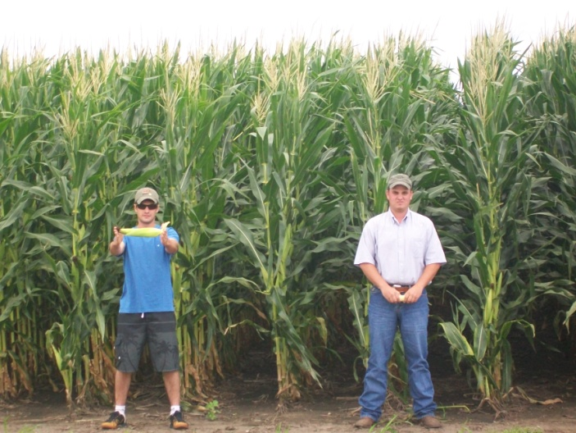
80 lbs/N 350 lbs/N
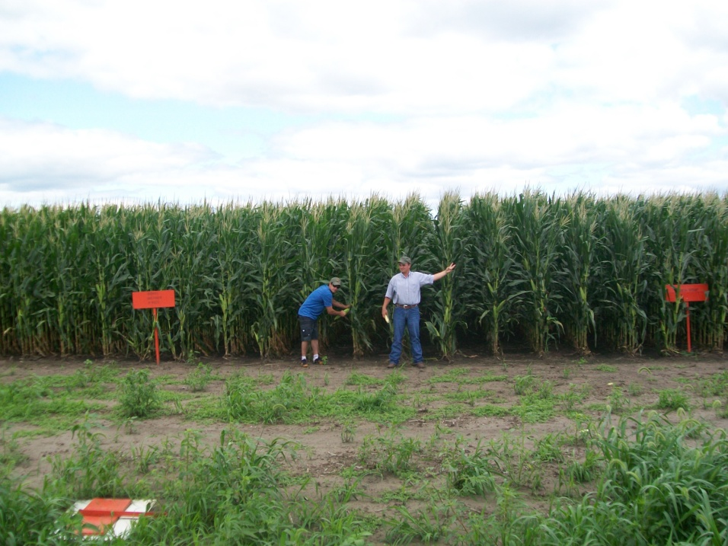
80 lbs/N 350 lbs/N
Recommendation:
SBNRC sidedress Rec = 65 lbs/ac, with the producer applying around 185 lbs at sidedress. Yield potentials were predicted to be more than 210 bu/ac.
Outcome:
The farmer practice had the highest yields, however, when figuring gross profit using $4.00 corn and $0.35/lb N, the SBNRC flat rate had the highest profit. Additionally the RT-200 VRT Treatment yielded slightly lower however produced the highest profit margin because of the lower total N rate applied. Results are presented in the table below.
Treatment | Avg Profit | Avg Yield | Total N-rate (lbs/ac)
Farmer Practice | 698 | 195.36 | 235
SBNRC Flat Rate | 716 | 189.73 | 115
RT-200 VRT | 731 | 190.14 | 82.7
N-Rich | 685 | 208.88 | 420

Location:
St Charles County Missouri, Part of the 09 large scale implementation of sensor based Tech
Farmer Cooperator: Jim Boerding
Current Crop: Corn
Previous Crop: Soybeans 35 bu/ac
Lat, 38°48'45.41"N Lon, 90°32'47.02"W

Situation:
Planting date: May 3rd, 2009
Sensing date: June 13th, 2009
Cumulative GDD: 780
Physiological Growth Stage V-7 to V-8
N Rich NDVI: .854 @ 350/lbs
Farmer NDVI: .813 @ 50/lbs
This trial ended up being an interesting situation, since in 2008 this field was completely covered with flood water. However, the producer did get in some late soybeans that made around 35 bu/ac after flood waters receded. A significant N response was expected since there was standing water for over a month. However the N-Rich strip was not clearly visible, with the main difference being in height and total biomass.
Recommendation:
The decision was made to apply an additional 65 lbs/N on top of the producers 50 lbs N/ac preplant. This producer usually applies much more N, around 200 lbs/N total. Yield potentials were expected to be around 180 to 200 bu/ac since growing conditions were good with plenty of moisture at the time of sensing.
Outcome:
The RT-200 VRT had the highest yield and the highest profit margin, when using $4.00 corn and $0.35 lb N. The SBNRC flat rate yielded just 1 bu/ac lower than the farmer practice however, had higher profit since less N was applied. Results are presented in the table below.
Treatment | Avg Profit | Avg Yield | Total N-rate (lbs/ac)
Farmer Practice | 729.70 | 199.92 | 200
SBNRC Flat Rate | 754.61 | 198.71 | 115
RT-200 VRT | 769.43 | 201.13 | 100.4
N-Rich | 706.52 | 207.26 | 350

