Research Proposal
Submitted To
Oklahoma State University
Department of Plant and Soil Sciences

Evaluation of Drum Cavity Size and Planter- tip on Singulation and Plant Emergence in Maize
(Zea Mays L.)

JAGMANDEEP SINGH DHILLON
Graduate Student
Fall 2014
Department of Plant & Soil Sciences
Oklahoma State University

Introduction
Maize (Zea mays L.) is one of the most important cereals in the world. Maize production in the world exceeded 1 billion metric tons in 2013 (FAOSTAT, 2013) and accounts for the largest tonnage produced by any major cereal. Maize delivers 30% of food calories, besides rice and wheat, to more than 4.5 billion people in 94 developing countries (Shiferaw et al., 2011).
In developing countries, 29 M ha of maize is planted by hand and average yields are near 1.8 Mg ha⁻¹ (FAOSTAT, 2013). Farmers in developing countries practice farming on a small scale (0.1 to 2 ha) and are said to be resource poor (Ibeawuchi et al., 2009). Commonly used implements for hand planting include a stick planter, cutlass, dibbler or hoe depending on local traditions ,which are highly labor intensive (Adjei et al., 2003; Tweneboah, 2000). Omara et al. (2014) observed that when planted by hand, two to three maize seeds are dropped per hill and covered by surrounding soil. This results in multiple seeds that emerge, non-uniform germination, seed rotting due to deep planting and loss of seed due to improper covering (Aikins et al., 2010).
Many researchers have reported the importance of homogenous crop stand to achieve higher crop yield (Nafziger et al., 1991; Ford and Hicks, 1992; Nielson, 2004; Liu et al., 2004; Tollenaar et al., 2006; Rutto et al., 2014). Improved homogeneity should lead to increased water use efficiency, nutrient use efficiency, solar radiation, and more uniform inter-plant competition which affects yield. This is currently lacking in many developing nations where two to three seeds are planted per hill resulting in heterogeneous competition and decreased yields. Single seed placement could help to reduce this in-field heterogeneity.
Although there have been numerous attempts to develop maize hand planters for farmers in developing countries, there have been few products developed that actually singulate individual maize seed. Aikins et al. (2010) compared 30 local hand planters with 5 different maize varieties and concluded that 53% of the time planters delivered less than or greater than 2 seeds and 70% of the time planters delivered less than or greater than 3 seeds. These results showed that seed metering by hand planters is generally poor.
Oklahoma State University (OSU) developed a singulating maize hand planter (GreenSeeder) capable of placing one seed at a time in the planting hole with up to 80% singulation efficiency and 20% multiple seed delivery over a range of seed sizes (Omara et al., 2014).
The GreenSeeder offers additional benefits like removal of chemically treated seeds from farmer’s hands, decreased soil erosion due to improved homogeneity of the plant stand, and a method using a different internal drum to accommodate mid-season fertilizer application. It’s an all-terrain hand planter capable of being operated in topographically steep slopes (hilly areas) that might not be well served by mechanization. Planting with the GreenSeeder is also less labor intensive than the traditional hand planting operation of making a hole, bending to drop seeds within the plant hole, and covering the hole with soil.
The GreenSeeder is made up of a polyvinyl chloride round pipe (PVC) with a diameter of 5.8 cm which is connected to a metering delivery system. The seed metering system consists of an aluminum/plastic tube which contains a reciprocating drum, spring and brush. The bottom end of the metering system is connected to a pointed tip/shovel, which can plant to depth of about 5 cm depending on the force applied by the operator. Angle and cavity depth of the drum are crucial for delivering single seeds. The GreenSeeder is easily operated by striking the ground surface with the planter leaning towards the operator, keeping the tip in the ground and moving the handle forward and then pulling the handle out of hole to drop the seed. With each strike, a reciprocating drum rotates upward and receives one seed; excess seeds are removed by an internal brush, and each individual seed is dropped as the planter is moved upwards, thus rotating the internal drum.
The drum cavity and angle (internal drum) have proven to be crucial for delivering a single seed per strike during operation of the GreenSeeder (Omara et al., 2014). Previous testing has also shown that during planting, the depth to which the seed is planted can vary greatly. Heterogeneity of planting depth can lead to delayed emergence. Depth control (tip stop) recently installed, can aid in planting seeds at a uniform depth. However, its effect on emergence and yield has not been investigated.
This study therefore aims to investigate the effect of drum cavity size and depth control on emergence and yield of maize.

Objective
The objective of this study is to evaluate effect of drum cavity size and GreenSeeder tip on the emergence and yield of maize over a range of maize seed sizes.

Review of Literature
Hand Planter Importance
According to Cairns et al. (2012) the demand for maize will double in developing countries by 2050; with the global population expected to exceed 9 billion and highest population growth occurring in developing countries. Current planting techniques adopted in developing countries are highly inefficient, as apparent from the low average yields 1.8 Mg ha⁻¹ (FAOSTAT, 2013).
Planting maize with a hand planter shows significant advantage in seedling emergence compared to traditional planting practices. This fact was brought out by comparison between hand planter and cutlass, dibbler, hoe in Ghana (Aikins et al., 2011).
In earlier work, Aikins et al. (2010) evaluated the performance of 30 hand planters for maize planting and inorganic fertilizer application. According to their findings they experienced poor seed and fertilizer metering of hand planters, and thus concluded that quality control for the metering mechanism of hand planters is vital.
The OSU GreenSeeder has been shown to achieve 80% singulation, in other words deliver a single seed per strike. Chim et al. (2014) reported that placing 1 instead of 2 or 3 seeds per hill could increase yields by 40%.
Effect of depth of sowing and uneven emergence on corn yield
According to Alessi and Power (1971) a 10 mm increase in planting depth at a constant temperature of 13 ºC results in a delay in emergence by 1 day.
Gupta et al. (1988) deduced that with an increase in planting depth from 25 mm to 75 mm, time to corn emergence increased, due to a decline in temperature with depth and the increase in distance the cotyledon has to travel before emergence.
Carter et al. (1989) concluded that uneven plant emergence creates competition between early emerging and late emerging plants and tends to decrease production of late emerging plants. Various reasons for uneven emergence include inconsistency in soil moisture, soil temperature, seed depth and other reasons like soil crusting, herbicide injury, or because of insects or diseases (Carter et al., 1989).
Martin et al. (2005) depicted delayed and uneven emergence as the reason for plant grain yield differences with uneven planting depth being the main cause for this irregular emergence.
According to Nielsen (2004), two-leaf stage difference between adjacent plants can reduce yield by up to 1% with every 1-day delay in emergence.
In their study on emergence and spacing variability, Liu et al., (2004) and Tollenar et al., (2006) found that plants next to a gap demonstrated some compensatory yield gain but no compensation is provided in yield by plants near late emerging plants.

Effect of Singulation and plant spacing on corn yield
In 2013 Average maize production in the USA was 9.9 Mg ha⁻¹ whereas in developing yields hover near 1.8 Mg ha⁻¹ (FAOSTAT, 2013). The reason behind this large gap in production level is that in the USA, highly mechanized planters are used which are accurate at planting single seeds with uniform spacing and depth.
Liu et al. (2004) reported a 6 to 10% reduction in yield with double and triple stands within 0-3 cm compared with uniforms stands. Tollenar et al. (2006) studied crowding stress related to increase in inter-row spacing and concluded that plants within close proximity suffer yield reduction.
Nafziger (1996) reported a yield reduction from 0.22 to 0.18 kg per plant with two seeds per hill as the number of hills per hectare increased from 44460 to 74100 plants ha⁻¹ but overall yield increased from 10.6 to 13.2 Mg ha⁻¹ with same.
Teasdale (1994) concluded that an increase in plant population resulted in an increase in corn leaf area and a decrease in light transmission to the soil, which helps in suppression of weeds. He also observed a decrease in yield with an increase in plant population beyond the optimum range (75000 and 100000 plants ha⁻¹). This is possible due to a reduction in the number of kernels and ears per plant.

Materials and Methods
To accomplish the objective of this study, two maize trials were established at Efaw, and the Agronomy Research Farm, both near Stillwater, OK, in June 2014.
Soil classification at the Efaw research station is Ashport silty clay loam (fine-silty, mixed, superactive, thermic Fluventic Haplustolls) and at Stillwater, Kirkland Silt Loam (fine, mixed, thermic Udertic Paleustolls).
A randomized complete block design with 3 replications and 9 treatments was used at the two experimental sites (Figures 1 and 2). Plant population was kept at 74000 seeds ha⁻¹ with a row spacing of 76 cm, and plant-to-plant spacing of 18 cm.
Counts of emergence of maize seedlings including single and multiples were taken and NDVI sensor readings were collected at V10 stage in order to predict the final yield.
Statistical analysis was accomplished using SAS version 9.3 (SAS Institute, Cary, NC, USA. PROC GLM was used to analyze the effect of drum cavity and tip on maize yield. Mean separation was performed using LSD (𝝰 = 0.05). Linear plateau models were used to determine trends in emergence over time.

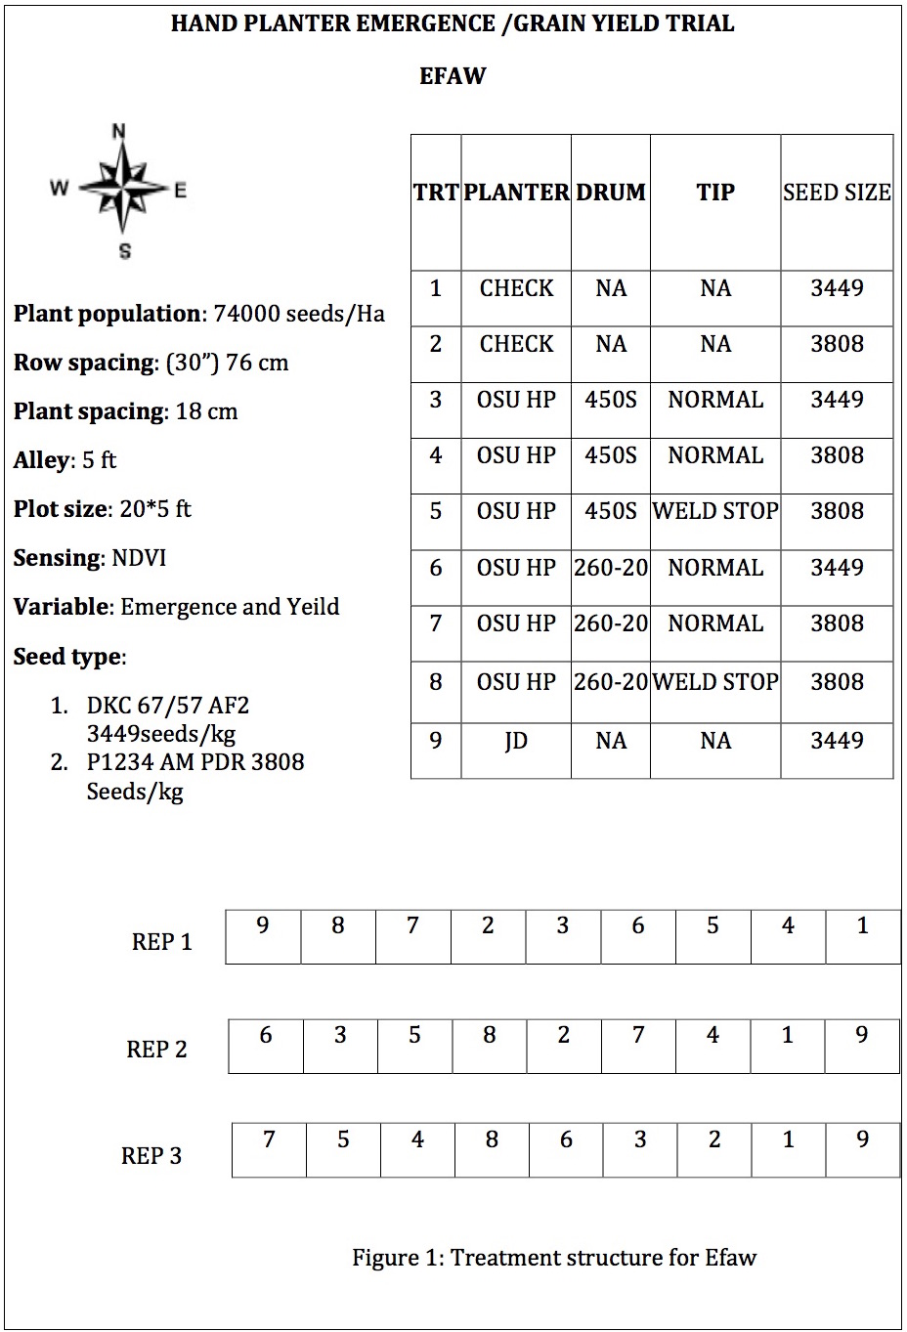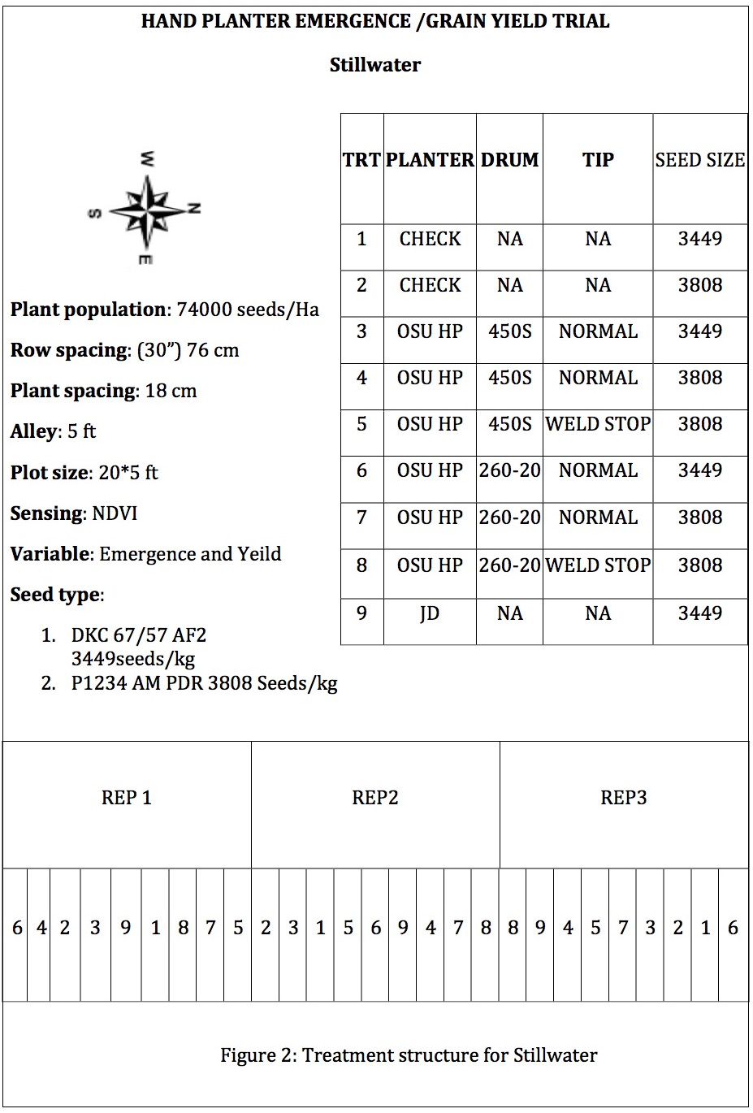

REFERENCES
Adjei, E.O., S.H.M. Aikins, P. Boahen, K. Chand, I. Dev, M. Lu, V. Mkrtumyan, S.D. Samarweera and A. Teklu. 2003. Combining mechanization and conservation agriculture in the transitional zone of Brong Ahafo Region, Ghana. ICRA Working Documents Series 108, International Centre for Development Oriented Research in Agriculture, Wageningen
Aikins, S.H.M., Afuakwa, J.J.,Adjei,E and Kissi, G. 2011. Evaluation of different planting tools for maize stand establishment. Journal of science and nature 2(4): 890-893
Aikins, S. H. M., A. Bart-Plange and S. Opoku-Baffour.2010. Performance evaluation of jab planters for maize planting and inorganic fertilizer application. Journal of Agriculture and Biological Science. Vol 5, No. 1
Alessi, J., and J. F. Power. 1971. Corn emergence in relation to soil temperature and seeding depth. Ag Journal 63: 717–719.
Bekele, S., B. M. Prasanna, J. Hellin, and M. Banziger. 2011. Crops that feed the world 6. Past successes and future challenges to the role played by maize in global food security. Food Security 3(3): 307-327.
Cairns JE, Sonder K, Zaidi PH, Verhulst N, Mahuku G, Babu R, Nair SK, Das B, et al. 2012. Maize production in a changing climate: impacts, adaptation and mitigation strategies. Adv. Agron. 114 1–58
Carter, P.R. and E.D Nafziger. 1989. Uneven emergence in corn. North Central Regional Extension Publication No. 344.
Chim, Bee Khim, Peter Omara, Jeremiah Mullock, Sulochana Dhital, Natasha Macnack, and William Raun. 2014. Effect of seed distribution and population on maize (Zea mays L.) grain yield. Int. J. Agronomy (in press).
Ford, J.H., and D.R. Hicks. 1992. Corn growth and yield in uneven emerging stands. J. Prod. Agric. 5:185–188.
Gupta, S.C., E.C. Schneider, and J.B. Swan. 1988. Planting Depth and Tillage on Corn Emergence. Soil Science Society Am. J. 52: 1122-1127.
Ibeawuchi, Izuchukwu Innocent., Obiefuna Julius Chiedozie, Ofor, Moarian Onome, Ihem, Emmanuel Ememnganha, Nwosu Fidelis Okwudili, Nkwocha Vincent Ikechukwu, and Ezeibekwe Innocent Obioha. 2009. Constraints of Resource Poor Farmers and Causes of Low Crop Productivity in a Changing Environment. Reasearcher.
Liu,W., M.Tollenaar,G.Stewart,andW.Deen.2004.Responseofcorngrainyieldtospatialandtemporal variability in emergence. Crop Science 44: 847–854
Martin, K.L., P.J. Hodgen, K.W. Freeman, R. Melchiori, D.B. Arnall, R.K. Teal, R.W. Mullen, K. Desta, S.B. Phillips, J.B. Solie, M.L. Stone, O. Caviglia, F. Solari, A. Bianchini, D.D. Francis, J.S. Schepers, J.L. Hatfield, and W.R. Raun. 2005. Plant-to-plant variability in corn production. Agron. J. 97:1603–1611.
Nafziger, E.D., P.R. Carter, and E.E. Graham. 1991. Response of corn to uneven emergence. Crop Sci. 31:811-815.
Nielsen, R.L. 2004. Effect of plant spacing variability on corn grain yield. Available at www.agry.purdue.edu/ext/corn/research/psv/ Update2004.html (verified 20 Mar. 2006). Purdue Univ., West Lafayette, IN
Nafziger, E.D. 1996. Effects of missing and two-plant hills on corn grain yield. J. Prod. Agric. 9:238–240
Rutto, Emily., Cody Daft , Jonathan Kelly , Bee Khim Chim , Jeremiah Mullock , Guilherme Torres & William Raun.2014. Effect of delayed emergence on corn (ZEA MAYS L.) Grain yeild, Journal of Plant Nutrition, 37:2, 198-208
SAS Institute Inc. 2008. SAS/STAT ® 9.2 User’s guide.Cary, NC: SAS Institute Inc.
Teasdale, J. R. 1995. Influence of narrow row/high population corn (Zea mays) on weed control and light transmittance. Weed Technol. 9:113- 118.
Tollenaar, M., W. Deen, L. Echarte, and W. Liu. 2006. Eff ect of crowding stress on dry matter accumulation and harvest index in maize. Agron. J. 98:930–937.
Tweneboah, C.K., .2000. Modern Agriculture in the Tropics with Special Reference to Ghana. Co-Wood Publishers, Accra, Ghana.

