Delivery of the OSU Singulating Hand Planter
Maximizing singles and minimizing misses
http://nue.okstate.edu/Hand_Planter.htm
Personnel
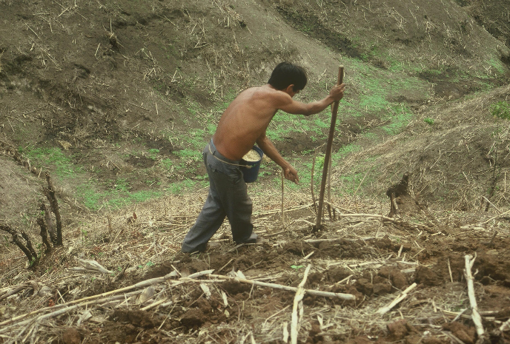
Randy Taylor, Professor, BAE (randy.taylor@okstate.edu)
Adrian Koller, Switzerland (adrian.koller@hslu.ch)
Andrew Slavens, BAE (andrew.slavens@okstate.edu)
Wayne Kiner, Manager, BAE Lab (wayne.kiner@okstate.edu)
Kyle Hiner, BAE Graduate Student
Eric Lam, CIMMYT, engineering (eric.lam@okstate.edu)
Joshua Ringer, Indigdev (joshuaringer@indigdev.com)
Nyle Wollenhaupt, Retired, AGCO (nyle.wollenhaupt@gmail.com)
Dr. Edgar Ascencio, El Salvador (noelascencio@yahoo.com)
Rebecca Harman, Tennessee (Becca.mattingly@gmail.com)
Roman Gordon, Panama (gordon.roman@gmail.com)
Peter Omara, Uganda
Lawrence Aula, Uganda
Daniel Alidekki, Uganda, PASS
Jeremiah Mullock, PASS
Jagmandeep Dhillon, India, PASS
Bruno Figueiredo, Brazil, PASS
Sulochana Dhital, Nepal, PASS
Natasha Macnack, Suriname, PASS
Tyler Lynch, PASS
Melissa Golden, PASS
Nicole Remondet, PASS
Bill Raun, PASS
Initial ideas for the development of a viable hand planter for the third world came from work in Central America. The needs for a new planter were predicated on the demands to remove chemically treated seed from the hands of producers in the developing world whose method of planting maize required skin-to-seed contact. Placing 2-3 seeds by hand, per hole made by striking the soil with metal tipped persimmon sticks is presently a common practice in the third world where maize is grown on highly marginal landscapes.
The need for improving the production environment for maize farmers, has also embedded the need for more homogenous plant stands, both distance to-and-from each seed, and with a planter that delivered one seed per strike.
Mechanical changes that have taken place and results that have accompanied these changes follow.
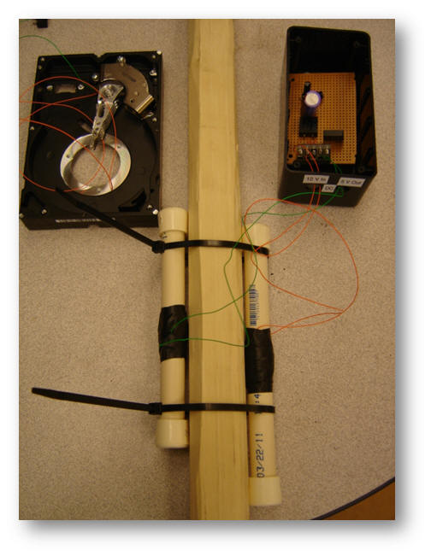
We have come a long way since the design on the right was first constructed by a senior design BAE team. A later design by Kyle Hiner (below) further evaluated a more mechanical approach that did show promise but that crushed the seed.
Despite notable progress over the years, the continual nemesis of “misses” prevented our group from moving forward. Using our present design (inner and outer housings), misses have been encountered, but when less than 300 ml of seed was placed in the hopper, and the planter was gently shaken following every 2-3 strikes, we did achieve >80% singulation (with a range of seed sizes, using the 450s drum). However, this was principally tied to certain operators (Peter Omara and Lawrence Aula) who had a seemingly ergonomic connection to the planter and whom could consistently deliver higher percent singulation than other operators.
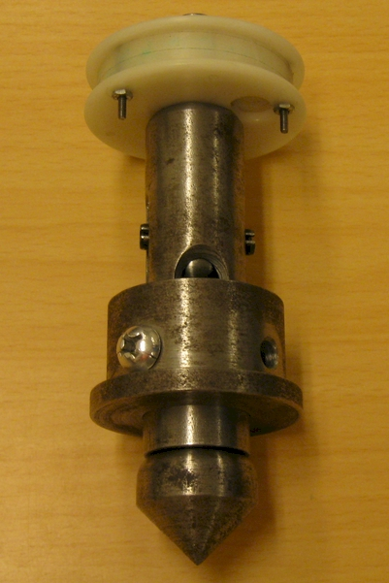
Many variables have been tested in an attempt to eliminate misses. While the focus has been on maximizing singulation, an overall acceptance of multiple seeds per strike has been preferred over the presence of any misses. Eliminating misses has in essence been a priority. Variables evaluated have included but were not restricted to inner housing brush strength, brush length, drum cavity size, drum cavity depth, and pre-cavity agitation on the drum.
Optimizing singulation has further evaluated the interaction of seed size (range between 2500 to 4000 seeds/kg) and the size/depth of the drum cavity.
Operator has also been extensively evaluated, and whether or not shaking the hand planter (intention was to break up bridging), once every 4-5 strikes, improved singulation.
Several methods of vibration have also been tested. Attaching various configurations of vibrating toothbrushes, assisted in decreasing the number of misses. This method essentially helped to break up seed bridging that was taking place within the inner housing. Nonetheless, even with 2-3 vibrating toothbrushes, duct-taped to the outer housing, it was not enough to completely resolve inner seed bridging. Nonetheless, it did help versus a check-run where the hand planter was used with no vibration.
Understanding that the problem was clearly inner-housing seed bridging that had led to the occurrence of misses, ensuing testing to place something inside the seed reservoir that would go up and down and break up bridging, when it occurred, has been sought.
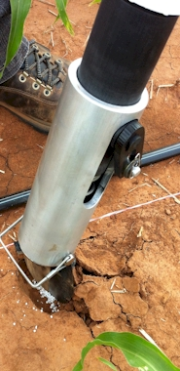
Most recently, the changes that have been effected have included the use of a spring loaded cable (spring attached to the seed reservoir cap, then attached to a spring, and this to a bicycle-brake-cable that extended downward, the length of the PVC seed reservoir, and attached to the rotating drum). At the lower extremes of the cable, beads were placed (bottom to top, about 20 cm) so as to guarantee disturbance of any seed bridging that would take place just above the drum. While cumbersome, and an unlikely fix, this agitation, completely eliminated misses.
Urea fertilizer application using the fertilizer drum
Small nails placed diagonally inside the inner housing have also been evaluated, but have not resolved seed bridging and a resultant decrease in misses.
Other methods of placing something internally that would go up and down within the inner housing have been discussed. A cut inside, accompanied by an outer attachment to the rotating drum-arm is currently being considered.
This document simply serves to communicate a few of the variables that have been evaluated in our quest to deliver an operational singulating maize hand planter. It does not include the differences in planter prototypes recorded over time. Also, we as a group are cognizant of the use of our hand planter for various other seed types and alternative fertilizers.
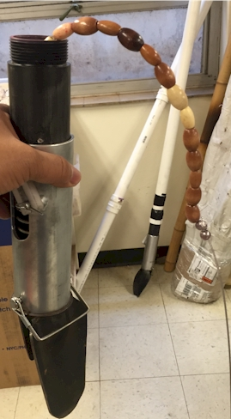
Use of internal cable and agitation beads (spring loaded at the top and attached to the rotating drum)

