2018 CYMMIT trip
Tyler Lynch, Robert Lemings, Elizabeth Eickhoff, Peter Ormara, Alimamy Fornah and Everett Hrbacek

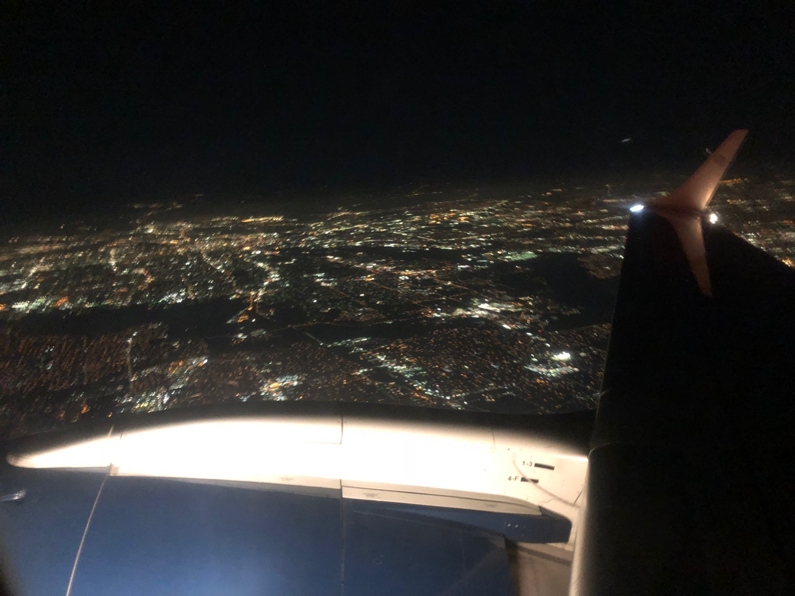
Leaving Dallas, starting our journey.
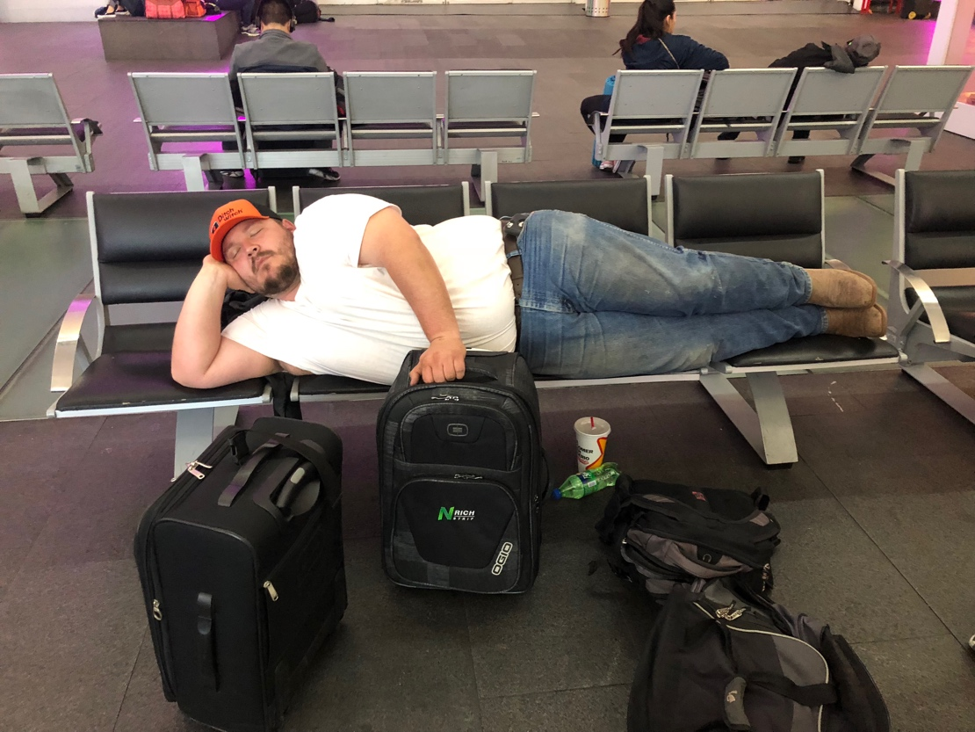
Seven-hour layover in Mexico City was hard on Robert.
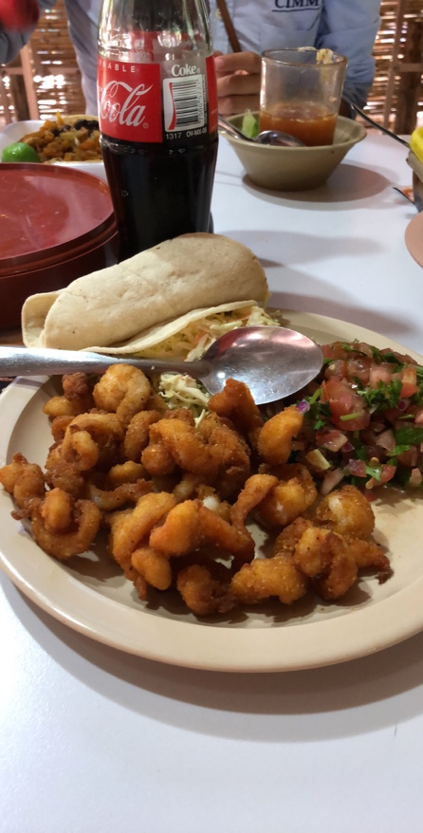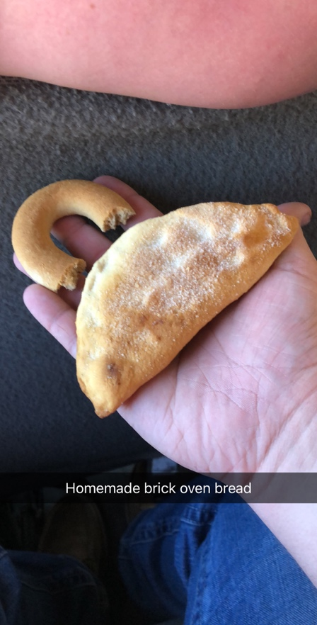
Our first food experience in Obregon!
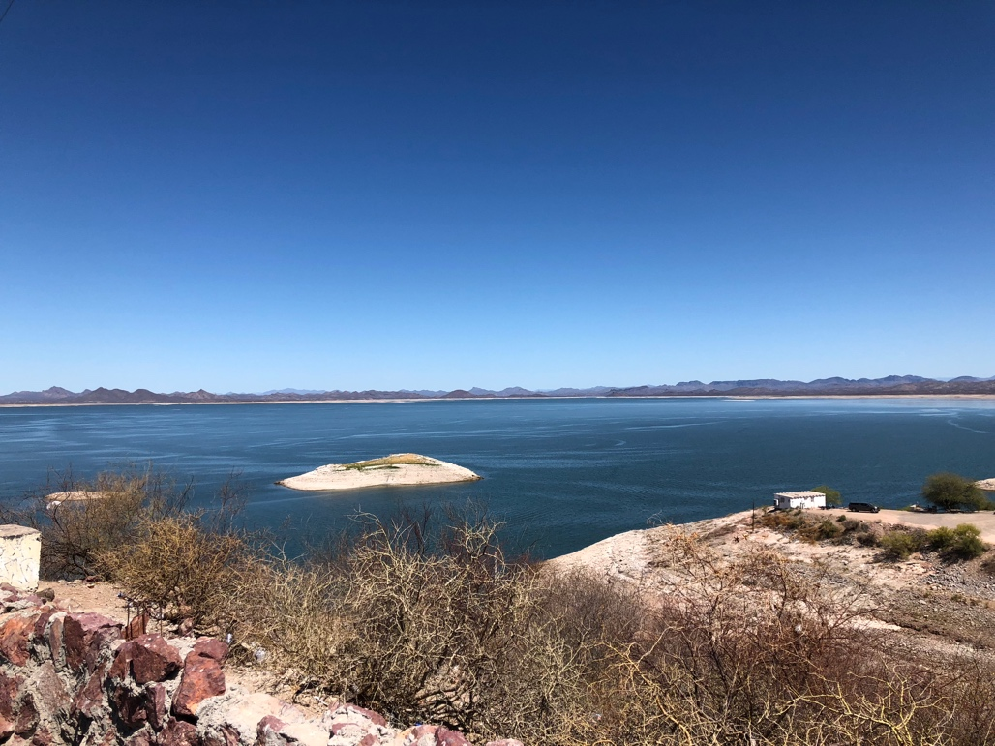
Visiting the main reservoir where the farmers get their irrigation water

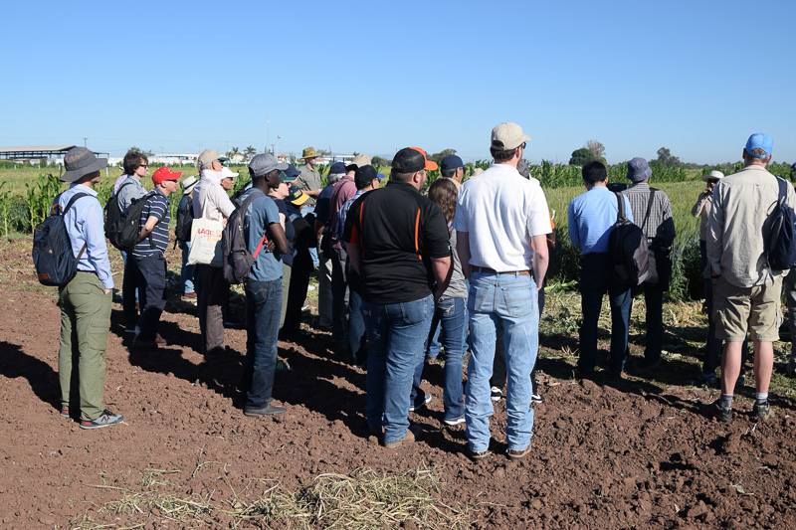
First speaker of the trip talking about wheat breeding trials
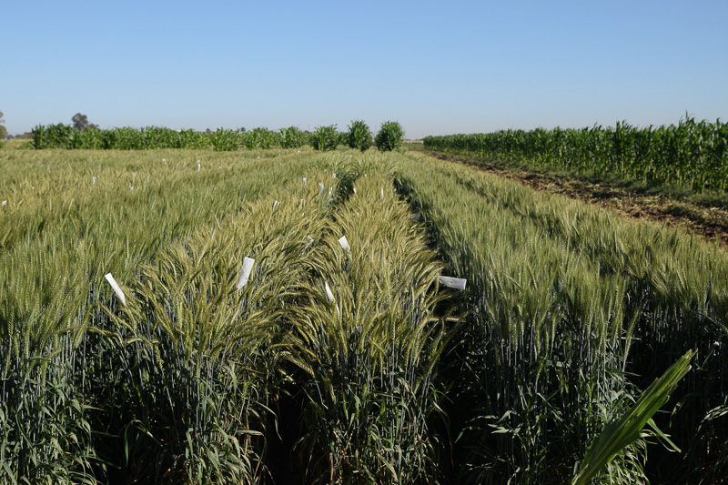
Wheat rows with heads covered for selective breeding

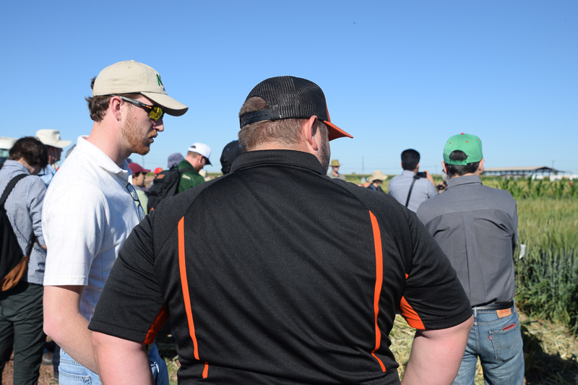
Robert and Tyler listening to the breeder showing off his trials.
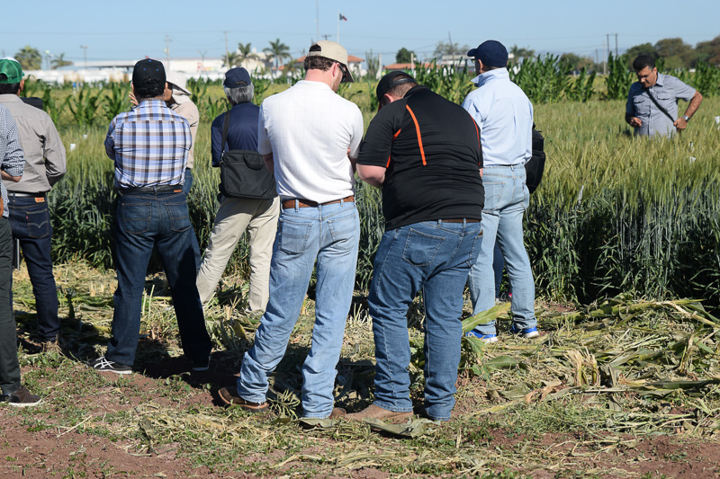
The focus didn’t last too long before they started playing in the dirt.
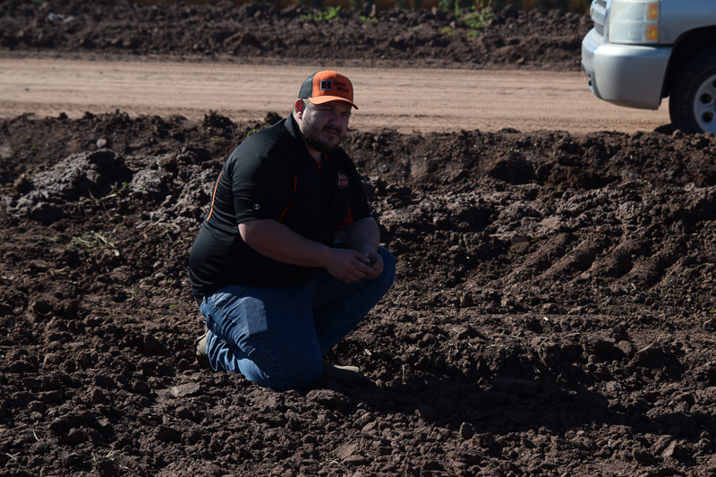
Robert assessing the soil type around the breeding plots.
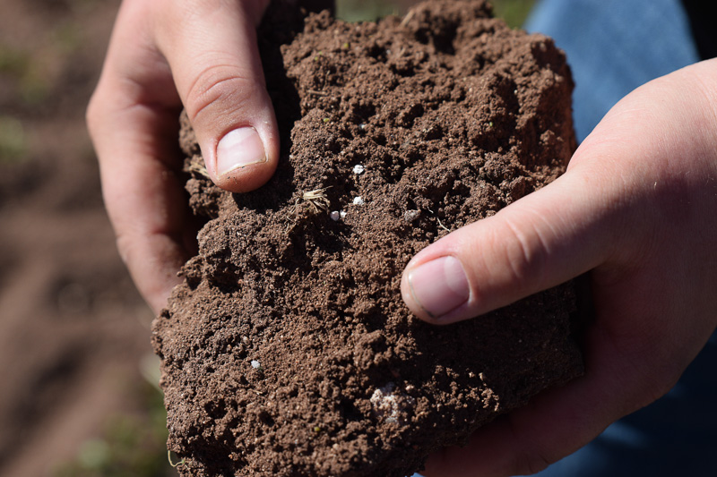
Upon further inspection of the soil Robert found undissolved fertilizer prills in the soil.
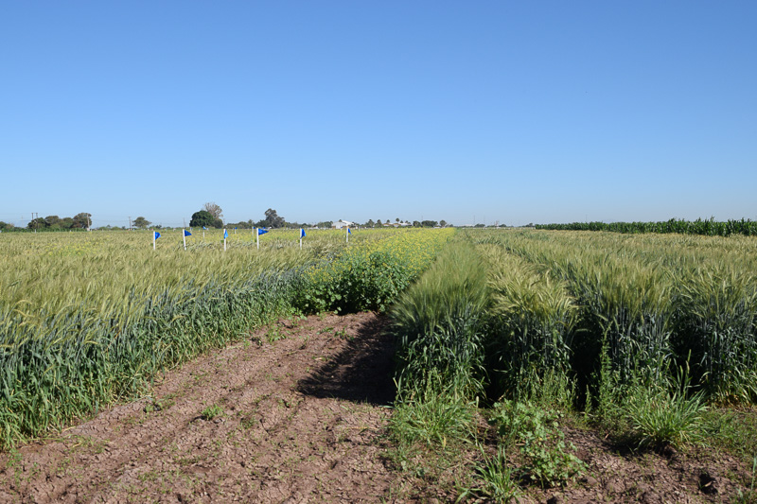
Canola planted in strips between the breeder plots to reduce cross pollination.
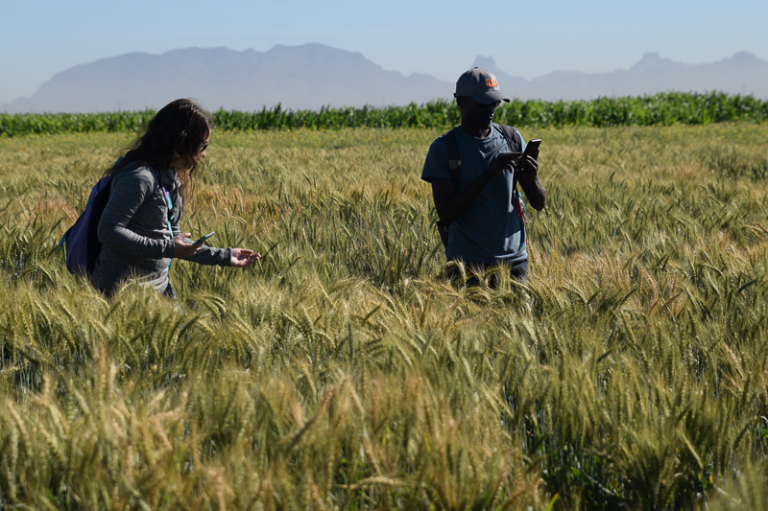
Liz and Peter taking pictures of wheat that had been marked by red spray paint, a visual marker showing it had been selected for breeding.
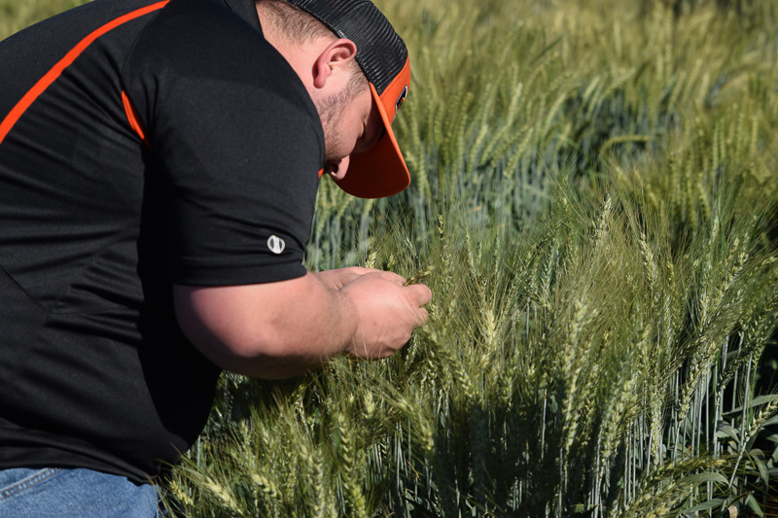
Robert examining wheat out in the field.
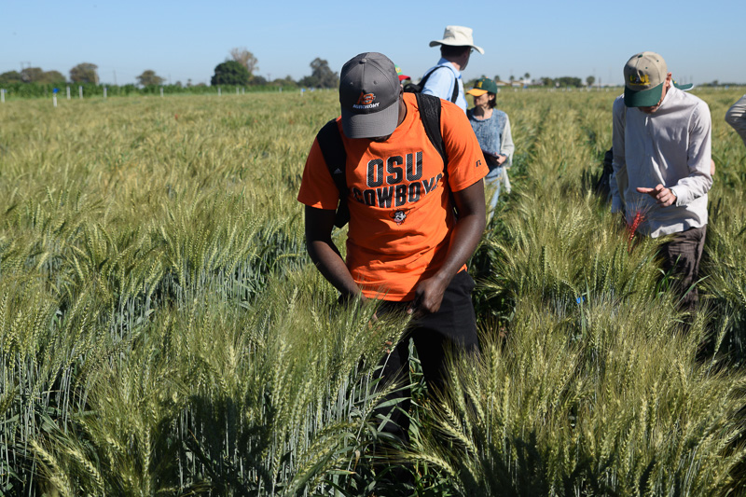
Alimamy also examining some wheat out in the field.

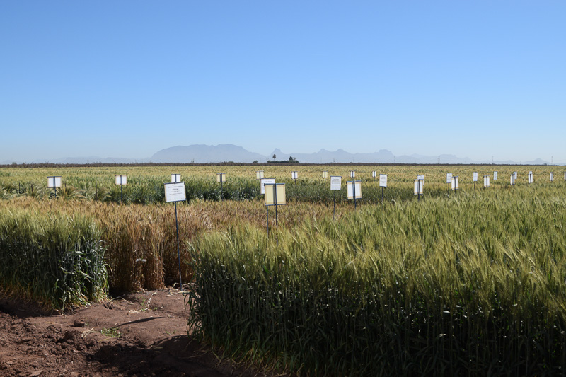
Variety plots indicated via a labeled plaque describing what they are.
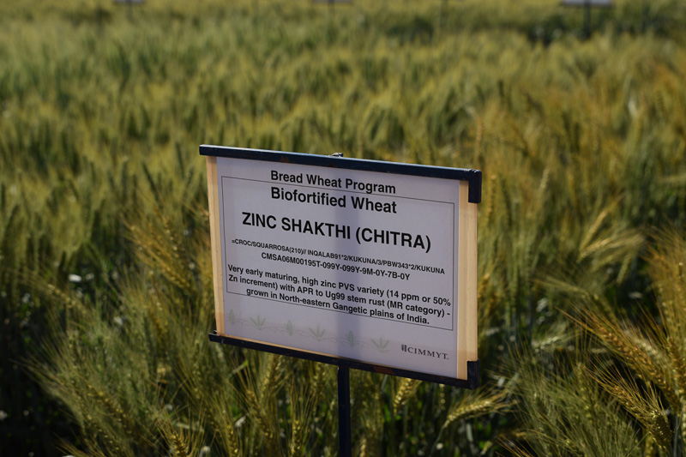
Close up showing one of the many plaques indicating what variety is planted.

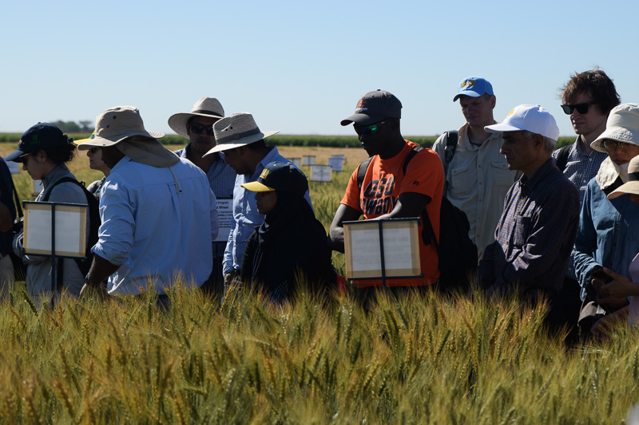
Alimamy following along while the speaker talks about each variety.
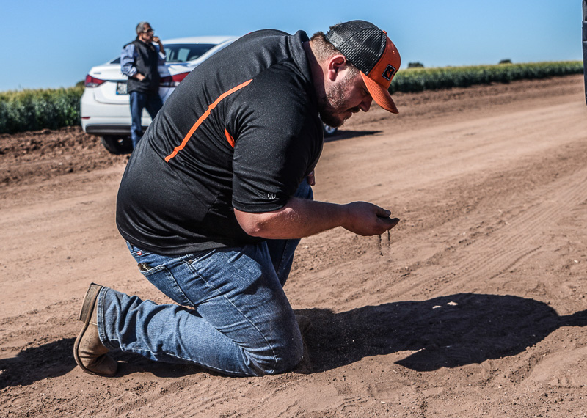
No matter where we went Robert was always inspecting the soil.
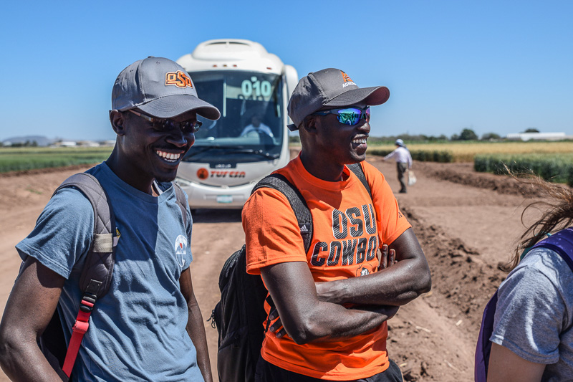
Peter and Alimamy were all smiles as we listen to more speakers.
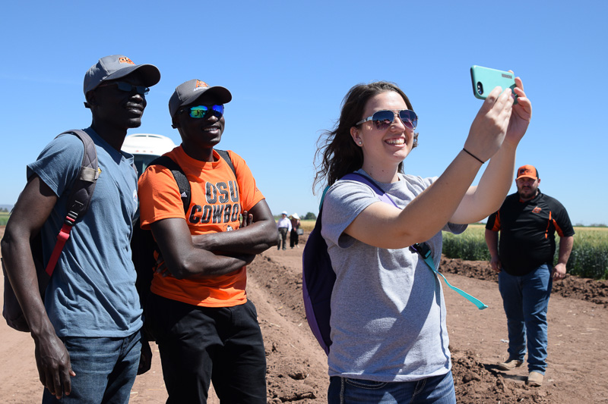
Capturing the moment with a selfie! And then there is Robert…hunting for more soil id presume

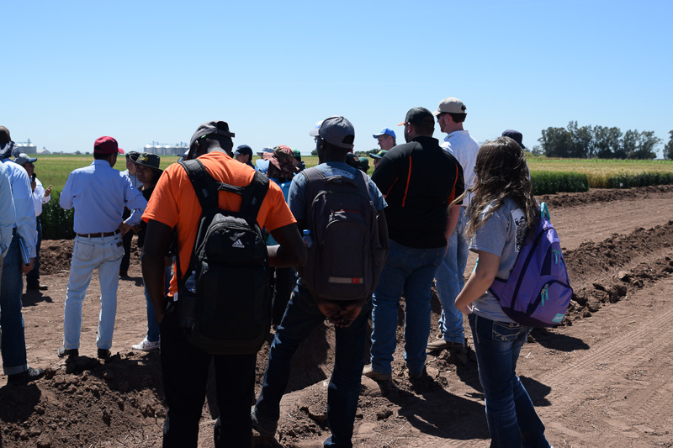
Listening to a speaker talking about his Durum wheat trials.
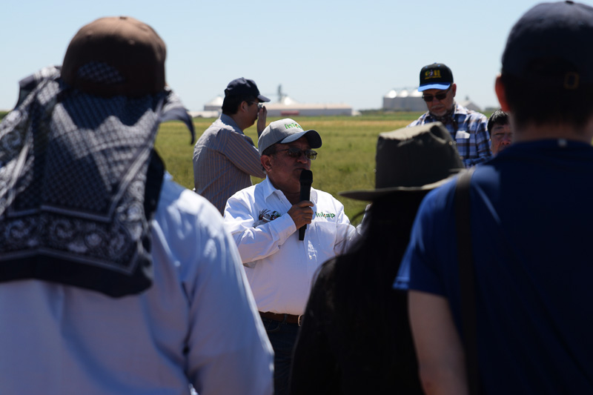
A gentleman talking about his durum trials.

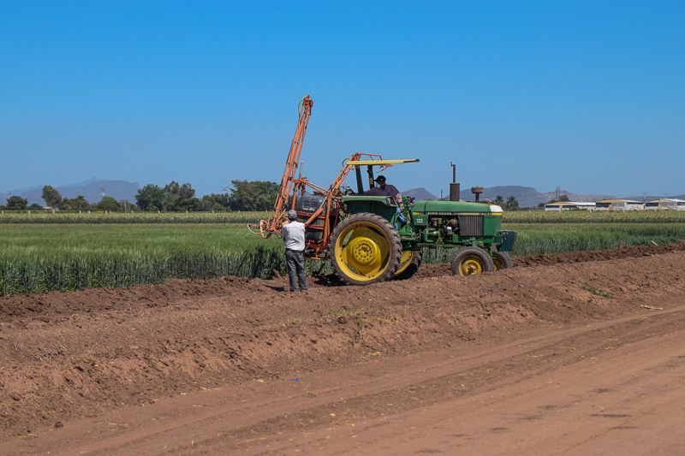
As we listened to the speakers, these men were hard at it applying what appeared to be fungicide to some wheat.
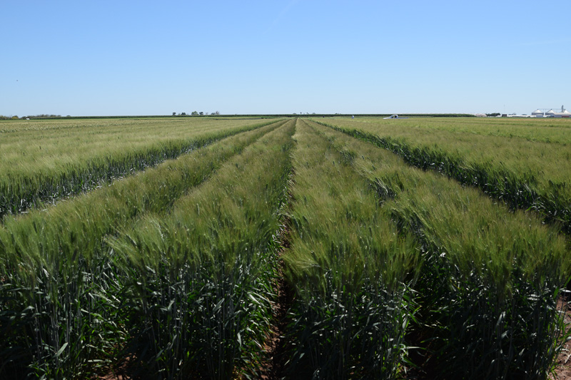
Some really good-looking durum wheat plots.
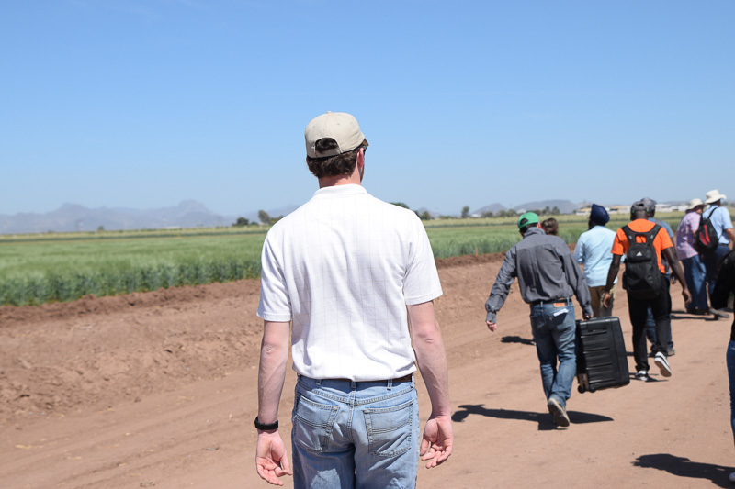
Always on the move, eager to learn more.
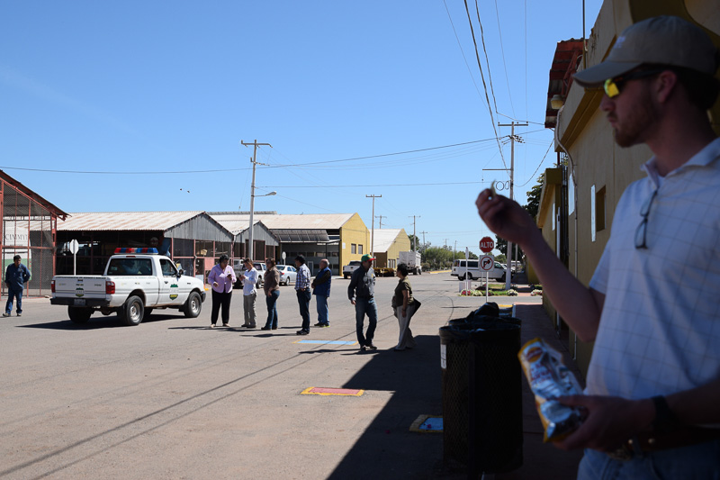
Snack break at the station while we wait to head to the next stop.

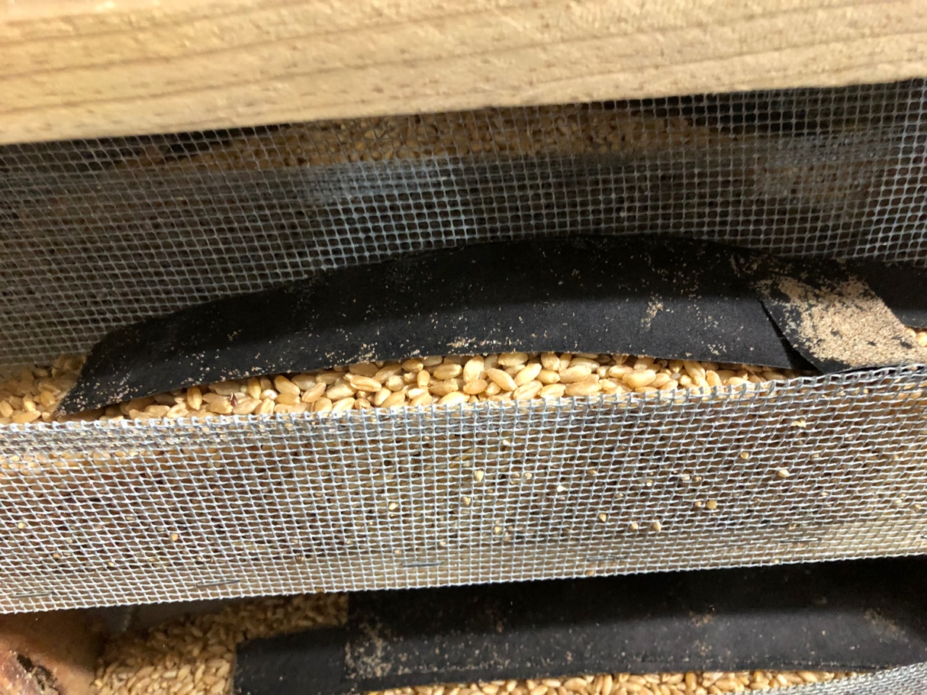
Inside the rooms where they grow a species of Lepidoptera for biological control at the station.
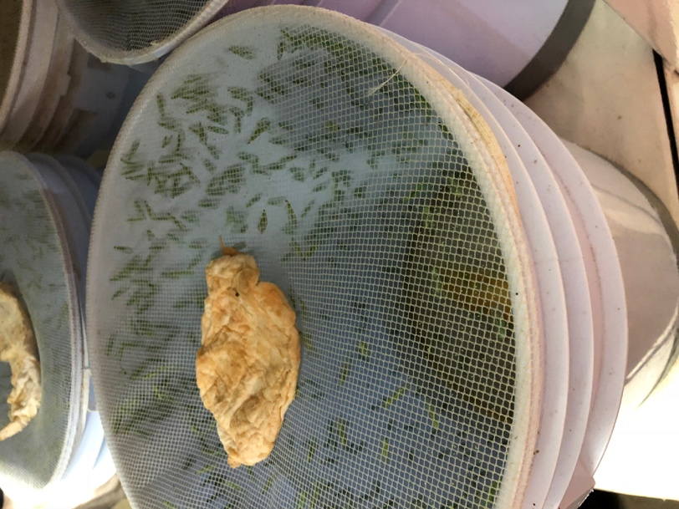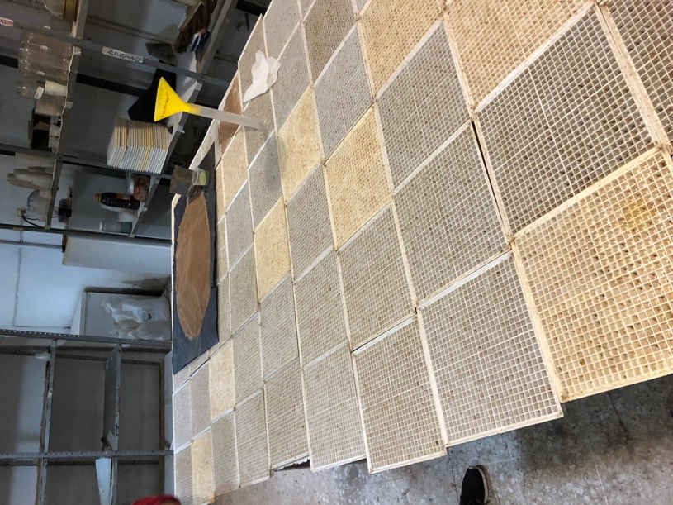
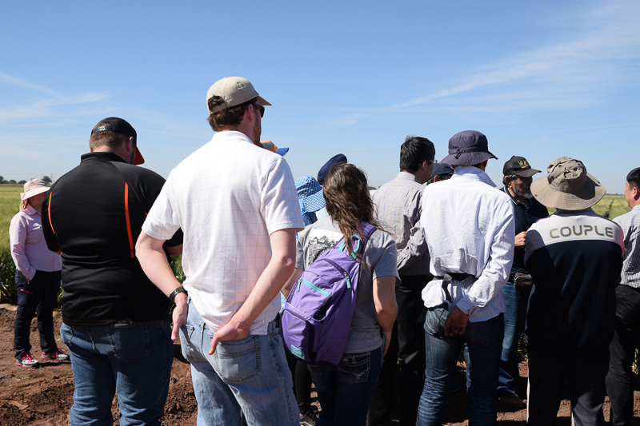
Our first stop with Dr. Sayre.
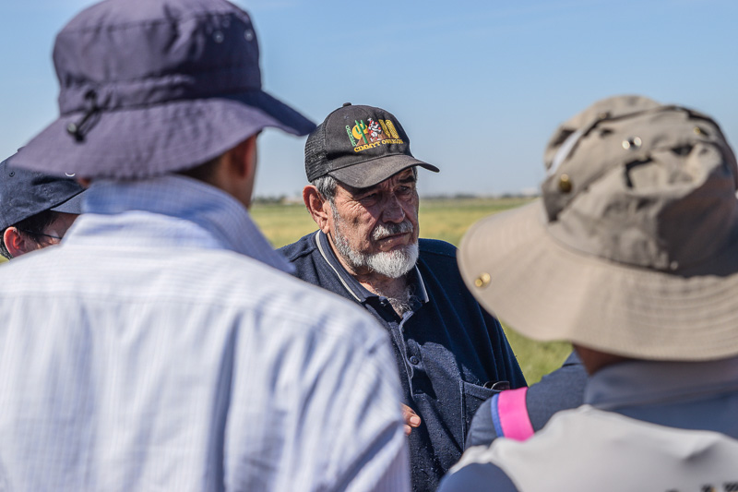
Dr. Sayre giving us some background to his time spent with Dr. Raun.

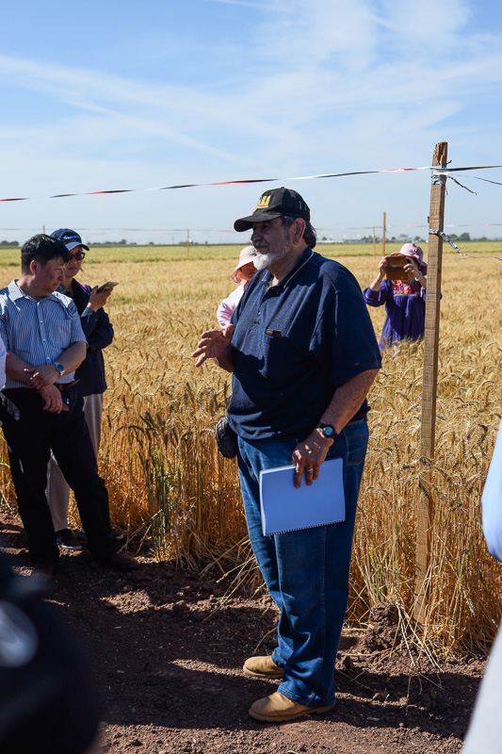

Dr. Sayre talking about his drought study and his introduction of the bird tape out in the fields.

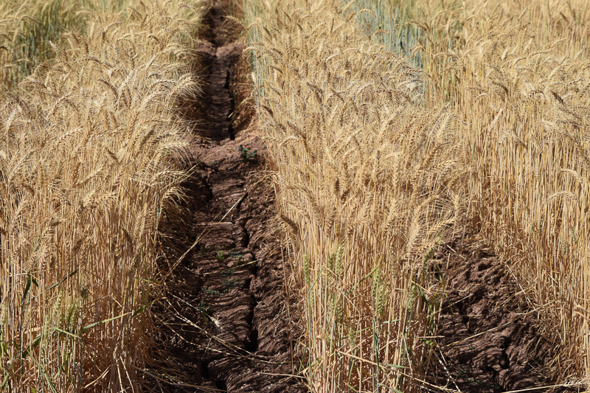
Very characteristic cracking of Vertisols in Dr. Sayres drought trials.
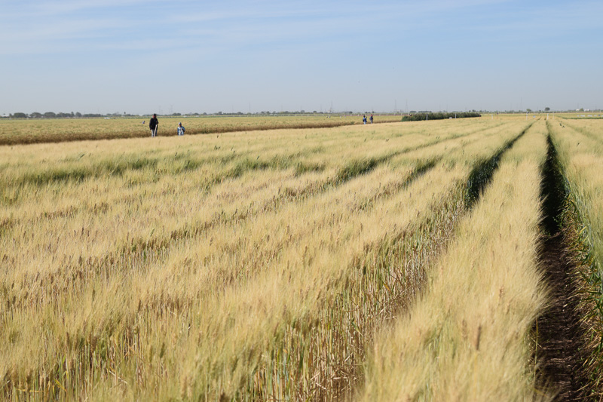
Visible Nitrogen response in another one of Dr. Sayres trails.

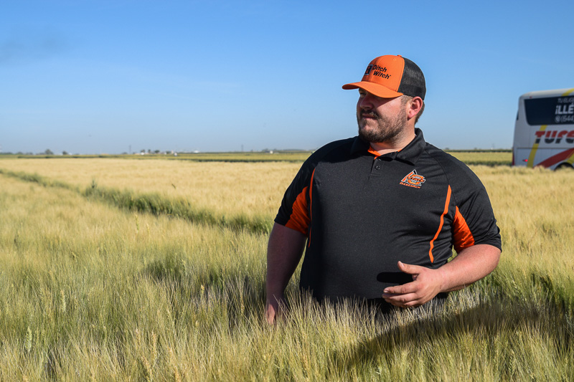
Robert striking a pose in the field.
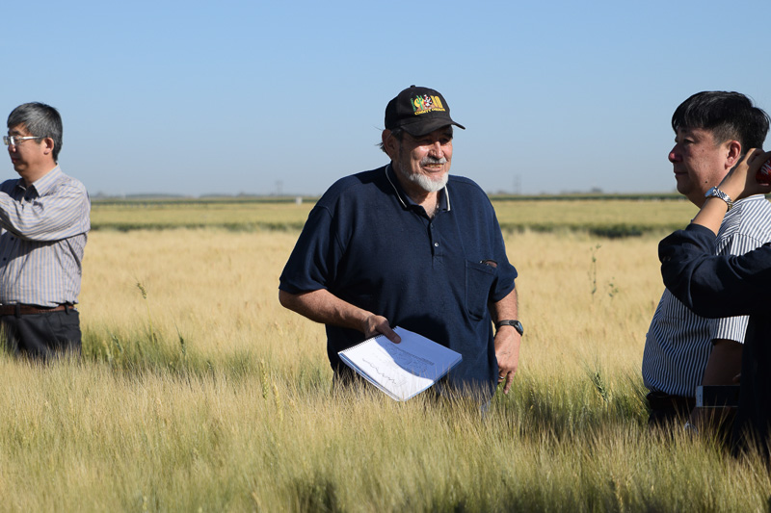
Dr. Sayre talking about some of his work with people from China.

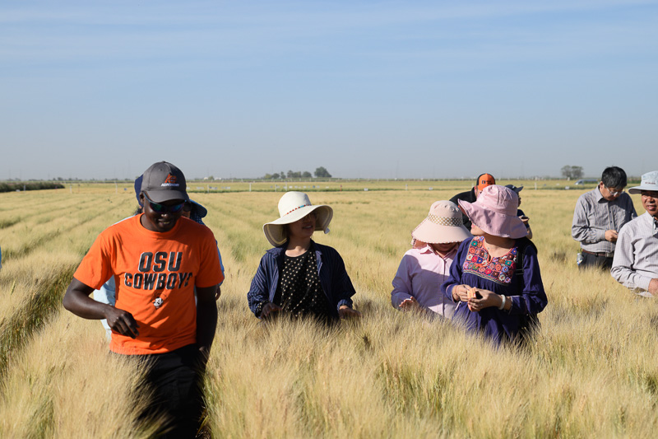
Always big smiles from Alimamy.
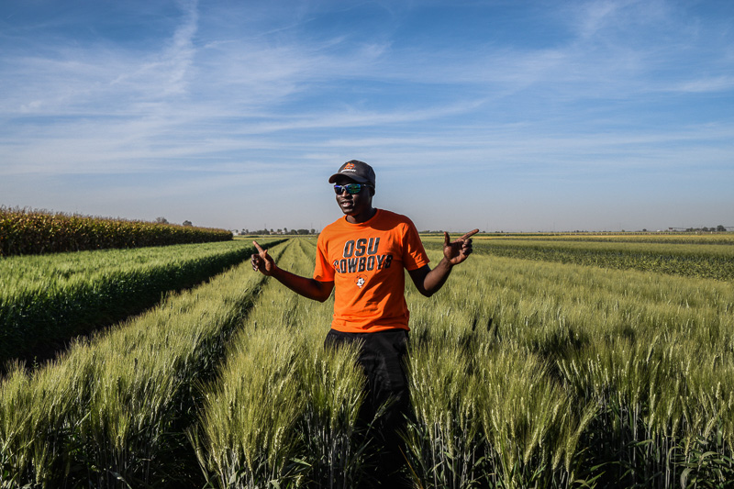
Alimamy posing for a picture out in the field.

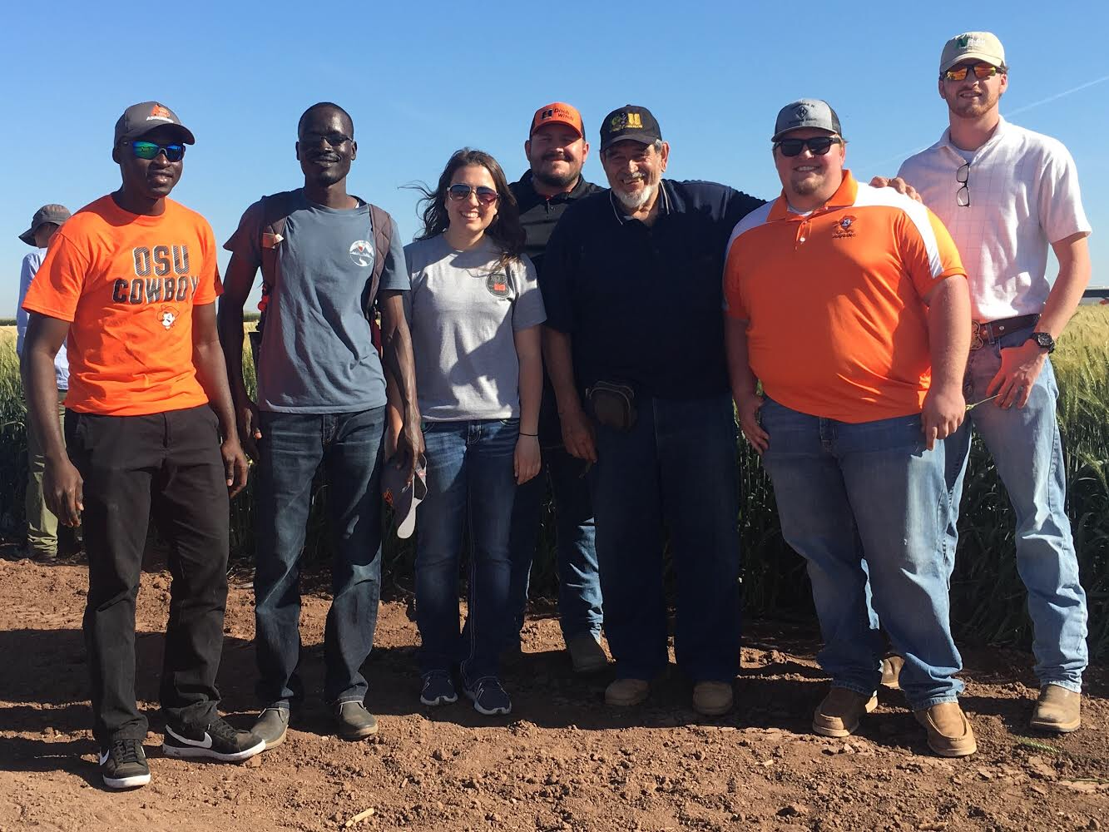
Group photo with Dr. Sayre after hearing all about his trials on day one.
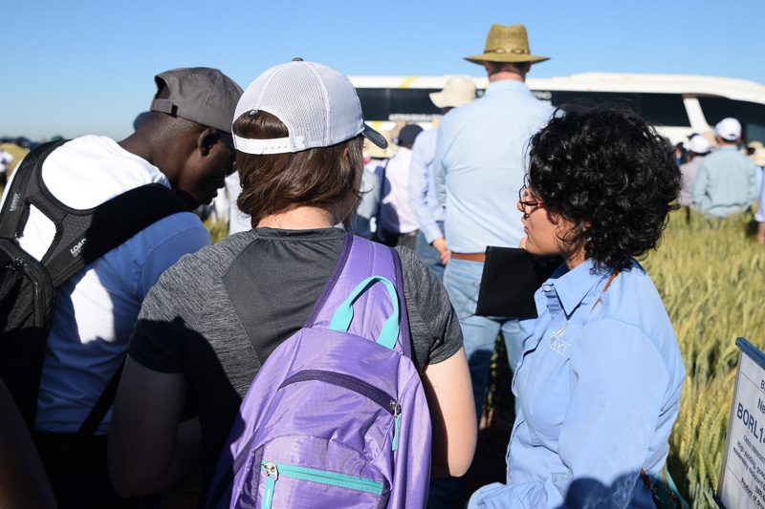
Liz and Alimamy talking to our wonderful guide Lorena just after our group photo on day two.
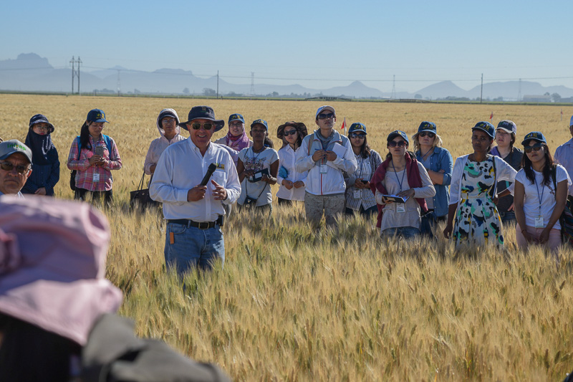
Day two out in the field listening to more speakers.
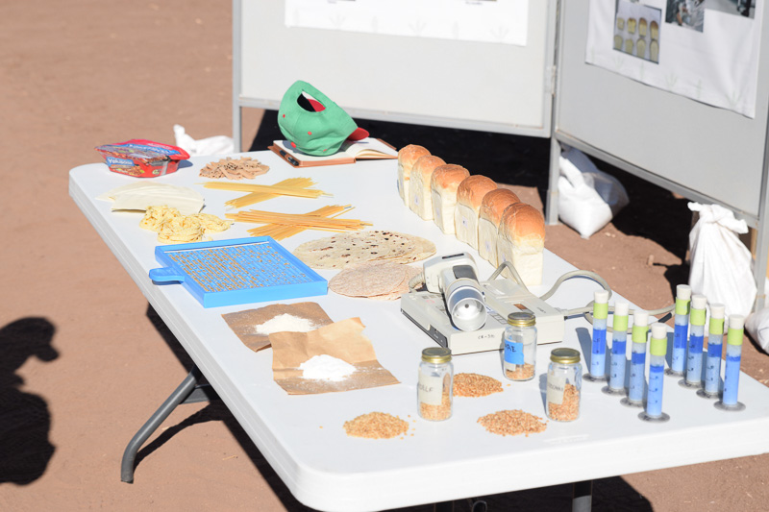
Bread quality demonstration.
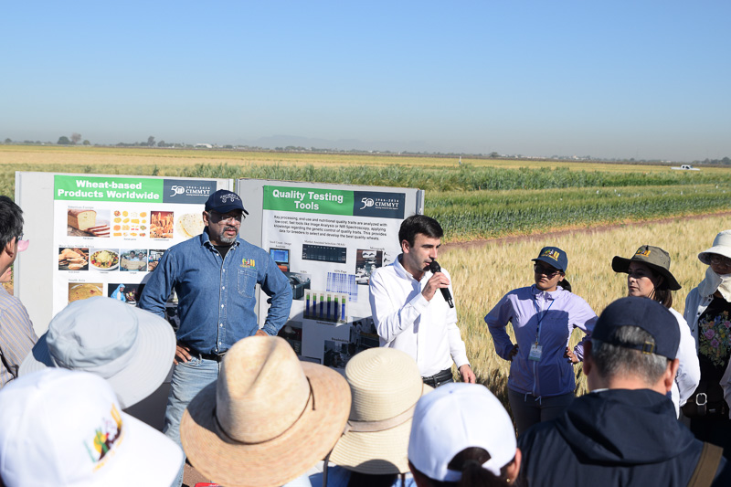
Carlos talking about the bread wheat quality.

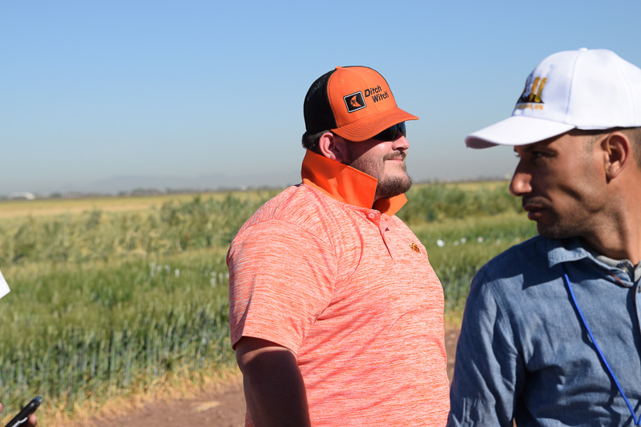
Robert trying anything to beat the hot sun.
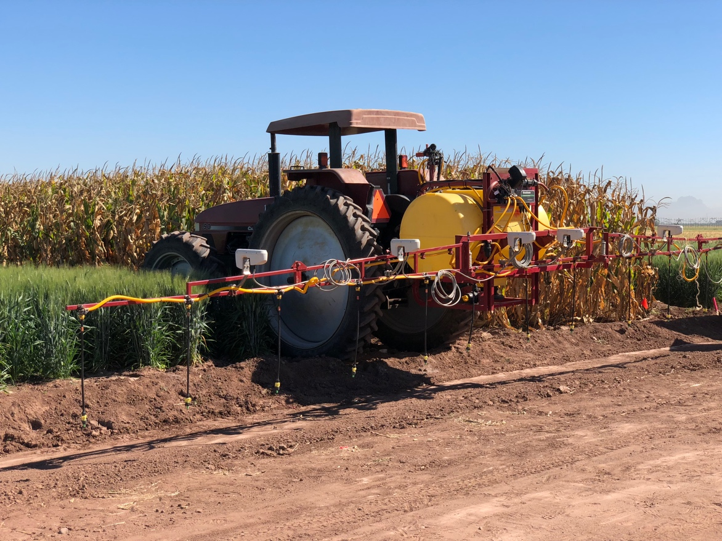
Sprayer equipped with OSU’s Greenseeker Technology.
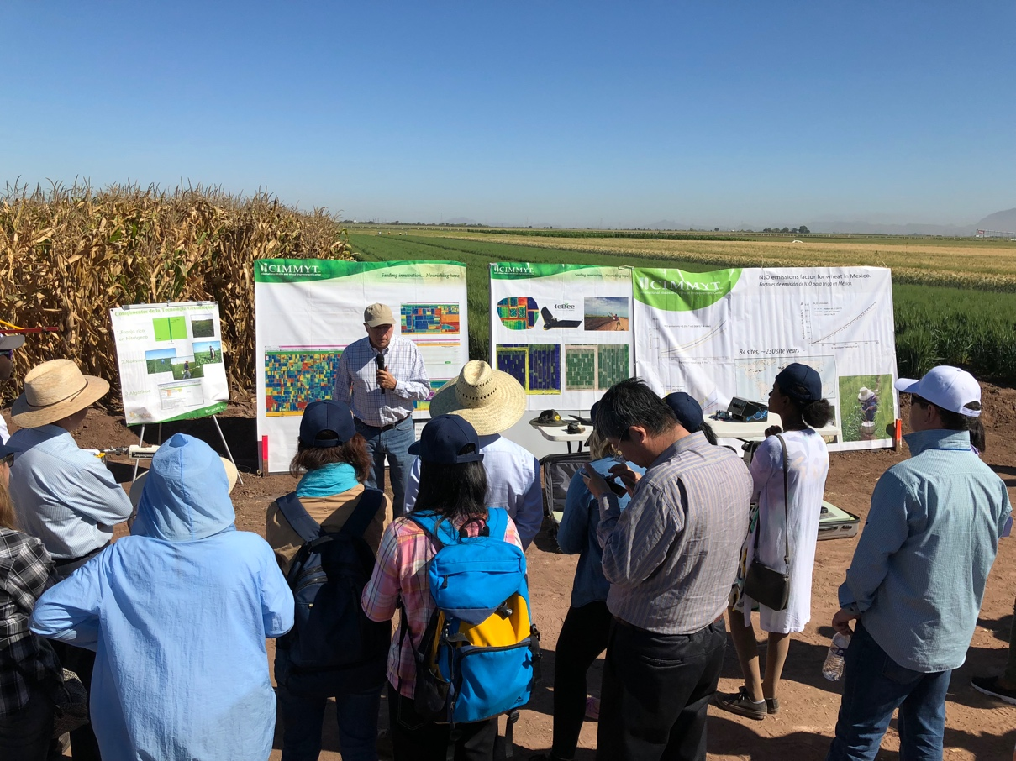
Dr. Ortiz taking about their research collaborations with OSU and the Greenseeker
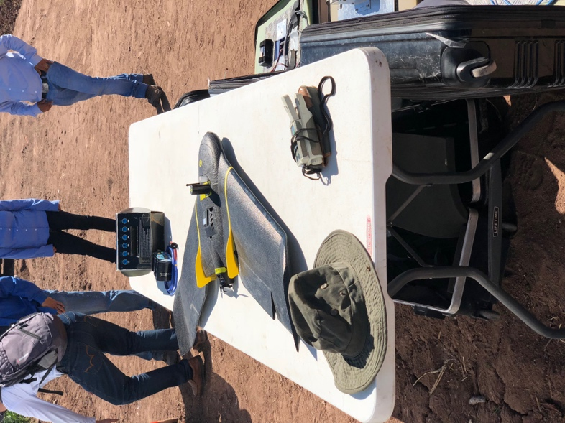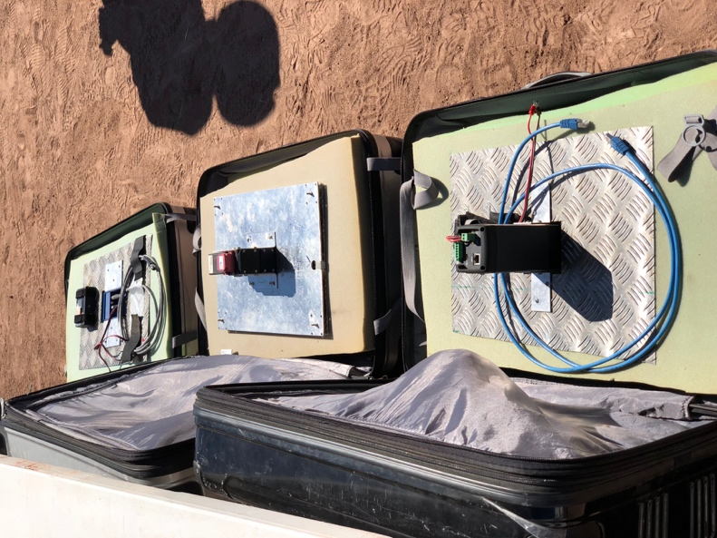
Drones and cameras used to capture arial NDVI
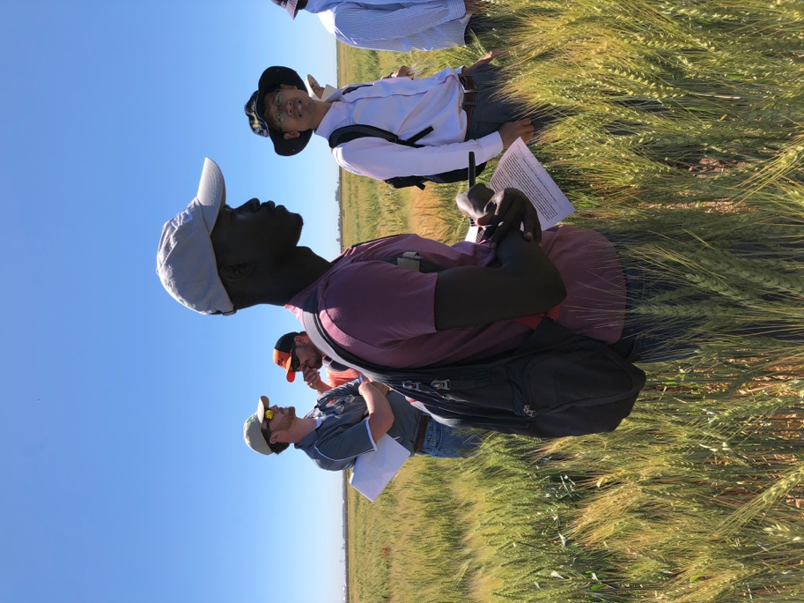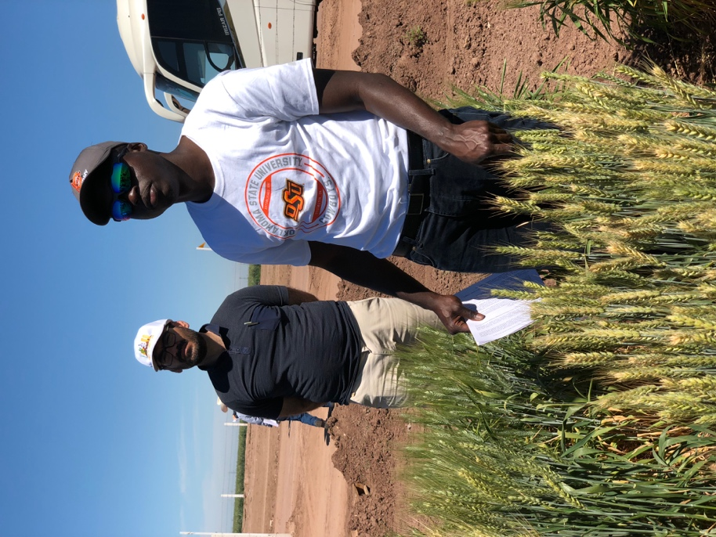
Peter and Alimamy listening to more speakers talk about different breeding trials.
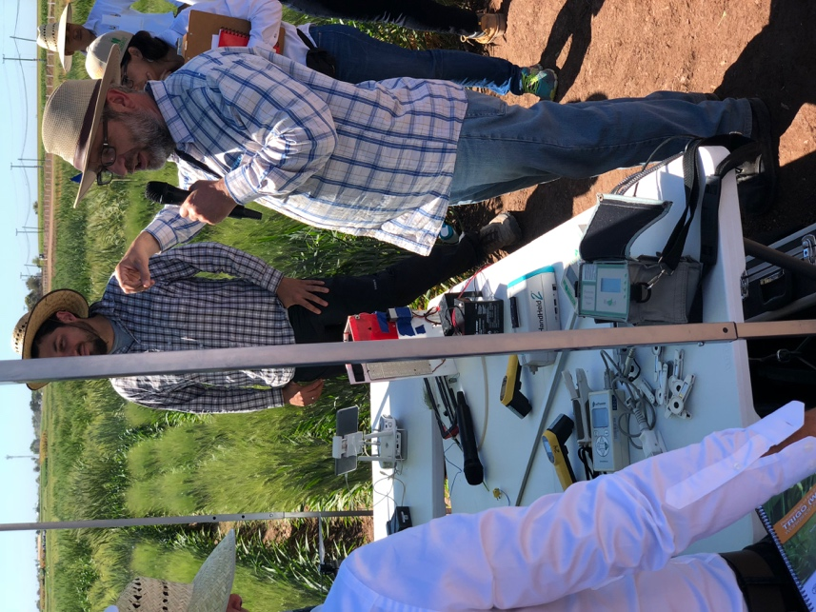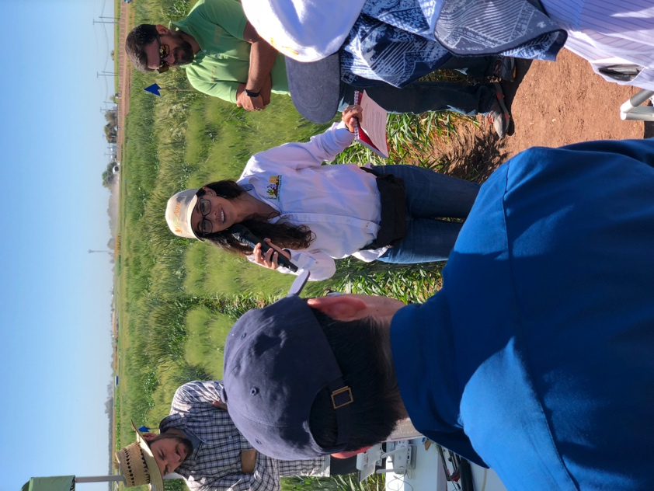
Listening to a very interesting talk about the plant physics research being done.
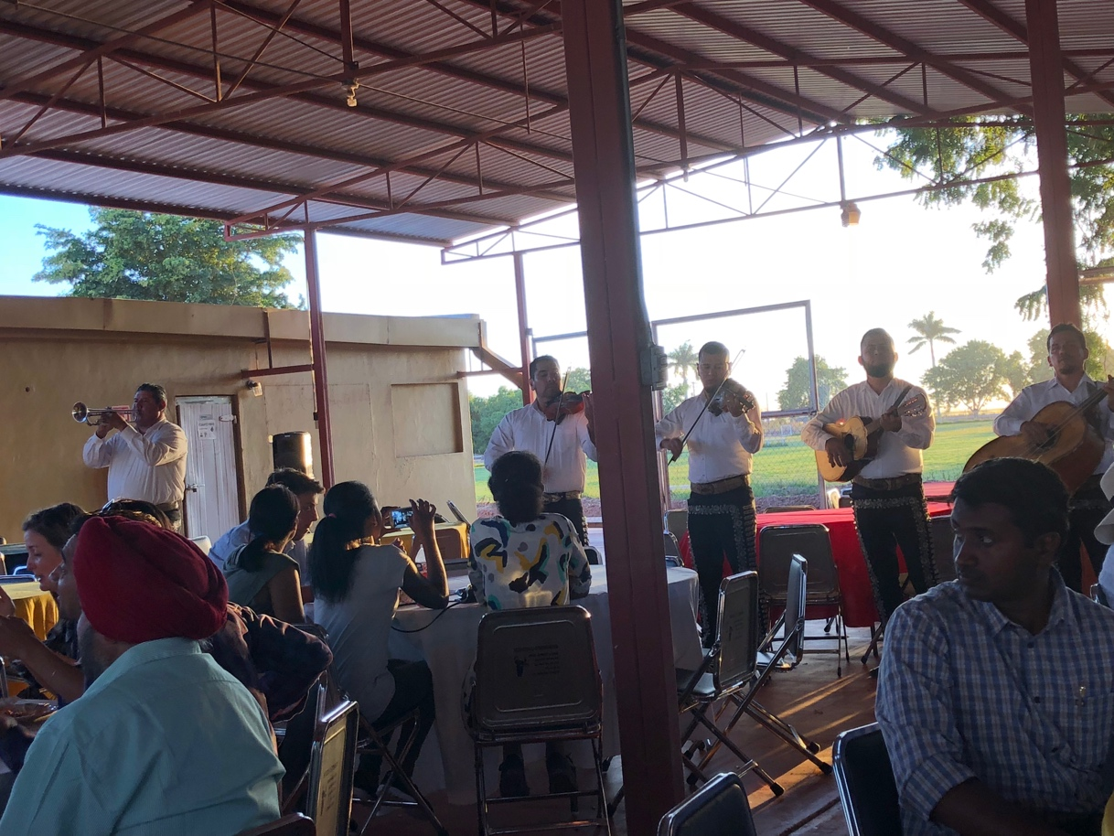
Mariachi band at the BBQ
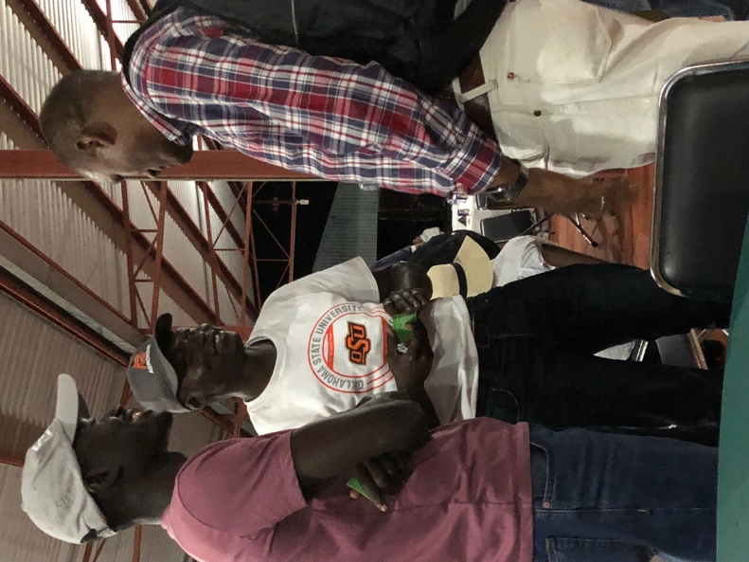
Peter and Alimamy doing some networking at the BBQ.
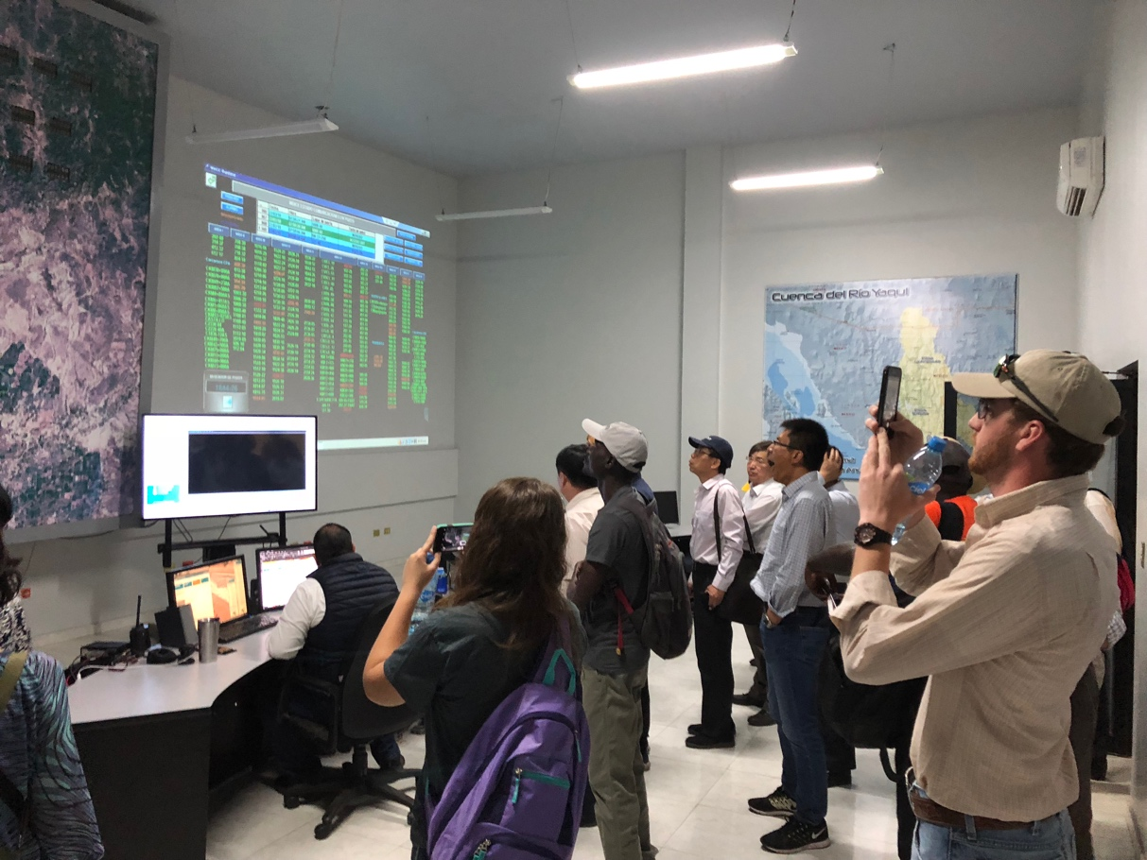
Inside the control room at the Water District Center.
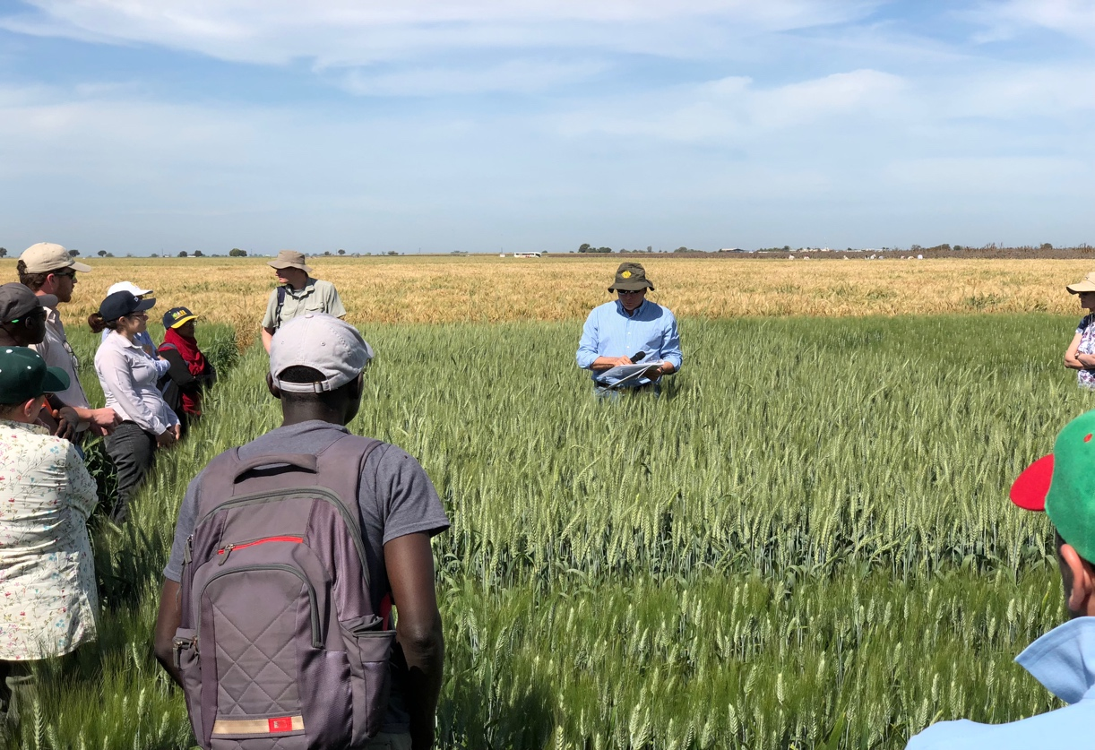
Going over Greenseeker trials with Dr. Ortiz.
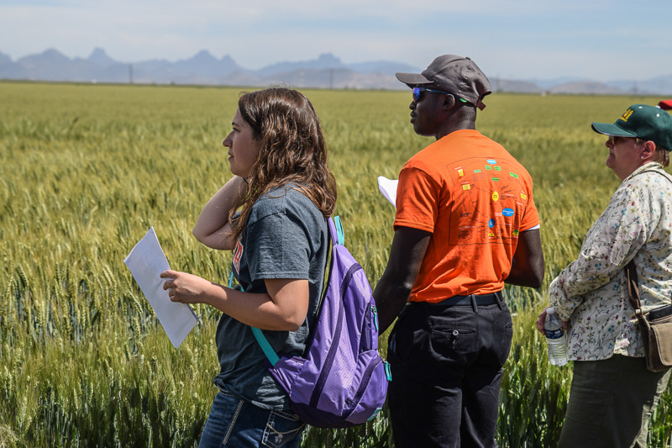
Liz and Alimamy listening to Dr. Ortiz talking about the famer practice trials.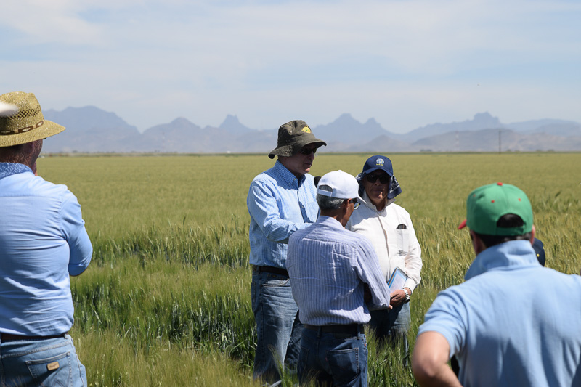

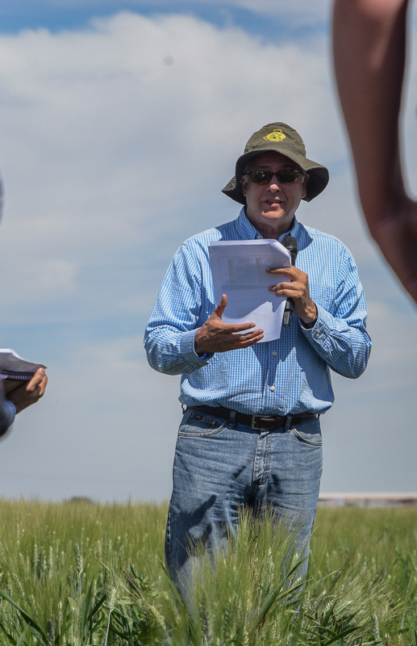
Dr. Ortiz explaining his trails.

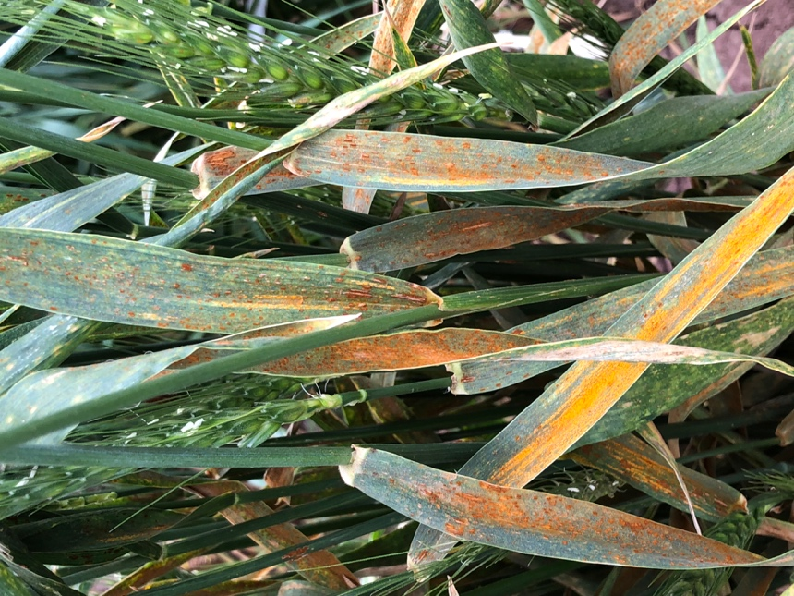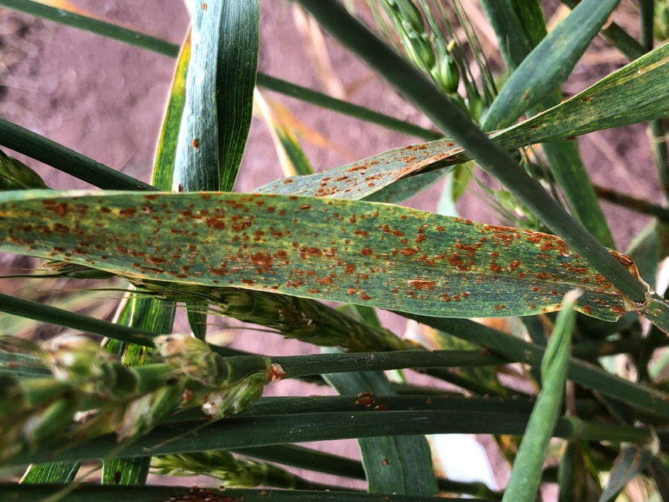
Some rust we found on some susceptible wheat breeds.
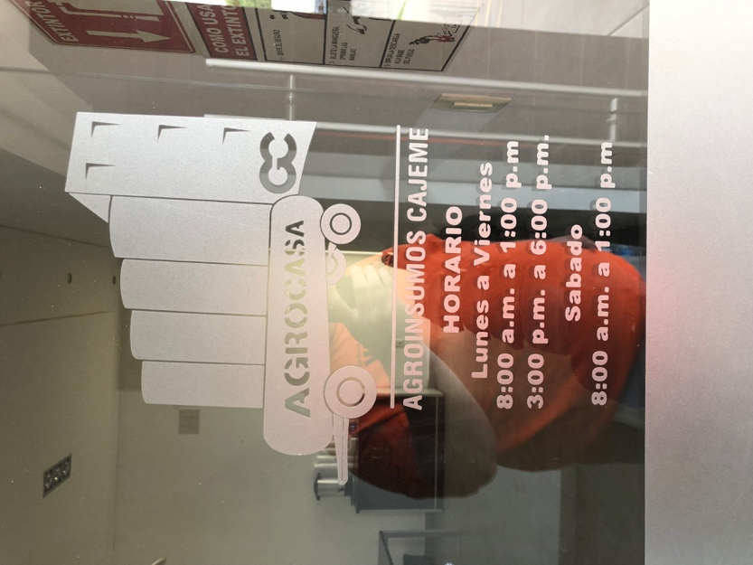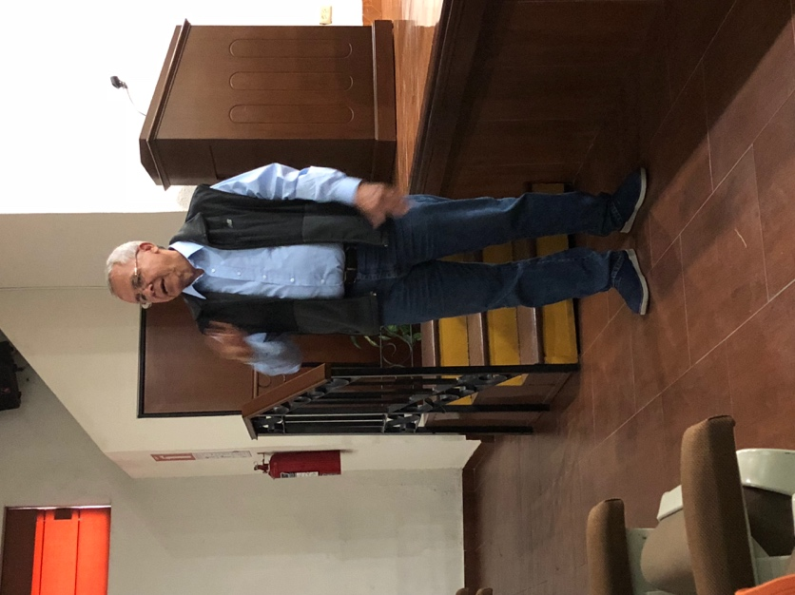
At the local COOP for our personal tour of the facilities.
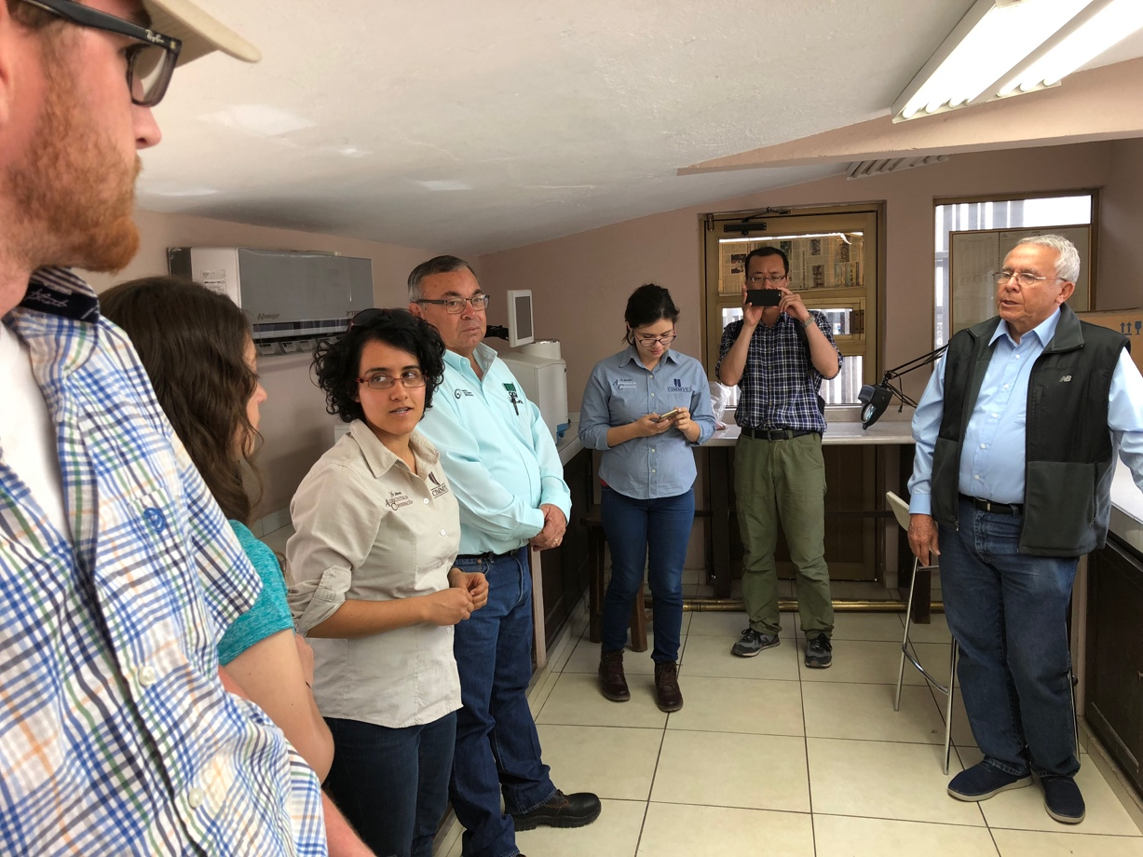
Inside the scale house talking with the president of the COOP.
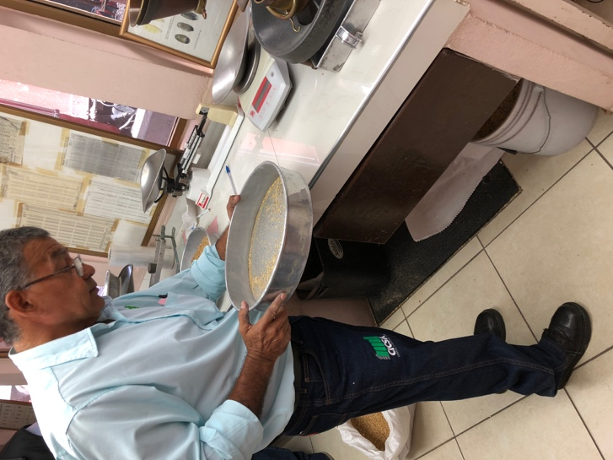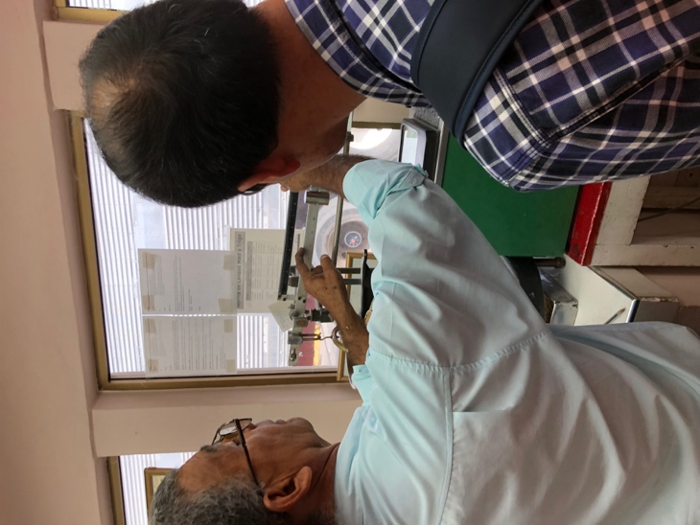
Getting a lesson on grain grading with a sample of durum wheat from an employee that has worked at that location for over 50 years.
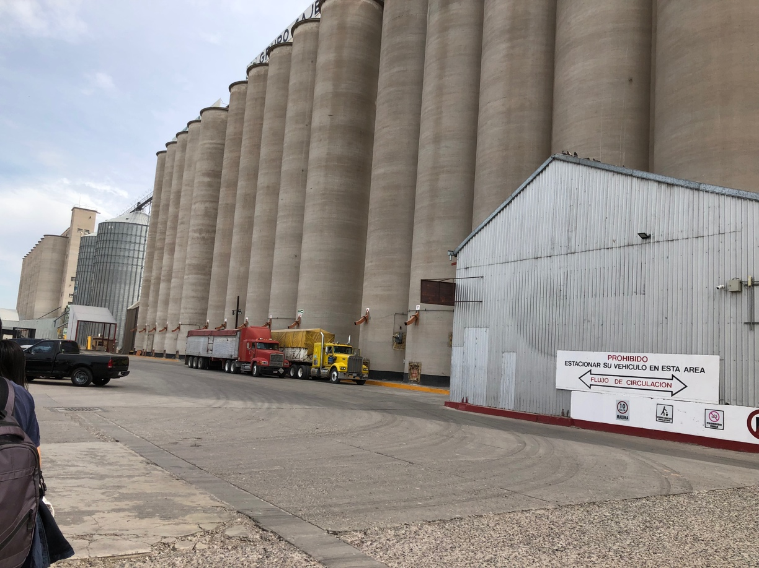
Outside the scale house where we went and looked at all the elevators and where they unloaded trucks and where they loaded rail cars.
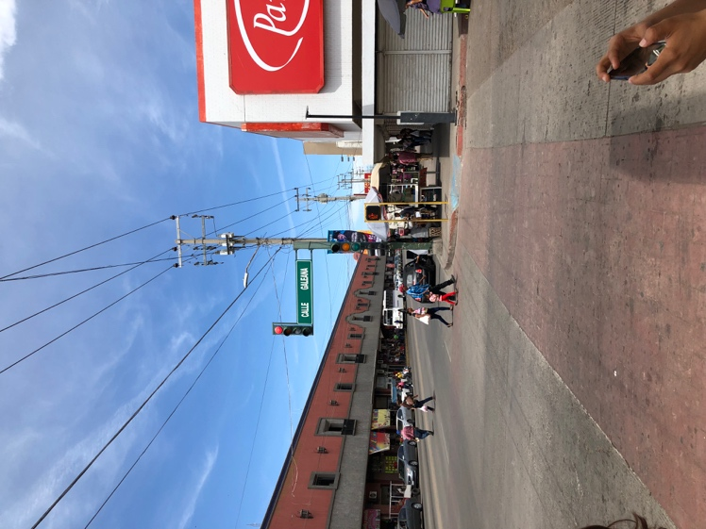
Making our way to the local markets where we bought some souvenirs.
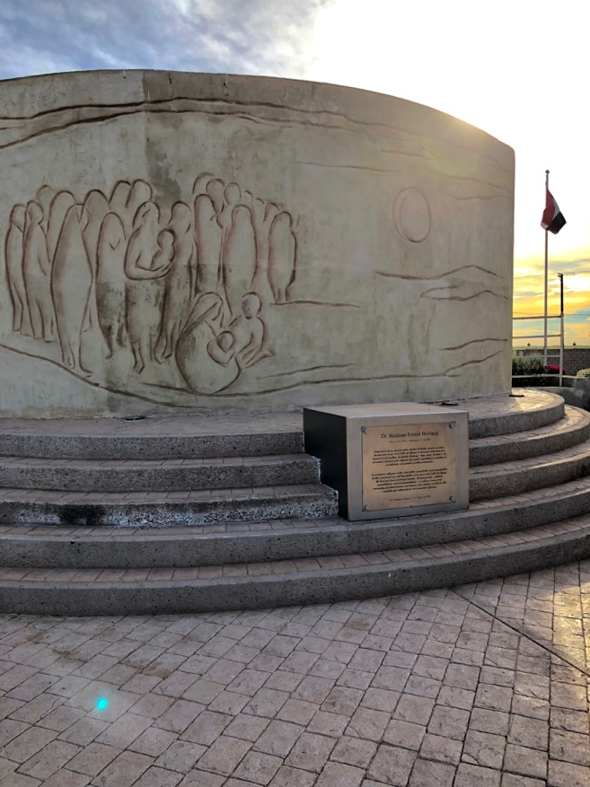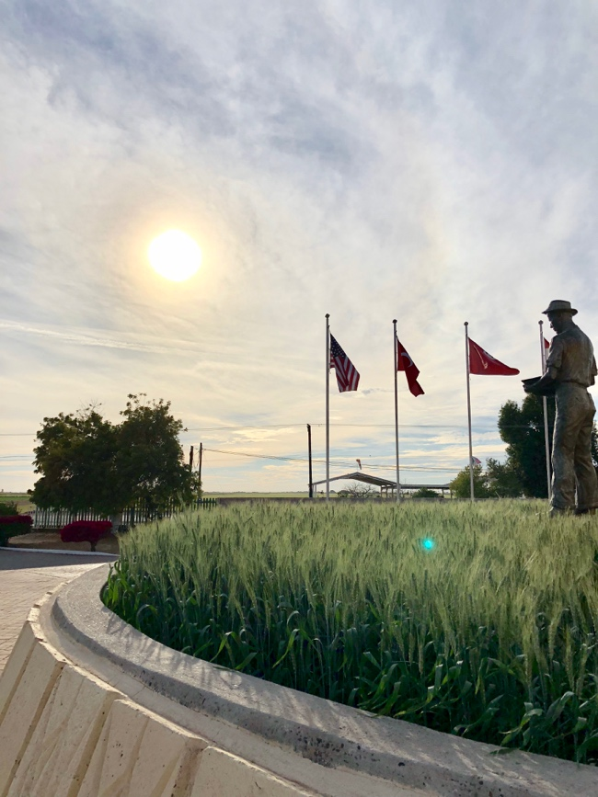
One of our final stops was the memorial for Dr. Borlaug. This Plaque shows where half of Dr. Borlaug’s ashes were buried.
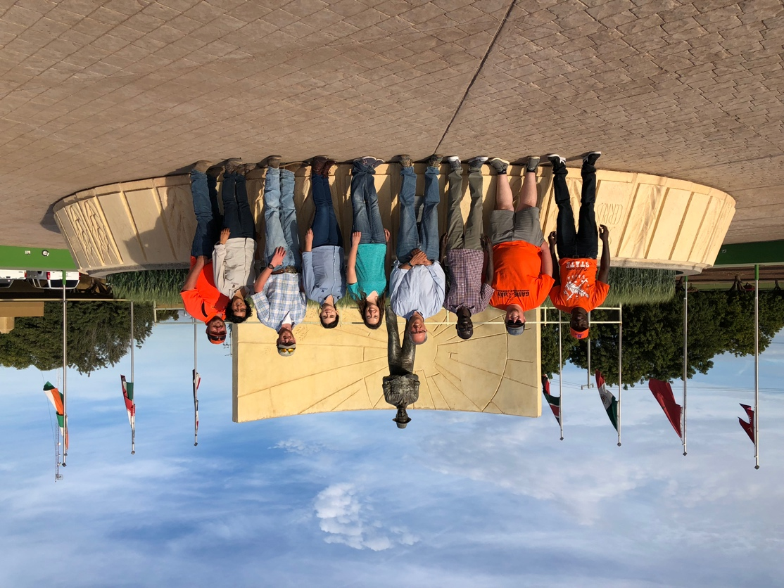
Our final group photo with Dr. Ortiz before we left.
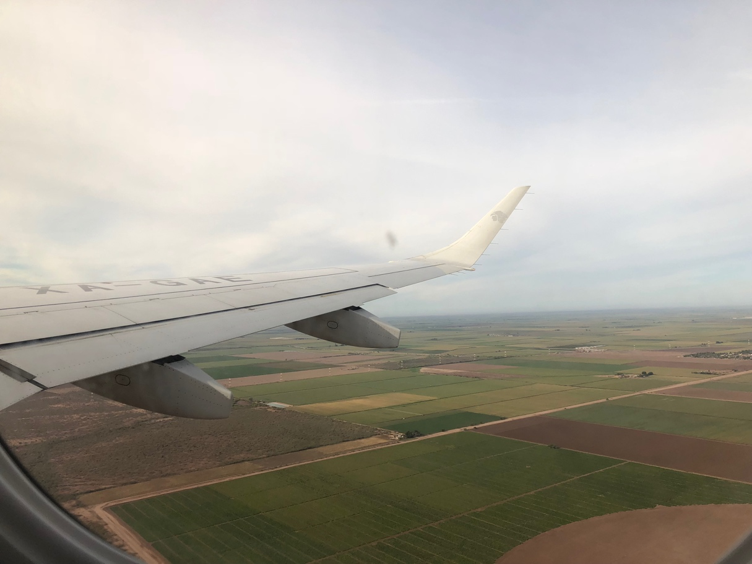
Our view from the flight as we say goodbye to the beautiful Yaqui Valley and the last picture from the trip of a lifetime! What an unforgettable week full of knowledge, humbling experiences, and an insightful look into worldwide agriculture. CYMMIT is a place where few come together with a common goal to better the lives of the masses around the world. A standard set by Dr. Borlaug long ago.

On the behalf of all of us involved, a big thank you to Dr. Raun for this wonderful experience and to all those involved in making this trip as special as it was. We will carry the knowledge and the memories from this trip as we each embark into our future careers. Hopefully one day we may too contribute to the lives of the masses.
Thank you.

