Sample Processing, OSU
- Samples are first dried in an oven at 90 C for 24 hours.
- Samples are then ground in a Wiley mill and returned to the envelope after passing through a 1 mm sieve
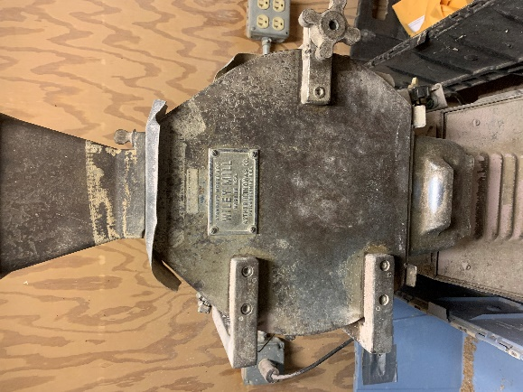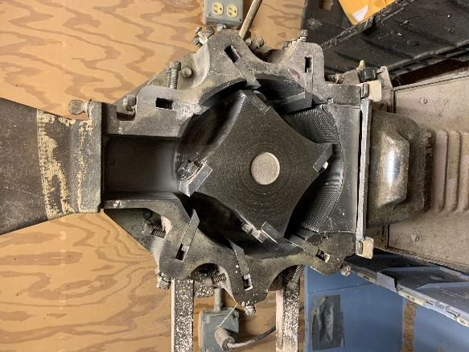
- To process samples to a finer particle size they move to the rolling-pin grinder
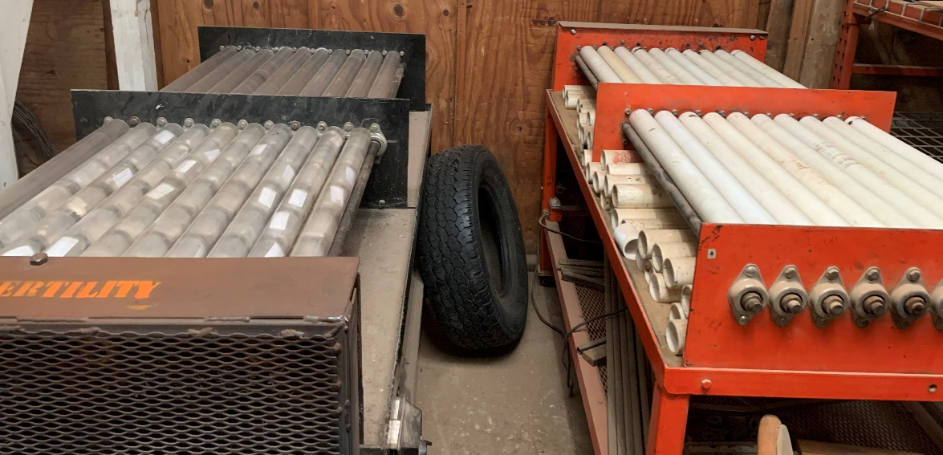
- Bottles are first labeled with Avery 5960 labels, using mail merge on Microsoft Word

- Insert 4 clean stainless steel rods into the labeled bottles
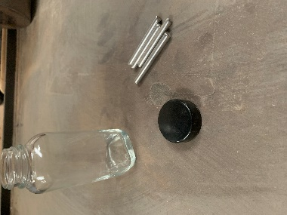
- Next two scoops of the sample are placed in the corresponding bottle (soil, grain, plant tissue)
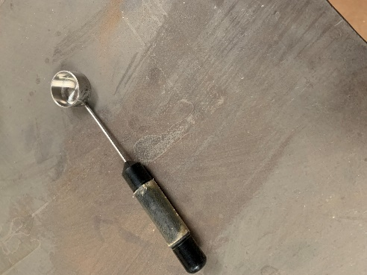
- Place the cap on tightly and tape the cap to prevent loosening during the rolling process
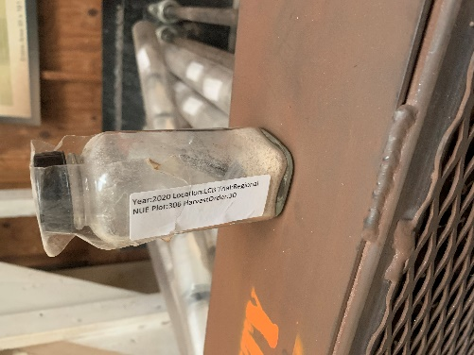
- After the taped bottles are placed in the PVC tubes, they should face the center of the tube (higher chance of breaking the cap if faced outwards)
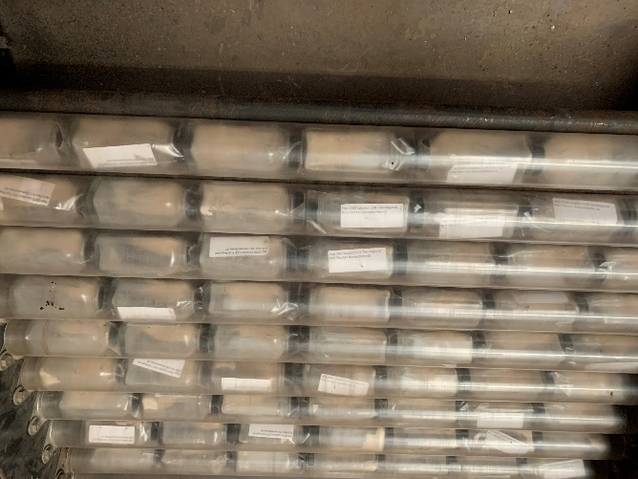
- If any tube is not full of samples, place empty capped bottles to finish filling the entire tube

- Once all tubes are full start the roller for 24 hours

- After 24 hours of rolling the samples, they can be removed and placed in coin envelopes with the corresponding label
- Clean the bottles, lids and rods with soap and water with the help of bottle brushes
- Rinse with 0.05 normal hydrochloric acid
- Allow time to dry before next set of samples

