**Soil Fertility Research and Education Advisory Board**  
  
**2012 UPDATE**

Partial Funding coming from SB432 (formerly SB314)

**Summary:**

The Oklahoma Senate Agriculture Committee, the Oklahoma Agribusiness Retailers Association, Oklahoma Farm Bureau, American Farmers and Ranchers, and Oklahoma State University currently oversee the inspection fee on the sale of each ton of fertilizer ($0.35 proportioned to the Oklahoma State Department of Agriculture and $0.30 to Oklahoma State University (soil fertility research). This senate bill from 1989 was modified in 2009 (Senate bill 432) whereby the fertilizer inspection fee was increased to $1.00/ton (split between OSDA, and OSU). Sustained funding has resulted in many significant products and services for Oklahoma Producers, and that are summarized.

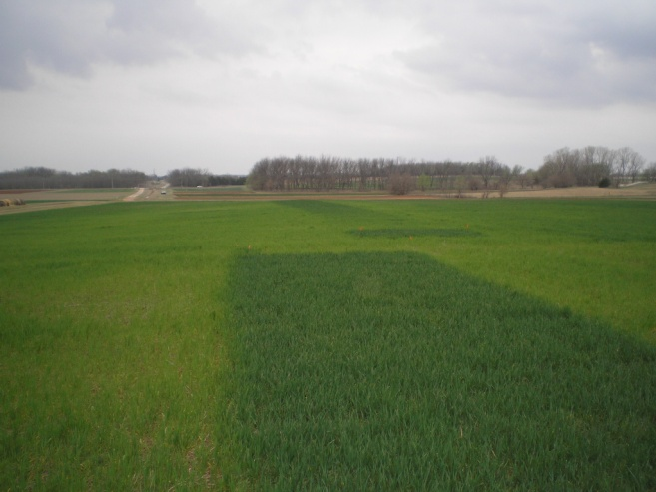**Products:**

1. From 2005 to 2012, 25,000 N Rich Strips have been put on in Oklahoma and that over this 6 year period, represented 1,973,040 acres. Using the published average profit of $10.00/ac for producers using the GreenSeeker and OSU N Rate recommendation, this represents a total positive economic impact of **$19,730,400** for our state. The proven benefits of N Rich Strips in cereal crops in Oklahoma, requires that OSU sustain the extension of this N fertilization approach.

**2. Alternative Product Evaluation.** Product evaluation has always been an important component of extension as producers require a source of unbiased information. Nitrogen stabilizers, slow release N sources, P enhancers, and soil additives are being tested in wheat, sorghum, soybeans, corn and canola. Some of the predominate products have been under continued testing for many years while others are only evaluated for one or two crop years. A list of products being evaluated and the results are available at [www.NPK.okstate.edu](http://www.NPK.okstate.edu). Products included are Avail, Nutrisphere, Agrotain, ESN, Super U, CoRoN, and MESZ.

**3. Impact of Soil Acidity.** Critical soil pH levels were recently established for both sorghum and sunflower, as both of these crops are traditionally grown on the calcareous soils of the high plains. With the introduction of no-till in Central OK, many producers are planting these crops into acidic soils with no understanding of the impact of soil acidity. Critical levels will be established for sesame, wheat and canola. While some varieties may be classified as aluminum tolerant there is still a loss of production when grown under acid soil conditions. These trials will be used to establish relative yield values for new varieties for years to come.

**4. The Greenseeker N Fertilization System** developed entirely at OSU is now used on over 2,000,000 acres in the USA. This system was endorsed by the late Dr. Norman Borlaug (Nobel Peace Prize Winner) in April of 2007. These systems are now sold by Trimble, whereby producers can variably apply nutrients on the go. These commercially available systems improve use efficiency and environmental sensitivity.

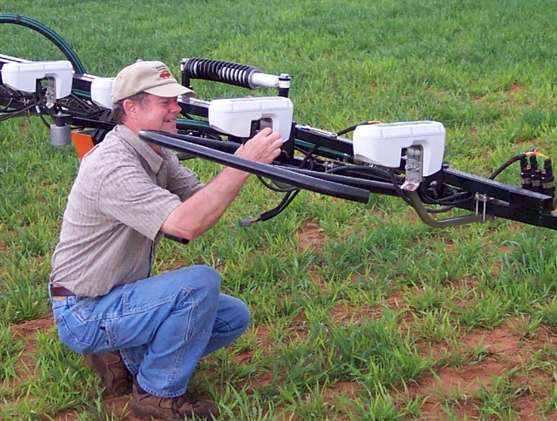

**5. OSU Pocket Sensors,** and soon to be released commercial Trimble sensors are a direct product coming from the original GreeenSeeker sensor. Like the GreenSeeker sensor, they will be used all over the world for the collection of NDVI data (yield prediction, disease incidence, protein prediction).

**6. Grain Protein Optimizer Released.** Producer interest in grain protein led OSU to develop a simple and tool whereby producers can enter mid-season NDVI values to see if they will need added N so as to stay above the 11% wheat grain protein minimum (Kansas City Board of Trade, November 2010, “deliverable grades of HRW shall contain a minimum 11% protein … ”)

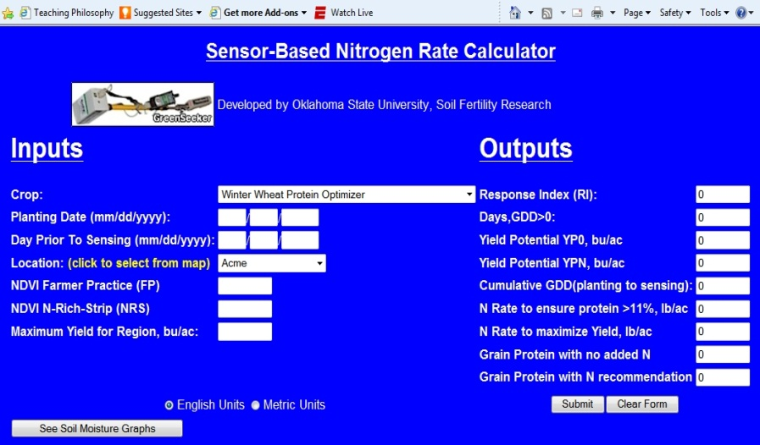<http://www.soiltesting.okstate.edu/SBNRC/SBNRC.php> , option 29

**7. First Web-Based N fertilization Portal** for multiple crop algorithms including winter wheat, corn, cotton, bermudagrass, sesame, and canola. This has put Oklahoma producers on the cutting edge of precision agriculture. [www.nue.okstate.edu](http://www.nue.okstate.edu)

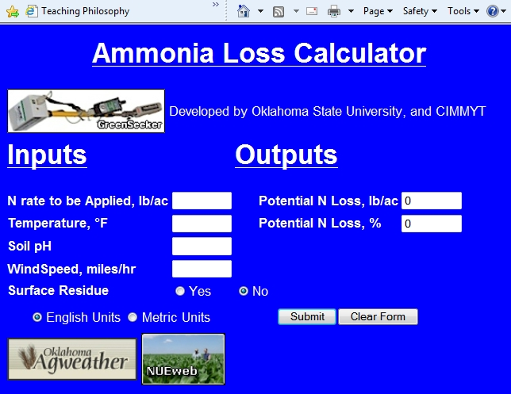**8. Ammonia** (**NH3) loss Calculator** (<http://nue.okstate.edu/N_Fertilizers/Urea.htm> ). At any time during the year, farmers wishing to apply urea on the surface without incorporation can get an estimate of the potential N loss that they will encounter. Using the Oklahoma Mesonet data feed, temperature, relative humidity, and wind speed are automatically accessed at the station closest to that producer, and the predicted loss of N as NH3 reported. Based on the results, farmers can either chose to proceed, or delay their application based on a simple forecast.

 **9. NPKS Rich Strips.** Using the strip applicator developed by our engineering team 43 N, P, K, and S Rich strips were placed in producer fields throughout Oklahoma, and where current OSU variety testing is taking place.

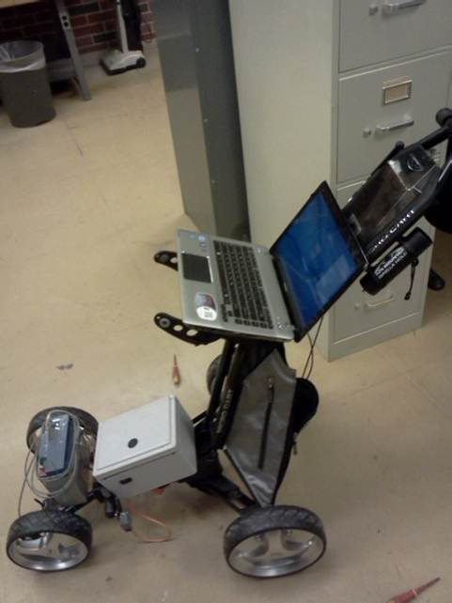

**10. Use of stalk diameter to predict yield and adjust fertilizer rates.** Using microwave technology (di-electric properties), the stalk diameter of individual plants can be determined. We are using this information to predict by-plant grain yield, and as function of these differing yield levels, adjust fertilizer rates on a by-plant basis. It is important to note that once yield level is predicted, this can be used to adjust inputs of all required nutrients since all plants have characteristic optimums for each element in question. Response time has been significantly improved using improved nozzles and rate controllers, yet, continued validation in the field is required.

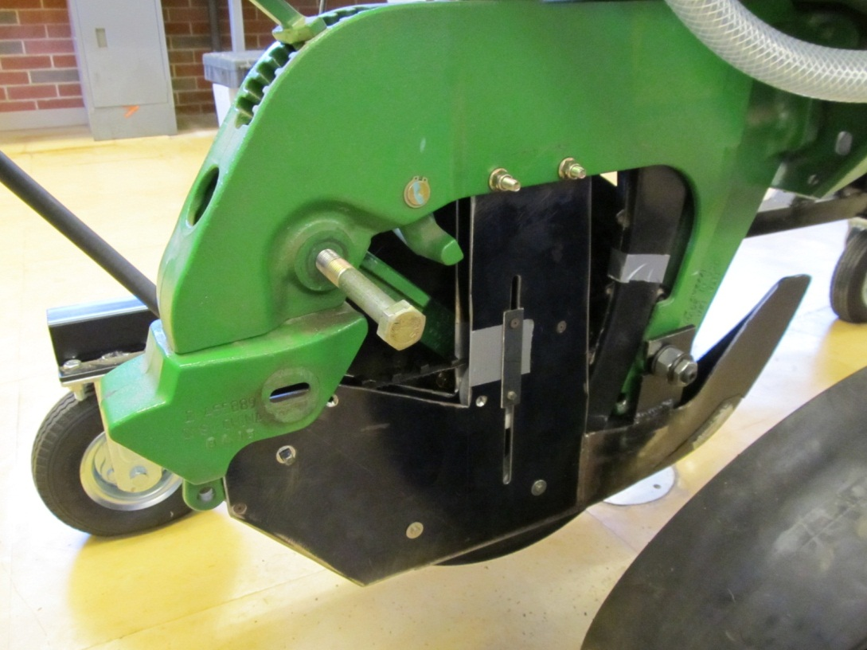 **11. Seed placement leads to fixed leaf orientation.** Biosystems and Agricultural Engineering efforts have recently resulted in the development of a planting system capable of planting corn seeds that will result in consistent across-the-row leaf orientation. When leaves are symmetrically oriented across the row, light interception is increased, plant populations can be increased, and maize grain yields increase. This approach will also allow the maintenance of grain yields while reducing seed rates.

**Sustained Focus Areas**

1. Benefits of variable rate technology for treating spatial variability
2. Continued demonstration of the N Rich Strip in many crops including canola, corn, switchgrass, and sorghum
3. Participation in regional trials with Kansas, Nebraska, Missouri, Colorado, Iowa, and Minnesota.
4. Continued search for alternative light indices capable of detecting P, K, S, and other micronutrient deficiencies.
5. Commitment to graduate degree training.
6. Continued development of regionally specific algorithms for improved N fertilization (<http://www.soiltesting.okstate.edu/SBNRC/SBNRC.php>)
7. Development of GreenSeeker based phone applications.
8. Funding and collaboration with BAE students/faculty in the development/evaluation of relevant precision agriculture technologies. Current projects include by-plant recognition, seed placement-seed orientation, hand-planter, new-age-wireless VRT system design.
9. Refinement of the pocket sensor for widespread use and adoption
10. Funding of equipment needs, especially a combine for wheat and corn that will exceed $240,000, dry combustion, Carbon-Nitrogen analyzer (currently cost $55,000), and a new age planter currently being developed.

As production levels increase, it becomes more and more difficult to improve efficiency. This paradigm is similar to wanting to go faster while hoping to improve your fuel efficiency, and which obviously is not possible. Plant breeding projects cannot rest because they come up with one or two varieties that are considered to be acceptable, and neither can our work focusing on nutrient use efficiency. Nitrogen contamination of lakes and streams, and the environmental pressures that high-input agriculture has, demand that we sustain some of our current work. Retaining and improving upon current NUE levels that frankly are still very low, will require more work looking at in-season applications, using various foliar N products, crop rotation, and zero-till systems that will also deliver improved water use efficiency. How rainfall and water supplies are used will become increasingly important as we move forward.

**Project Funds Needed**

NPKS –farmer field demo’s $40,000  
John Deere Vacuum Planter/refurbishing $10,000  
Kincaid Research Combine $250,000  
Seed Orientation Research Funding BAE $20,000  
Graduate Student Assistantships, 3, BAEr $75,000  
Dry combustion C-N analyzer $55,000  
**Total** **$450,000**

**Current Students on Assistantship, paid by checkoff program**Yeyin Shi assistantship, Biosystems and Agricultural Engineering, China  
Jorge Rascon assistantship, Biosystems and Agricultural Engineering, Mexico  
Grace Okiror, Biosystems and Agricultural Engineering, Kenya  
Yesuf Mohammed, assistantship, Ethiopia  
Guilherme Torres, PhD assistantship, Brazil  
Emily Rutto, PhD assistantship, Kenya  
Natasha Macnack, PhD assistantship, Suriname  
Jeremiah Mullock, PhD assistantship, USA  
Lance Shepherd, MS assistantship, USA  
Courtney Dunkel, MS assistantship, USA  
Ethan Wyatt, MS assistantship, USA  
Peter Omara, MS assistantship, Uganda  
Kranthi Rashmi, MS assistantship, India

**Faculty**  
BRIAN ARNALL, Assistant Professor, PaSS  
RANDY TAYLOR, Professor, BAE  
NING WANG, Professor, BAE  
HAILIN ZHANG, Regents Professor, PaSS  
JOHN SOLIE, Regents Professor (Retired), BAE  
MARVIN STONE, Regents Professor (Retired), BAE   
BILL RAUN, Regents Professor, PaSS