Hand Planter Plan
Objective: To develop, test, and deliver 50 functional, durable, and affordable hand planters for use in planting maize in the third world within two years.
Phase I.
1. Discover and discuss, 20 potential planter ideas that should be pursued. Present pro’s and con’s of each idea.
2. Select 5 of 20 potential ideas that should be taken to full scale prototype assembly
3. Put the 5 selected prototypes through various planting tests using different seed, soil moisture, soil texture, and surface residue. Record success/failure of each prototype
4. Select two of the prototypes for assembly/construction analysis (need consulting engineer, outside evaluation)
Phase II.
Planter selected in Phase I needs to be sent out to various manufacturers to determine cost of production and alternative costs if produced in volume.
Phase III (beyond year 2).
Select specific regions in Africa, Central America, and South America where the first prototype will be released.

Hand Planter Specifications:
Total weight: with seed/fertilizer, not more than ______ lbs
Seed storage: ______ seeds
Fertilizer storage: _______ lbs
Depth of planting: between 1.5 and 2 inches (but capable of going deeper with more force)
Weight: with seed ______ without seed _______
Design Requirements
1,000,000 cycles, no failures or 10 years
1 seed per cycle
Acceptable doubles: 1/100
Acceptable blanks: 1/100
Design constraints:
Must be able to work on a range of soil textures
Must be able to work at various soil moisture levels
Must work with seed weighing from 0.20 to 0.30 g
*Should work for delivering between 1.00 and 3.00 g of urea fertilizer (granular)

Cost versus Performance?

Grant Proposal
This project will deliver a device capable of planting maize seed that is very similar in shape, size, and weight to the one seen in Figure 1, but that can reliably plant one seed, in various soil textures, moisture, and tillage systems. Initially, development, production, and delivery will need to be subsidized, thus the need for grant funds. But with time, local manufacture/industry creation of the new hand planter would also lead to more jobs. Added benefits of the new hand planter would be to remove chemically treated seeds (organophosphates, carbamates, chlordanes, +others) from the hands of small farmers. Decreased soil erosion from improved contour planting, and plant proximity will also be achieved
This new device will offer an affordable, easily adoptable technology for virtually all third world maize farmers. With modest funding for development and initial subsidized hand planters, this could provide widespread increases in third-world maize production that would rival most advances made in the last 50 years.

Introduction
Much research has been devoted to studying the effects of plant population on maize grain yields. Nielsen, (1991) found that the yield loss due to uneven plant spacing averaged 61 kg/ha per cm increase in standard deviation of plant spacing. This work further noted that uniform plant spacing is important for maximizing corn grain yields. Nafziger (1996) reported that yield decreases due to skips can be minimized by increasing plant population. While increasing population is a possibility in the developed world, third world farmers really don’t have this option. Work in Pakistan reported that 10 to 15 cm maize plant spacing in 60 cm rows resulted in maximum yields (Zamir et al., 1999). There is currently a lot of work evaluating twin-rows or narrow plant spacing (38 versus commercially common 76cm rows), but results have been inconclusive (Farnham, 2001). Pommel et al. (2001) showed that when maize was planted at the same population, but where plant spacing was irregular, light interception decreased by 10%. Moddonni et al. (2001) showed that uniform plant distributions resulted in increased light interception, so long as the critical leaf area index (LAI) was not realized.

The current method of planting maize in the third world (Sub Saharan Africa, Asia, Central and South America) is using heavy sticks that are poked into the ground, followed by placing 2-4 into the soil indention and culminated by covering the seeded indention with soil, with their feet (Figure 1). These small hills holding chemically treated maize seed are roughly 25 to 50 cm apart.

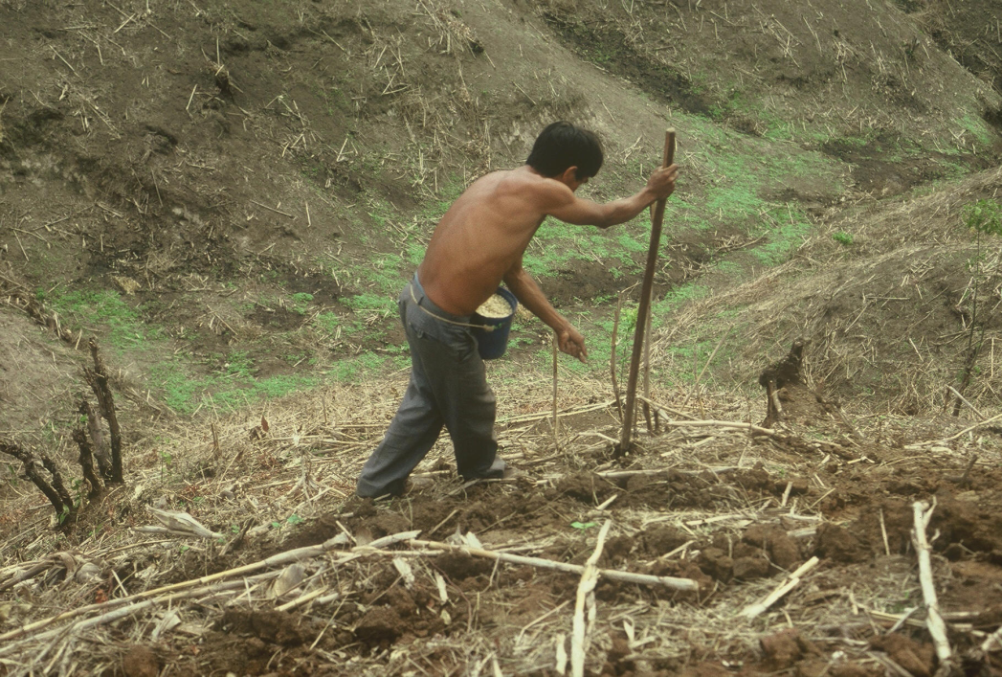
Figure 1. Hand planting maize on a hillside, Opico Quezaltepeque, El Salvador.
This method of planting is commonplace for third world maize farmers, largely dictated by terrain, circumstance, and resources (Figures 2,3). Of the 159,531,007 hectares of maize in 2009, there were approximately 34,409,010 hectares in the developing world. Of that total, around 60% was planted by hand, representing just over 20,645,000 hectares or 13% of the total maize area in the world (www.faostat.org. Web 24 Sept. 2010).
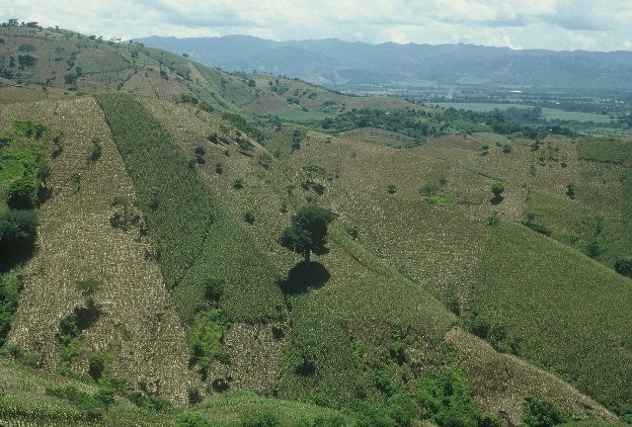
Figure 2. Maize planted hillside, Opico Quezaltepeque, El Salvador.
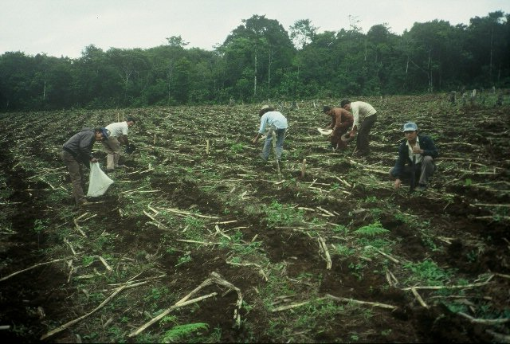
Figure 3. Maize tillage/residue, La Esperanza, Honduras
Comprehensive data collected from farmer fields in the USA, Argentina, and Mexico showed that over all sites, plant-to-plant variation in corn grain yield averaged 2765 kg ha⁻¹ or 44.1 bu ac⁻¹ (Martin et al., 2005). They further noted that methods which homogenize corn plant stands and emergence can decrease plant-to-plant variation and increase grain yields. Research by Hodgen et al. (2007) showed that if corn plants are delayed by as little as four days, the yield depression of that individual delayed plant was as much as 15 percent. Combined this work delineates the importance of decreasing plant to plant variability in emergence and distance between plants.
If single seeds could be planted 14-17 cm apart, much like conventional planters accomplish in the developed world, production levels could easily increase 25%. Despite the fact that third world maize yields are generally less than 2.0 Mg/ha (Dowswell et al., 1996), this 25% yield increase on 60% of the hand planted maize area in the third world would be worth more than 1.8 billion dollars/year (corn price at $0.18/kg)
Dual Use for Africa
Considering the extremely low N rates applied for cereal production in Sub Saharan Africa (average of 4 kg/ha) extension of any kind of N management could potentially lead to significant increases in production. The hand planter that will be developed will also serve as a mid-season urea fertilizer applicator. In the same way that 0.2 to 0.3g corn seed is being incorporated into the soil, using the new hand planter, mid-season N can be applied beneath the soil surface, and next to the emerged plant. The major improvement is incorporating urea N fertilizer that when left on the surface as it is currently applied in the third world, up to 50% of the applied N can be lost as NH3. At current fertilizer N prices, a 10% increase in nitrogen use efficiency could result in potential increases in revenue (both production and NUE) exceeding 140 million dollars per year for sub Saharan Africa alone (Table 1)

References
CIMMYT mega-environment database; C.R. Dowswell, R.L. Paliwal and R.P. Cantrell, Maize in the Third World, Boulder, Colorado, Westview Press, 1996.
Farnham, Dale E. 2001. Row spacing, plant density, and hybrid effects on corn grain yield and moisture. Agron. J. 93:1049-1053.
Hodgen, P.J., R.B. Ferguson, D.C. Rundquist, J.S. Schepers, and J.F. Shanahan. 2007. Individual Corn Plant Nitrogen Management. Ph.D. diss. Univ. of Nebraska, Lincoln, Nebraska.
Martin, K.L., P.J. Hodgen, K.W. Freeman, R. Melchiori, D.B. Arnall, R.K. Teal, R.W. Mullen, K. Desta, S.B. Phillips, J.B. Solie, M.L. Stone, O. Caviglia, F. Solari, A. Bianchini, D.D. Francis, J.S. Schepers, J.L. Hatfield, and W.R. Raun. 2005. Plant-to-Plant Variability in Corn Production. Agron. J. 97:1603-1611.
Maddonni, G.A., M.E. Otegui, and A.G. Cirilo. 2001. Plant population density, row spacing and hybrid effects on maize canopy architecture and light attenuation. Field Crops Res. 71:183-193.
Nafziger, E.D. 1996. Effects of missing and two-plant hills on corn grain yield. J. Prod. Agric. 9:238-240.
Nielsen, R.L. 1991 (Rev. 2001). Stand Establishment Variability in Corn. Purdue Univ. Agronomy Dept. publication AGRY-91-01. Available online at http://www.agry.purdue.edu/ext/pubs/AGRY-91-01_v5.pdf. (URL verified 10/30/04).
Pommel, B., Y.Sohbi, and B. Andrieu. 2001. Use of virtual 3D maize canopies to assess the effect of plot heterogeneity on radiation interception. Agric. Forest Meteorology. 110:55-67.
Zamir, Ibni Shahid M., Muhammad Maqsood, Muhammad Arif Saifi, and Nadeem Yousaf. 1999. Effect of plant spacing on yield and yield components of maize. Int. J. Agric. & Biology

Calculations
Total Maize Area, World: 160,968,730 ha
Total Maize Area, Developing World: 34,409,010 ha
Percent of developed world maize planted by hand
(60% of the developed world maize total): 20,645,400
Average Maize Yield, Developing World: 2.9 Mg/ha (Pingali, Pander, CIMMYT, 1999)
25% Yield Increasing using Hand Planter 0.73 Mg/ha
Yield increase, Mg (20,645,400*0.73) 15,071,142 Mg
Maize value/Mg ($5.00/bu = $196/Mg) $2,953,943,832
Calculations
76,000 seeds/ha (average seeding rate)
Average farm size, developing world Land area: 0.5 to 2 ha
80,000 seeds per bag (commercial hybrids)
Average weight = 45 lbs = 20.41 kg = 20410g
Average weight per seed = 0.26 g/seed
40 lbs N/ac topdress = 44.8 kg N/ha (using urea) = 97.4 kg material/ha
Planting 76,000 seeds/ha
97400 g/76,000 plants = 1.28 g/plant (40lbN/ac) 3.20 g/plant (100 lbN/ac

Table 1. Production and nitrogen use statistics for cereal production in Sub Saharan Africa, the United States, and the WorldO Web site (2002 to 2005 data)
 | SAA | USA | World
Population | 699,813,000 | 300,000,000 | 6,500,000,000
Cereal production, ha | 88,435,068 | 56,404,000 | 657,085,620
Maize, ha | 26,801,040 | 30081820 | 138,163,504
Wheat, ha | 2,631,932 | 20226410 | 210,247,188
Sorghum, ha | 25,829,881 | 2301470 | 41,689,272
Rice, ha | 8,477,895 | 1352880 | 147,455,159
Millet, ha | 20,480,119 | 200000 | 34,242,897
Cereal production, Mt | 97,317,420 | 364,019,526 | 693,427,825
Maize, production, Mt | 40,473,062 | 280,228,384 | 601,815,839
Cereal yields, Mt/ha | 1.10 | 6.45 | 1.06
Maize, yields, Mt/ha | 1.51 | 9.32 | 4.36
Fertilizer N, Mt | 1,307,443 | 10,878,330 | 84,746,304
Fertilizer N, Mt (cereals) | 784,466 | 6,526,998 | 50,847,782
N rate, cereals (kg/ha) | 3.99 | 52.07 | 34.82
assuming 45%N
Expenditure on Fertilizer N (cereals) | 706,019,220 | 5,874,298,200 | 45,763,004,160
assuming $0.90/kg N
Estimated value for a 10% NUE increase | 168,424,807 | 1,401,346,471 | 10,917,018,881

Hand Planter
- Seed singulation/partitioning/isolation
- Tip development/placement (tip/soil interaction)
- Holistic design (weight, ergonomics)
- Dual seed placement/fertilizer applicator

El Salvador Survey Data (241,000 ha’s)
Average yield: 2.59 Mg/ha
0.4m between hills
2 plants/hill
0.8 m row spacing
62,500 plants/ha = (2 plants/(.4*.8)) = 2/0.32 = 6.25 plants/m2
Stick that the producers use, weighs on average 3 pounds.
They use two different “tip” designs. Pointed and Non pointed. The non-pointed ones are used on the better soils that are not compacted.
Objectives: To determine the corn yield / yield reduction associated with double and triple planting multiple seeds, at different spacing and N rates.
Corn Plant Spacing Trial
Trt Plant Spacing Row Spacing Number of seeds/hill N Rate
cm cm kg N/ha
- 20 76 1 0
- 40 76 1 0
- 20 76 2 0
- 40 76 2 0
- 20 76 3 0
- 40 76 3 0
- 20 76 1 100
- 40 76 1 100
- 20 76 2 100
- 40 76 2 100
- 20 76 3 100
- 40 76 3 100

