Logic for Using “Estimated N Removed in Cereals Coming from the Soil and that Deposited in the Rainfall as 50% of the Total” to compute World Estimate of Nitrogen Use Efficiency
From Page 632 (Keeney 1982). “Also N recovery by agronomy crops is seldom more than 70% and the average value is probably nearer to 50% (Allison, 1955; Viets, 1965; Charp 15, L.T. Kurtz and R. A. Olson).
From Page 613. “No net transfer of mineralization for soil organic N was included in Table 3, on the assumption that an equivalent amount of N is immobilized as is mineralized.
(From AJ, 91:357-363) N removed in cereals coming from the soil and that deposited in rainfall (50% of the total)

Discussion
Using the macro-statistics available from FAO, a world estimate of cereal NUE was sought. In order to obtain this estimate of NUE, several assumptions were needed. Considering the magnitude of errors embedded within this type of computation, was a world estimate of NUE even needed? The Raun and Johnson (1999) manuscript suggests that yes it was needed and could be accurately estimated.
Key to this computation was accepting work from Alexandratos (1995) who reported that 60% of the world fertilizer N applied, was used for cereal production in the world. The world estimate for total fertilizer N consumption was available via FAO (1996), as such fertilizer N use in cereals (60% of the total) was computed. An accurate estimate of total grain N removal for all cereals was then sought. ((Total grain N removed – Indigenous N)/N applied)
The amount of grain protein in different cereals and other food products was established by (Thachuk and Ivine, 1969). Their work documented the relationship between percent N in cereals, and various other food products, and that could be converted into protein using common factors.
Cereal grain production statistics, for both the developing and developed world have been recorded for some time (FAO, 1996). Using known grain N concentrations for wheat (2.13), corn (1.26), rice (1.23), barley (2.02), sorghum (1.92), millet (2.01), oats (1.93), and rye (2.21) (Tkachuk, 1977), grain N removal was computed by multiplying the production numbers reported by FAO (1996), by the respective concentrations. These world grain N removal values, by cereal, were computed and reported accordingly in Table 1 from the Raun and Johnson (1999) manuscript.
In order to compute a realistic estimate of NUE for cereal production in the world, more was needed. Further knowledge of N removed coming from indigenous sources (rainfall, soil N mineralization) was reported by Keeney (1982) and was estimated to be 50% of the total grain N removed. This was in turn used to determine the macro-estimate of NUE reported by Raun and Johnson (1999). This NUE estimate was determined as ((total cereal grain N removal – N removed in cereals coming from the soil and that deposited in the rainfall) / world estimate of fertilizer N applied to cereals). These values from the 1999 paper are included in Table 1 below (taken from the 1999 AJ paper).
The Keeney (1982) estimate of N removed in cereals coming from the soil and that deposited in rainfall (50% of the total) was required in this work. Was this estimate of 50% correct and should this have been lower or higher? For our world estimate of NUE, the 50% value that Keeney reported is supported by published research. Nonetheless, changing this value to 40 or 60 does not change the final world-NUE-estimate to such an extent as to be outside the range found for by-site, and by-location-NUE’s included in Table 2. Table 2 should be expanded and that could be a source for an additional publication on NUE’s.
http://cropwatch.unl.edu/credit-soil-organic-matter-nitrogen
http://extension.psu.edu/plants/crops/grains/corn/nutrition/nitrogen-fertilization-of-corn

References
Alexandratos, N. (ed). 1995. World agriculture: Towards 2010: An FAO study. FAO. Rome, and John Wiley & Sons, New York.
Dobermann, A. R. 2005. Nitrogen use efficiency–state of the art. Proceedings of the International Workshop on Enhanced-Efficiency Fertilizers Frankfurt, Germany, International Fertilizer Industry Association, Paris (CD-ROM)
FAO. 1996. FAOSTAT. www.fao.org.
Glynn, Ian. 2010. Elegance in science: The beauty of simplicity. Oxford Univ. Press, USA.
Karlen, D.L., P.G. Hunt. T.A. Matheny. 1986. Fertilizer 15nitrogen recovery by corn, wheat, and cotton grown with and without pre-plant tillage on Norfolk loamy sand. Crop Sci. 36:975-981.
Keeney, Dennis R. 1982. Nitrogen management for maximum efficiency and minimum pollution. In Frank J. Stevenson (ed.) Nitrogen in agricultural soils. Agron. Monogr. 22. ASA, CSSA and SSSA, Madison, WI.
Olson, R.V. 1980. Fate of tagged nitrogen fertilizer applied to irrigated corn. Soil Sci. Soc. Am. J. 44:514-517.
Olson, R.V., and C.W. Swallow. 1983. Fate of labeled nitrogen fertilizer applied to winter wheat for five years. Soil Sci. Soc. Am. J. 48:583-586.
Raun, W. R., and G. V. Johnson. 1999. Improving nitrogen use efficiency for cereal production. Agron. J. 91(3), 357-363.
Sosulski, Frank W., and Gilbert I. Imafidon. 1990. Amino acid composition and nitrogen-to-protein conversion factors for animal and plant foods. J. Agric. Food Chem. 38:1351-1356.
Thachuk, R, and G.N. Irvine. 1969. Amino acid composition of cereals and oilseed meals. Cereal Chem. 46:206-218.
Wienhold, Brian J., Todd P. Trooien, and George A. Reichman. 1995. Yield and nitrogen use efficiency of irrigated corn in the northern Great Plains. Agron. J. 87:842-846.

Table 1. World cereal consumption of N fertilizers, N removal in cereal grain and estimated nitrogen use efficiency for cereal grain production.
World consumption of fertilizer-N 82,906,340 mT
Cereal consumption of fertilizer-N (60% of total)
0.60 * 82,906,340 = 49,743,804 MT in cereals 49,743,804 mT
World cereal production, MT
Wheat 586,960,900 mT
Corn 590,417,900 mT
Rice 569,683,000 mT
Barley 156,148,100 mT
Sorghum 70,667,040 mT
Millet 28,857,320 mT
Oats 30,881,440 mT
Rye 23,022,100 mT
World cereal grain N removal (production * %N) %N
Wheat 2.13 12,502,267 mT
Corn 1.26 7,439,266 mT
Rice 1.23 7,007,101 mT
Barley 2.02 3,154,192 mT
Sorghum 1.92 1,356,807 mT
Millet 2.01 580,032 mT
Oats 1.93 596,012 mT
Rye 2.21 508,788 mT
Total N removed in cereals 33,144,465 mT
N removed in cereals coming from the soil (50% of total) 16,572,232 mT
N removed in cereals coming from the fertilizer (50% of total) 16,572,232 mT
Estimated NUE = cereal fertilizer N removed/total N applied 0.33

Table 2. Reported nitrogen use efficiencies (NUE) in cereal crop production computed using the difference method and 15N isotopic discrimination.
Source Year Crop NUE, % Method
Olson and Swallow 1983 Winter wheat 27-33
Raun and Johnson 1999 All cereals 33
Olson 1980 Corn 25
Wienhold et al. 1995 Corn 35 15N
Karlen et al. 1996 Corn, Wheat, Cotton 20-34%
___________________________________________________________________________________

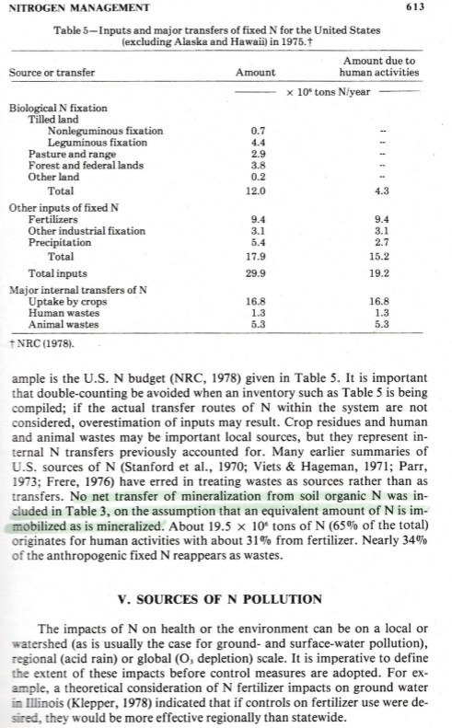
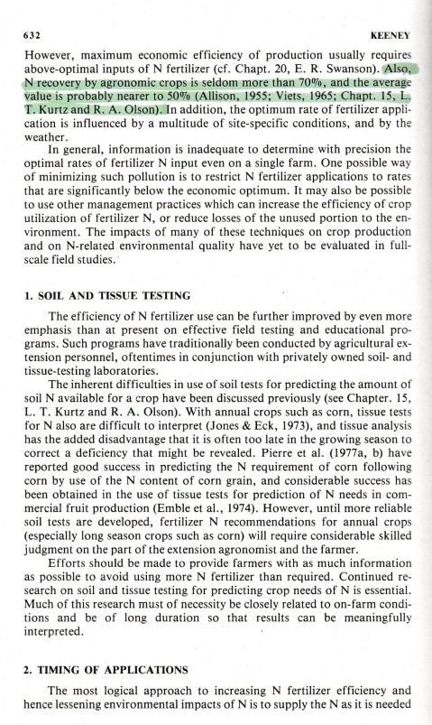
Miscellaneous
The percent N determined either from Kjeldahl methods or dry combustion could be multiplied by 5.7 for cereals to determine the estimated protein concentrations. This is facilitated by each product having known amino acid compositions and in turn, known N values (Sosulski, and Imafidon, 1990).

Dr. Sharma,
Thank you for call and for the comprehensive nature of your thoughts/concerns relative to our work. Included is the document that explains and delineates the use of the Keeney 1982 reference. This estimate (N coming from the rainfall and/or soil) could be viewed as being specious, but then I would ask what other estimate do I have and that could be cited? I would also ask what other estimate of fertilizer N used in cereals is there that could be cited (Alexandratos, 1995)? And what about N concentrations in the cereals used to make the holistic estimate of NUE?

Yes, this estimate of “World NUE” is totally different from the use of the “difference method” or “isotopic discrimination”, but don’t you find it interesting that it matches up with reports from many (maize and wheat) and that are in the literature (30 to 40%)? Table 2 in the document really should be expanded. Sulochana Dhital recently completed a survey paper that is now in-print, in Agronomy Journal, and that documents highly variable N demand in a country fixated on applying the same rate year after year. We do indeed have a serious problem.

In this light, it would be beneficial to generate an NUE survey paper as well.

Thanks for challenging our work and for thinking deeply about the N issues we face.

bill

