**Final Exam: SOIL 5112  
Tuesday, April 30, 2013  
8:00 am**

1. **The soil N test discussed by Dr. Bushong was originally developed in _Illinois_ and was called the __amino-sugar N test____________**
2. **Worldwide fertilizer prices paid by farmers has _____________ in the last 10 years**

**Doubled**

**Tripled**

**Quadrupled**

1. **What is the definition of a “critical level” point at which an increase in x no longer results in an increase in y**

[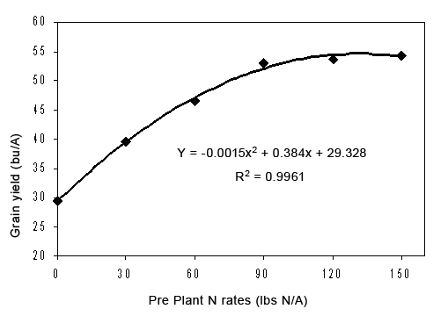](http://www.google.com/url?sa=i&rct=j&q=yield+by+nitrogen+rate+graphs&source=images&cd=&cad=rja&docid=gvgdw5jPKxUt4M&tbnid=n1Ox9JjYxl9xIM:&ved=0CAUQjRw&url=http://www.extension.umn.edu/cropEnews/2006/06MNCN10.htm&ei=IVF5Ua3rKqOf2QW29IHoBQ&bvm=bv.45645796,d.b2I&psig=AFQjCNFmfTVC5KAPpPeXtLueDPc3rC3Aqw&ust=1366991352347745)

1. **What would the critical level be for the data above.**

**Using Cate Nelson ___70_______________**

**Using a quadratic model ____120__________**

**Using a linear plateau _________70_______**

1. **For the graph included below, please modify the SAS code for a linear-plateau model**

**proc nlin data = one best = 3;  
parms b0= __0__ to __1__ by 0.01 b1=__4___ to ___8__ by _.5__ njoint=_.6____ to __.8___ by _.05__;**

1. **Plant to plant differences in corn grain yield averaged (AJ article)**

**47 bu/ac**

**4.7 bu/ac**

**14.7 bu/ac**

**104.7 bu/ac**

**COVARIANCE**

1. **The assumptions that must be considered when using analysis of covariance are….**

**The covariate must not be significant when evaluated as an independent variable**

**Covariate must be independent of treatment**

1. **When analyzed as a dependent variable, covariate needs to be _not significant as a function of treatment______**
2. **Covariance can be viewed as “a linear regression adjustment” within analysis of variance (T or F)**
3. **What are the dangers of analyzing data using ANOVA when data is not normal? What can be done to fix this?**

**Means will likely be skewed one direction or the other. Proc Rank or other data transformations can normalize the data**

1. **Fill in the SAS program below so as to properly use the covariate “prep” (pre plant soil test P)**

**Data one;**

**input rep trt yield prep;**

**cards;**

**1 1 30 42**

**1 2 35 40**

**proc glm;**

**class _rep trt;**

**model yield = rep trt prep;**

**lsmeans trt;**

**run;**

1. **What analysis was discussed in class that could possibly be used to account for underlying spatial variability?**

**covariance**

1. **Spatial variability in production fields was demonstrated to occur at**

**1 ft x 1ft**

**8 rows * 20 ft in length**

**Field to field**

1. **Name three causes of spatial variability encountered in agricultural production**

**Tire traffic, water ponding, variable weed infestation. (any answer that makes sense)**

1. **Third dimension of stability analysis discussed in class whereby a surface response model would be generated using the original Env. Mean versus Treatment mean and disease_______________________.**
2. **How many years (locations, sites, etc.) of data are required to generate a meaningful regression equation for use in stability analysis?**

**10**

1. **Stability analysis conducted on the Magruder Plots showed that ___K___ applications appeared to be beneficial in _____stress_____ environments.**
2. **You have an experiment with 3 reps and 12 treatments. The 12 treatments consist of a full factorial arrangement, where there are 4 nitrogen rates (NR) and 3 varieties (VAR).**

**Treatment N Rate Variety**

**1. 0 TAM101**

**2. 40 TAM101**

**3. 80 TAM101**

**4. 120 TAM101**

**5. 0 KARL**

**6. 40 KARL**

**7. 80 KARL**

**8. 120 KARL**

**9. 0 DUSTER**

**10. 40 DUSTER  
11. 80 DUSTER**

**12. 120 DUSTER**

1. **SAS program if you analyze this as a full factorial**

**Proc glm;**

**Class rep nrate variety;**

**Model yield = rep nrate variety nrate*variety;**

**Means nrate variety nrate*variety;**

1. **SAS program if you analyze this as a rep-treatment model**

**Proc glm;m**

**Class rep trt;**

**Model yield = rep trt;**

**Means trt;**

1. **If a treatment*environment interaction is significant what does it say about how treatment must be interpreted?**

**Must be interpreted by environment**

1. **What about treatment*year?**

**Must be interpreted by year**

1. **What advantages of 4 versus 3 reps were discussed in class?**

**Easier to pick up outliers with 4 reps. Also gives you the freedom of deleting an entire rep if the data is clearly skewed.**

1. **What does CGIAR stand for?**

**Consultative Group for International Research**

1. **What is a “synergistic” interaction? Graph would help (label the axes)**

**When response to a change in variable x, moves with the same positive or negative slope but at a slightly different rate**

1. **What is an “antagonistic” interaction? Graph would help**

**When a response to a change in variable x, changes with a positive slope (one variable) and a negative slope (second variable) and that can intersect**

1. **Two trials: LMSE = 58000 SMSE = 24000, dfe (both trials) = 20**

**Compute the F statistic. ______ Based on your knowledge of the table values, should these trials be combined?**

**(F values on the board) 58000/24000=2.41 F value 20dfn, 20dfd alpha 10% = 1.79**

**They should not be combined**

1. **I want to know what “percent of the mean” difference you need to say there are differences in treatments? (more or less, and why)**

**>15%,**

1. **(2 treatment means were 2500 and 3400 kg/ha). Using your answer in 26, what would this be in kg/ha? (for this data)**

**900kg/ha. 15% (2400, 3400 avg. 2900 *0.15 = 435**

1. **Fill in the blanks below on how you would use PROC CORR to establish the relationship between yield and NDVI with population, disease, height, and BYDV (barley yellow dwarf virus).**

**Proc corr;**

**var ___yield ndvi;**

**with ___population disease height bydv;**

1. **In order to merge two data sets that have rep, trt, yield, and location as identifiers, fill in the blanks below as to how this would be accomplished.**

**data loc1;**

**proc __sort; by rep trt yield location;**

**data loc2;**

**proc sort; by rep trt yield location ;**

**data comb; merge loc1 loc2 ; by rep trt yield location;**

1. **1. If you want to identify that you have a character variable variety (e.g., TAM101, OK101, HUSKER1, KSU2, CSU2), followed by rep and treatment (both in numeric form) provide an example of how this will look in the input statement.**

**data one;**

**input var $ rep trt ;**

**cards;**

1. **In order for SAS to understand that you have missing data, what must be entered within that cell? .**
2. **The very first “PROC” procedure that you should run in any program is ? proc print;**
3. **Which of the following have to be true in order to use an independent variable as a covariate?**

**a. the covariate has to be independent of “trt”**

**b. treatment must be significant when the covariate is analyzed as a dependent variable**

**c. must be collected before treatments are applied**

**d. must be collected after treatments are applied**

1. **What are the assumptions of analysis of variance?**

**Experimental error is random , independent, and normally distributed about a zero mean with a common variance**

**Treatment and environmental effects are additive**

1. **When should “LSMEANS” be used to replace the normally computed “MEANS?” (2 answers)**

**1. Presence of Missing data**

**2. covariance**

1. **___reps_____ ensures that you will have an estimate of experimental error**
2. **_randomization_______ ensures that you will have an unbiased estimate of experimental error**
3. **When you have missing data, what sums of squares should be used?**

**Type III**

1. **LSD’s cannot be used when the treatment structure includes __________________**

**Gradients in the treatment structure (e.g. N rates)**

1. **What is the main reason for blocking?**

**Known gradient in the field**

1. **If there isn’t a known “gradient” within a field trial, what experimental design is recommended?**

**CRD**

1. **SED times ___2____ is generally what would be computed using what mean separation procedure?**
2. **What is the main difference between the scientific method and the experimental method?**

**Scientific method is a broad term and that encumbers the reporting of survey statistics**

**Experimental method is more specific and that includes formulating a hypothesis, putting together a treatment structure to test the hypothesis, collecting structured data, analyzing the data, and interpreting the results.**

1. **What kind of error is incurred if a scientist “excludes” data that does not conform to his/her hypotheses?**

**bias**

1. **Good researchers aren’t necessarily characterized by being smart, but by……. Asking good questions**
2. **What is autocorrelation? Using an x-variable that has some association with the y-variable, and that results in higher than normal correlation (e.g., NDVI is correlated with red reflectance). Why? Because red is embedded within the computation of NDVI**
3. **For the example below, from the 2 linear regression equations, is there a**

**a. significant difference in the intercept components? ____no_______**

**b. significant difference in the slope components? _________no___**



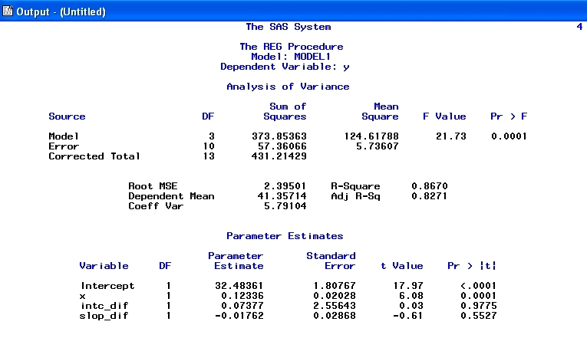

1. **For the data below (Yield by N rate study under zero-till and conventional tillage, what would the Cate-Nelson critical level (N Rate) be for the two tillage systems? (Draw the 2 cross bars for full credit.**

**Cate-nelson (conventional tillage) = no critical level**

**Cate-nelson (zero tillage) = 100**

1. **Below is a GLM for 1971 and 1981, treatments 1-6 from Experiment 502 in Lahoma Oklahoma. Using the analysis provided, answer the following questions.**
2. **When should the Type III sums of squares be used instead of Type I? missing data**
3. **Was there a need to use Type III sums of squares in this case for these 2 years of data?**

**no**

1. **Should treatment means have been interpreted over years or by year?**

**By year**

1. **What statistic did you use to make the decision in #c?**

**Large difference in year using the rep(yr) as the error term to test the effect.**

1. **Was there a treatment mean(s) (either year) that stood out, whereby you suspected an outlier?**

**Yes,**

1981 4 4 2169 668

1981 5 4 2345 710

1. **What statistic tells you that was likely a wheat experiment and not a corn trial?**

**CV of 14**

1. **What is meant by REP(YR)? reps were nested within year**
2. **What is REP(YR) used for? Used to test the main effect of year**

**Compute the SED for this experiment. Square root of ((104085*2)/4) = 228**

**square root (2*s2/reps)**

The SAS System 14:11 Thursday, April 25, 2013  
The GLM Procedure

Class Level Information

Class Levels Values

YR 2 1971 1981

REP 4 1 2 3 4

TRT 7 1 2 3 4 5 6 7

Number of Observations Read 56

Number of Observations Used 56

Dependent Variable: kgha

Sum of

Source DF Squares Mean Square F Value Pr > F

Model 19 8205054.58 431844.98 4.15 0.0001

Error 36 3747087.72 104085.77

Corrected Total 55 11952142.30

R-Square Coeff Var Root MSE kgha Mean

0.686492 14.41917 322.6233 2237.460

Source DF Type I SS Mean Square F Value Pr > F

YR 1 1431808.560 1431808.560 13.76 0.0007

REP(YR) 6 495662.840 82610.473 0.79 0.5810

TRT 6 3436281.580 572713.597 5.50 0.0004

YR*TRT 6 2841301.597 473550.266 4.55 0.0016

Source DF Type III SS Mean Square F Value Pr > F

YR 1 1431808.560 1431808.560 13.76 0.0007

REP(YR) 6 495662.840 82610.473 0.79 0.5810

TRT 6 3436281.580 572713.597 5.50 0.0004

YR*TRT 6 2841301.597 473550.266 4.55 0.0016

Tests of Hypotheses Using the Type III MS for REP(YR) as an Error Term

Source DF Type III SS Mean Square F Value Pr > F

YR 1 1431808.560 1431808.560 17.33 0.0059

Level of ---------kgha---------

TRT N Mean Std Dev

1 8 1860 458

2 8 1890 631

3 8 2264 190

4 8 2278 513

5 8 2356 474

6 8 2451 201

7 8 2560 205

Level of Level of ------kgha-------

YR TRT N Mean Std Dev

1971 1 4 2264 118

1971 2 4 2467 151

1971 3 4 2399 130

1971 4 4 2387 369

1971 5 4 2367 144

1971 6 4 2380 192

1971 7 4 2514 148

1981 1 4 1455 200

1981 2 4 1313 131

1981 3 4 2130 140

1981 4 4 2169 668

1981 5 4 2345 710

1981 6 4 2522 210

1. 7 4 2606 266
2. **What is this formula for? Standard error of the difference between two equally replicated means**

**square root (2*MSE/reps) or square root (2*s2/reps)**

1. **For the 3D scatter plot below, fill in the blanks for the program used to generate this output (variables are YP0 (yield potential) on the Z, Year on the X and RI0N (response index) on the Y). This is data from Experiment 502 that we looked at in class (long-term NPK trial at Lahoma).**

**proc** g3d_____ ;

scatter ____year___ * __ri0N_____ = YP0_______/shape='pyramid';

**run**;

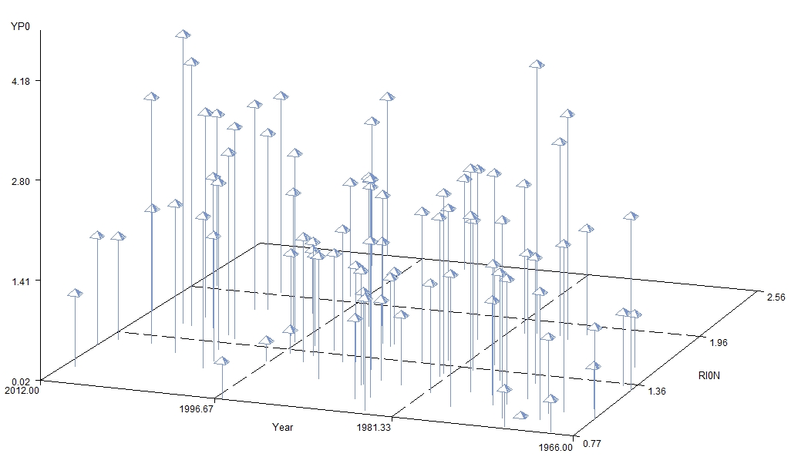

1. **If I had a fourth variable, “variety” (in addition to the 3 reported) where there were 2 different varieties evaluated, how could I look at this, on this same graph?**

**Different colored prisms, or different shapes**

1. **For this data set (visual observation), was there a relationship between RI0N and YP0 (yield)?**

**No**

1. **What does the following program do?**

proc iml;  
dens={0 100 600 1200}; **  
p=orpol(dens);  
t=nrow(p);  
do i=1 to t;  
pr=abs(p[,i]);  
pr[rank(abs(p[,i]))]=abs(p[,i]);  
do j=t to 1 by -1;  
if pr[j] > 1.e-10 then scale=pr[j];  
if abs(p[j,i]) < 1.e-10 then p[j,i]=0;  
end;  
p[,i]=p[,i]/scale;  
end;  
print p;  
run;

generates the coefficients for contrasts when the treatments had unequally spaced treatments or rates

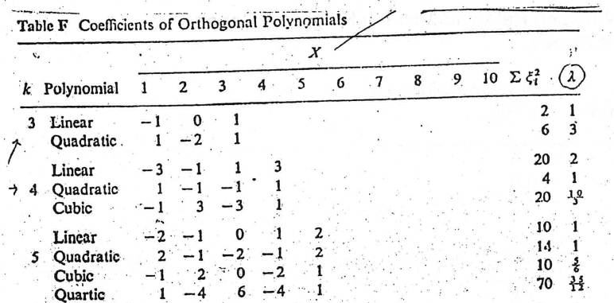

1. **You have an experiment with 4 N Rates (0, 20, 40, 60 kg N/ha) and 2 Tillage systems (Conventional and Zero-Till). Using the coefficients for equally spaced treatments above, produce the proper SAS statement for the following contrasts. (actual statement has to work in SAS, no errors).**
2. **N rate linear**
3. **N rate quadratic**
4. **N rate linear * tillage**
5. **N rate quad * tillage**

**Contrast ‘nrate linear’ nrate -3 -1 1 3;**

**Contrast ‘nrate quad’ nrate 1 -1 -1 1;**

**Contrast ‘nrate linear*tillage’ nrate*tillage -3 -1 1 3 3 1 -1 -3;**

**Contrast ‘nrate quad*tillage’ nrate*tillage 1 -1 -1 1 -1 1 1 -1;**