**CARIBBEAN AG MANAGEMENT NETWORK**

*Bringing science-based solutions to smallholding producers*

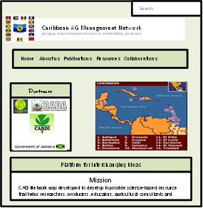**“*Mining has virtually maximized its growth, tourism has virtually maximized the availability of beaches which can be developed, manufacturing has contracted from a contribution of 19 per cent of GDP some 40 years ago to seven per cent today, and agriculture remains underdeveloped”*  -Former Prime Minister of Jamaica Edward Seaga**

**About us**

* The Caribbean Ag Management Network (CAG Network) was developed to provide researchers, extension educators, agriculture consultants, and students in the Caribbean region with an online source for **science-based** solutions on all aspects of plant and livestock management for smallholding agricultural systems.

**Mission**

* To provide a science-based resource that helps researchers, producers, educators, agricultural consultants and students in the Caribbean region make better plant and livestock management decisions and recommendations.
* To publish an online peer-review journal **Caribbean Agriculture**, facilitating **collaboration** among researchers in the Caribbean region and a wealth of resources for authors, producers, educators and students.
* To develop an online education center that provides a collection of **educational webcast modules** that is useful for self-training and the exchange of ideas on matters practical and theoretical.

**Publication**

Caribbean Agriculture

Caribbean Ag Management Network



* 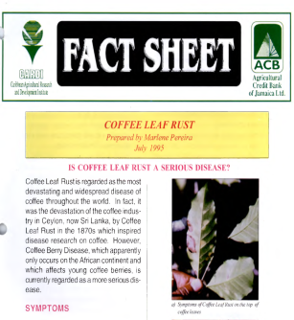CAG network will publish fact sheets, monthly magazine, images, videos and a bi-yearly online peer-reviewed journal **Caribbean Agriculture**.
* The **Caribbean Agriculture** **Journal** publishes applied crop and livestock system based research that has practical application for small holding limited resource production systems.

**Collaboration**

* CAG network will provide **constant support** to the latest development in Caribbean agriculture in your field of interest through open and straightforward communication.
* We can connect you to our established influential researchers and authors providing you a unique insight into the core research approach directly from the researcher.

**Contact us:** CAGnetwork.org