Overcoming the Global Issue of Salinity
The objective of this proposal is to increase agricultural production by finding salt tolerant crop species.
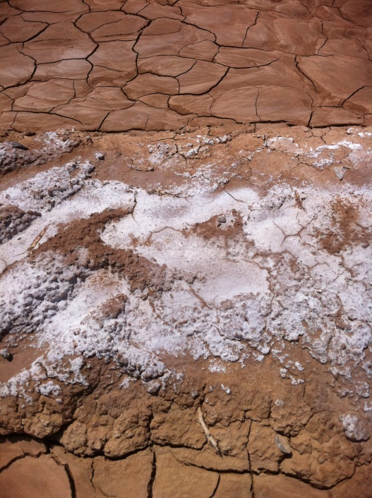
Currently, it is estimated that approximately 30% of the global irrigated farm land is affected by salinity. Over the next 50 years, the amount of land affected by salinity is expected to increase. With the increase of the global population in the next 50 years and the amount of land in production decreasing yearly, solving this salinity issue will be a challenge for the ever steady population increase.
There is research being conducted in several areas of the country looking for plant species and varieties that naturally have high levels of tolerance to salinity. The picture to the left was taken in Pecos, Texas. This shows how much salt builds up on the soil surface after crops have been irrigated. As you can see, the buildup of salt makes crop production very challenging.
Salinity is a global issue, affecting many producers around the world. The bottom line is, salinity often lowers yields substantially and can threaten the livelihood of agricultural producers worldwide.

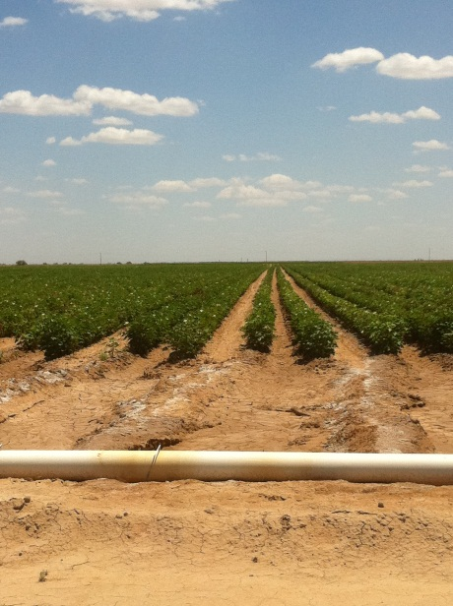
Solution
- Find and develop major commercial crop (i.e. Corn, Cotton, Soybean, Sorghum) varieties that are highly salt tolerant so that current irrigation water affected by salinity may be utilized.

