**Temperature Gradient Chamber (TGC) - a model for studying global warming effects**

Climate models predict increases in average temperatures worldwide, with wide-ranging impacts on local temperature and rainfall. Such changes not only present a risk to food supplies, farmer livelihoods, and rural communities but also on the agricultural sector’s responsiveness to changing yield and productivity patterns, production costs, and resource availability.

Warming trends are likely to reduce global yields by roughly 1.5% per decade without effective adaptation, with a plausible range from roughly 0.3%-4%. The upper end of this range is half of the expected 8% rate of gain from technological and management improvements over the next few decades **(Lobell et al. 2012).** This figure would be much higher if we consider the drought associated with increased temperature.

We will design TGC, developing a temperature gradient along its longitudinal axis using solar energy during the day and by heating at night **(Horei et al., 1995)**. In the daytime, temperature gradient is regulated by controlling the airflow rate of 2 fans mounted in the warm end of the TGC. At night and when solar radiation is low, temperature gradient is controlled using a line heater. Temperature will be measured by thermocouples positioned above crop canopy.

So, that the interaction effects can be assessed at different temperature regimes and the drought resulted by increased temperature, representation of the different parts of the world experiencing the same situation due to global warming.

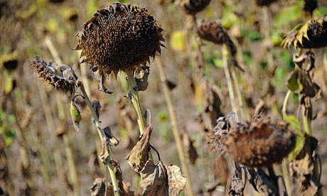

Dried sunflowers in a village near Sofia, Bulgaria. Heatwaves in Europe, some as hot as 40 C, have ruined the harvest in many regions of the country. Photograph: Vassil Doney/EPA

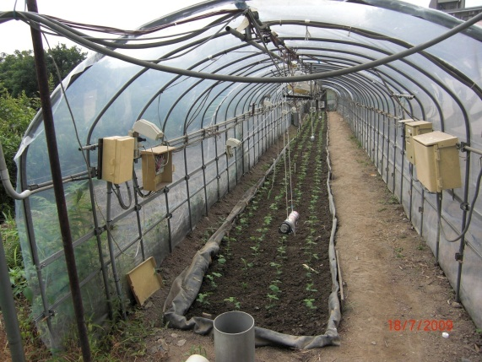

**Benefits:**

* How much water stress associated with warming increase susceptibility to heat damage?- construction of model
* Gives better estimates of rates of increased temperature and responsiveness of crop yields to warming, CO2 and drought (their combination)
* Screening of tolerant cultivars.
* Information to breeder about alteredphysiology due to unfavorable changes.
* Better management practices for better adaptation.

