Determining the Optimum Growth Window for NDVI Sensing in Order to Predict Yield in Winter Wheat in the United States Grain Belt
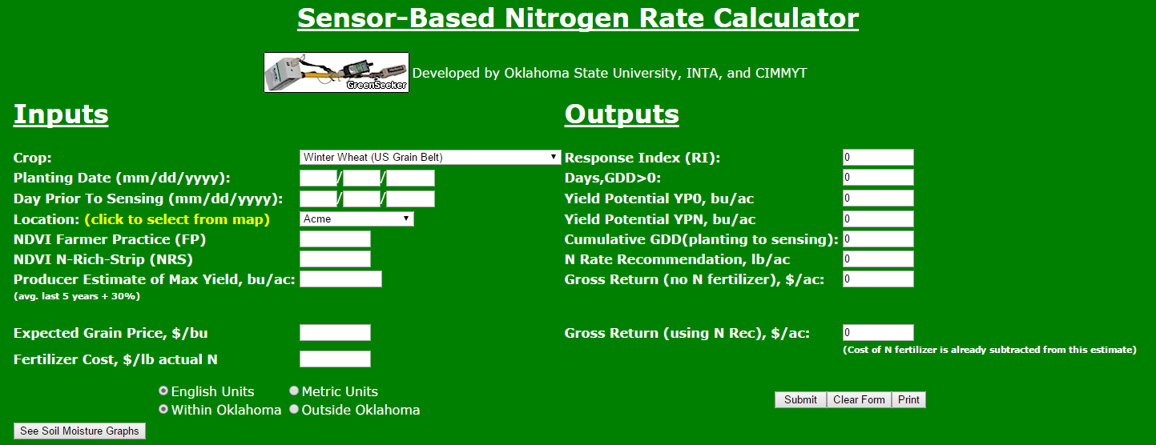
Rationale
Great advances have been made in the agricultural technology available to producers, such as the GreenSeeker and the corresponding on-line yield calculator for winter wheat in Oklahoma, yet these technologies are not often common practice. Nue.okstate.edu is home to a comprehensive top dress N calculator, based in part on NDVI sensor readings, that also has the capability to calculate predicted yield. In the University setting, it is easy and feasible to sense test plots numerous times throughout the growing season, however, such extensive testing may not be practical in a production setting.

Objective
Oklahoma State University Soil Nutrient Management has an extensive collection of NDVI and yield data from long term winter wheat trials that may be analyzed in order to determine a window in which a wheat crop may be sensed only once in a growing season in order to accurately predict yield.

Methods
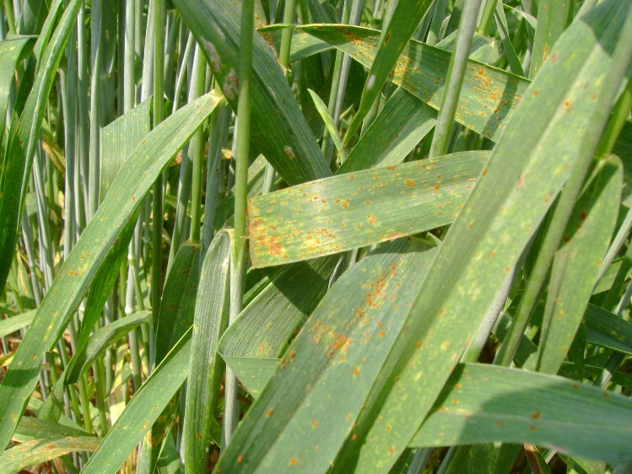
Values for Rsquare of yield prediction from NDVI readings as a function of actual harvest yield will be compared to determine the optimum growth window for NDVI sensing in order to predict yield. Dr. Brian Arnall, Assistant Professor of Precision Nutrient Management at Oklahoma State University (personal communication, April 15, 2015), sees the practical farmer application for this analysis being in allowing producers the opportunity to decide if potential yield is worth a late season fungicide application.
Leaf Rust on Wheat. (extension.udel.edu)

Conclusion
Ultimately, these findings would be converted into a ranking system of fungicide application economic threshold based on yield prediction. For example:
0-20 bu/ac- No application
21-50 bu/ac- Apply upon infection
50+ bu/ac- Preventative application

