Getting N Rates Right
Historically, yield goals have been used to determine nitrogen (N) rate recommendations and remain the same year after year. While better than some practices, yield goals can over estimate yield up to 15%. Yield goals do not account for the N mineralized and immobilized by the environment and residual N from the previous crop. The right N rate for grain crops will change from year to year due to these environmental impacts. Soil testing practices have been developed to help producers quantify how much N is present in soil at the time of application.
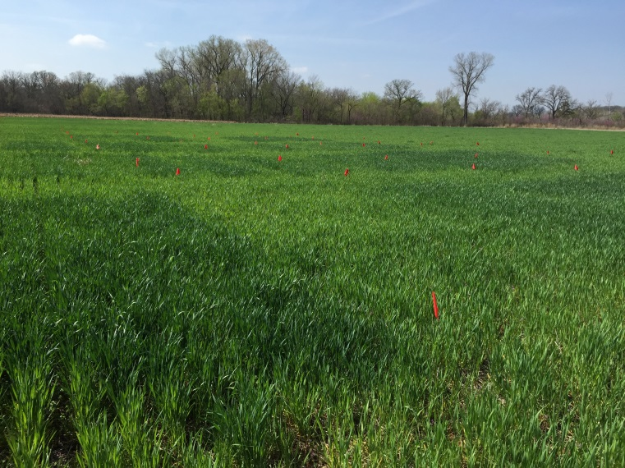
Eutrophication “dead zone” in the Gulf of Mexico
Over applying N can have a huge impact on environmental pollution which can result in strict governmental policies being put in place. Under applying N can result in the crop not meeting its yield potential which has a negative economic impact on the producer. It is more important than ever to get N rates right.
Oklahoma State University has developed the GreenSeeker sensor that will predict yield potential from NDVI during the crop’s growing season as well as developing a sensor based N rate calculator for many crop species, available to producers online.
Nitrogen response in wheat
Using the GreenSeeker in conjunction with N Rich Strips will allow the producer to compare N response in field and determine the optimum N rate to maximize yield and economic return. Basing mid-season N recommendations on this technology has shown to increase NUE by 15%. With the world NUE right around 35%, this increase of 15% would be a significant. The SBNRC recommendations have also shown to decrease N used by 20lbs/A. As the price of fertilizer continues to increase, this will go a long way in saving the producer money.
Online SBNRC for winter wheat
The future of nutrient management will rely heavily on precise N rate recommendations supplied by sensor based nitrogen rate calculators.

