HAND PLANTERS FOR AFRICA
Daniel Aliddeki Kizza .S
INCREASING USE-ABILITY, MAINTENANCE, YIELD AND REDUCING COST OF THE HAND SEED PLANTER IN RURAL AREAS OF UGANDA.
In Uganda and most Sub-Saharan Africa agriculture is one of the major contributors to the economy, in Uganda, agriculture contributes 48% to the National Economy and employs 80% of the people either directly or indirectly, of these over 65% are women who contribute 75% of the overall agricultural production and live in the rural areas of Uganda on small acreages of land (1-3 acres) growing mainly cereals, legumes and starchy foods, of the cereals, maize (Zea mays), millet (Pennisetum), soghurm (Sorghum bicolor), rice (Oryza sativa) etc, legumes include beans (Phaseoulus vulgaris), soya (Glycine max), groundnuts (Arachis hypogaea) etc, the seeds used for planting are in many cases chemically treated hybrid seeds that pose harm to the farmer due to exposure because they are carcinogenic, like earlier stated in papers, farmers work long hours bending tilling the land with heavy iron cast hoes, rushing to fit into the rainy seasons.
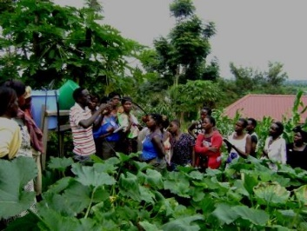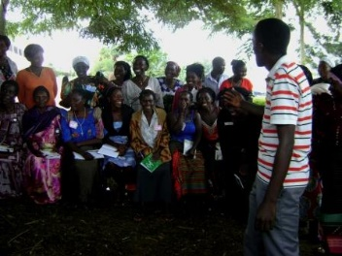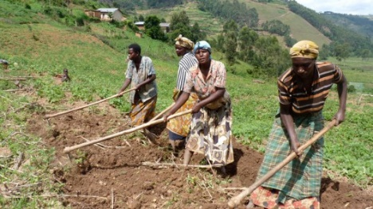
St Jude Family Projects and rural training center is a non NGO started in 1986 in Uganda, since 1993 it has worked with 186000 farmers teaching them better skills of farming and growing food, to prevent famine and hunger, and also conserve the environment through planting trees.
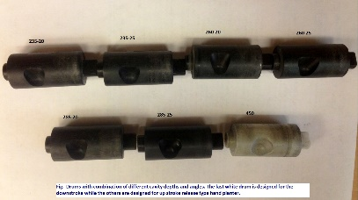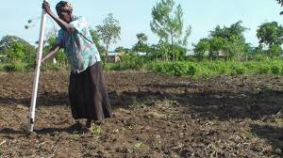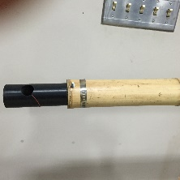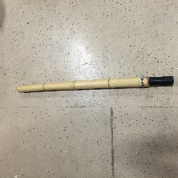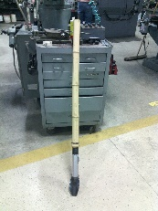
Modifications and benefits:
-Removal of chemically treated seeds from hands of farmers.
-Deduction in soil erosion through improved plant spacing.
-Accommodate mid-season Urea and Nitrogen fertilizer application.
-Place Urea below the surface reducing NH3 losses to.
-Diversification of the Hand seed planter to suit all kinds of seeds through doctoring of drums.
-Reduce purchase and maintenance cost of the hand seed planter by using locally available materials like bamboo.

