Mame Diaite-Koumba

Soil 5112, Oklahoma State University

Spring 2015

Drought and poor soil fertility in sub- Saharan African countries

The objective is to find a sustainable way to allow small farmers in Senegal to increase their yield by overcoming drought and poor soil fertility due to the very little rainfall.

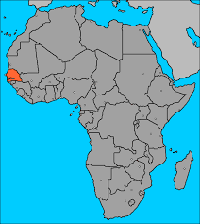

Source: www.heifer.org

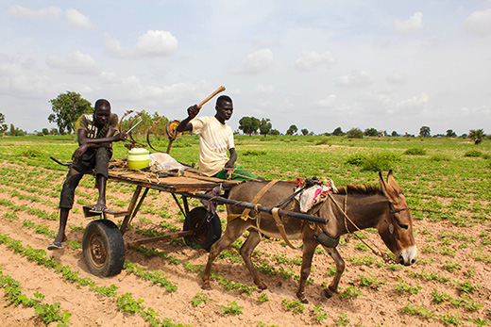

Source: www.worldbank.org

The method will be similar to conservative farming; maximizing the output by minimizing the input. In the case of conservation farming, farmers till and plant only a portion of their land each season growing crops in small spaced basins rather than plowing the entire field.

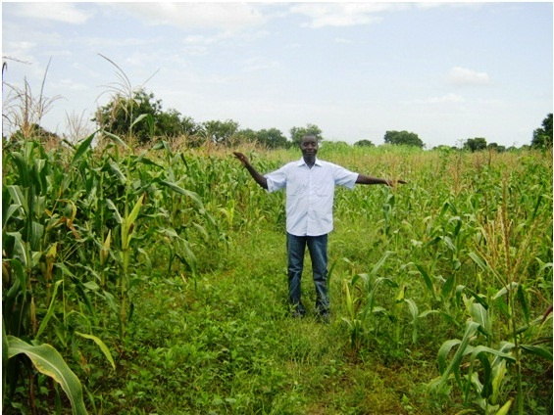

Source: www.usaid.gov

The limitation of this technique is that it requires using only a portion of the land therefore, limiting the potential output that could have been obtained if the entire plot was used. The conservative farming techniques have proven its effectiveness in Senegal. When tested on millet and maize, it increased the yield from 49% to 71%. Our goal would be to make the proper modifications to outgrow the yield even more