Research Proposal

Submitted to
Oklahoma State University
Department of Plant and Soil Sciences

I. Effect of Preplant Nitrogen Distance from Corn Rows on Grain Yield and Nitrogen Uptake

II. Mid-season Winter Wheat Nitrogen Rate Algorithm for Kansas and Oklahoma

Jeremiah L. Mullock
Spring 2014

Graduate Student
Department of Plant and Soil Sciences
Oklahoma State University

I. Effect of Preplant Nitrogen Distance from Corn Rows on Grain Yield and Nitrogen Uptake.

Abstract

Usage of real-time kinematic (RTK) global positioning systems makes it possible to accurately place nitrogen (N) fertilizer to optimize grain yield and N uptake. This study was conducted to evaluate the effect of preplant N placement, in the Southern Great Plains, at different distances from corn rows on plant stands, grain yield, and grain N uptake. Corn field experiments located in North-Central Oklahoma were utilized in years 2009, 2012, and 2013. Preplant bands of urea-ammonium nitrate (28-0-0) at two rates of N were applied at distances of 0, 8, 15, 25, and 38 cm from the corn row. Also included was a check (0 kg N ha⁻¹) and a high N reference applied 15 cm from the row. Orthogonal contrasts were used to evaluate the polynomial trend response to preplant N rate at the 15 cm distance, the response to distance placement pooled across N rates, and the interaction between distance placement and N rate.

Introduction

Nitrogen (N) is the most limiting nutrient for crop growth and current use efficiencies of N are estimated at 33% for cereal crops worldwide (Raun and Johnson, 1999) and 37% for corn systems (Cassman et al., 2002). Only one-third of applied fertilizer N is being utilized by the crop during the growing season (Raun and Johnson, 1999). Losses of N from the soil-plant system can lead to severe environmental impact, such as hypoxia. One of the largest hypoxic zones is in the Gulf of Mexico, and has been estimated to cover 20,000 km² (Rabalais et al., 2002). The annual load of N delivered to the Gulf of Mexico by the Mississippi River Basin has been reported at 1,568,000 t yr⁻¹ with 61% being in the form of NO₃-N (Goolsby et al., 2000). Low efficiencies of applied fertilizer N can be attributed to losses via denitrification, ammonia volatilization, nitrate leaching, gaseous plant N losses, and surface runoff (Raun and Johnson, 1999). Improvements in fertilizer N use efficiency can be achieved with practices that manage N to increase crop N uptake.
Real-time kinematic (RTK) guidance systems have the highest degree of accuracy, where passes are repeatable within ±2 cm (John Deere, 2014; Trimble, 2013). Producers that use RTK can increase efficiency in field activities from reduced skips and overlaps with implements. Typically, producers can increase their area of production by 15% because of increased speed and efficiency. This increase in field size can be used to justify the cost of RTK (Gan-Mor et al., 2007). Use of RTK allows for including additional management practices including strip tillage, controlled traffic, subsurface drip irrigation, and accurate and variable rate placement of nutrients and chemicals.

Review of Literature
Roots are the source of uptake of water and nutrients and respond dynamically with a changing environment. Root growth of corn decreases with severe water and N stress, while moderate stress increases root growth (Eghball and Maranville, 1993). The majority of corn roots are in the area next to corn plants, where root densities are twice that found in the mid-row (Mengel and Barber, 1974). Similar results were found by Anderson (1987) where root mass at the soil surface from the mid-row decreased by 90% from samples collected within the row. To optimize the spatial distribution of the roots for N uptake, fertilizer applications could benefit from being placed closer to the row.
Application of N has been shown to increase root weight and length in the upper 7 cm of soil (Anderson, 1987). Applications of localized N have been documented to increase growth of roots (Drew and Saker, 1975; Granato and Raper, 1989). Corn root length and weight has been shown to increase in the area closest to N application (Durieux et al., 1994). The results from a study by Kaspar et al. (1991) found that fertilizer placed next to the row increased root weight and length when compared to fertilizer injected directly between rows. Placement of N fertilizer bands at increasing distances from spring wheat rows caused a delay in N uptake of 0.5 day for every centimeter away from the row (Petersen, 2001). These findings demonstrate that placement N bands can increase root growth and also minimize the time for N uptake to occur.
The majority of compaction from wheel traffic occurs after the first pass of machinery (Bakker and Davis, 1995). It is estimated that greater than 60% of field area is covered with tracks when using a minimum tillage system, and exceeds 100% coverage in conventional tillage (Soane et al., 1982). This is important to understand the effect of wheel traffic on root growth and nutrient uptake. Wheel traffic compaction decreased root growth in the mid-row by 50% compared to rows that did not have compaction from machinery (Kaspar et al., 1991). The horizontal distribution of corn roots at the soil surface decreased with inter-row compaction (Chaudhary and Prihar, 1974a). Reeves et al. (1992) found no difference in corn yield from wheel compaction as was explained by an increase in roots in non-compacted inter-rows. Despite the lack of yield differences, N uptake by corn plants decreased by 10% from wheel traffic compaction (Torbert and Reeves, 1995). Chaudhary and Prihar (1974b) found higher corn yields and N uptake with banded placement over broadcast applications where inter-row compaction was present, while in non-compacted soils the yield increase of banded placement over broadcast was reduced. As suggested by Kaspar et al. (1991), fertilizer use efficiencies can be increased by not placing fertilizer in areas with machinery traffic because of reduced root growth. This is due to the fact that corn roots compensate for the environment. Where roots are redirected away from compacted areas and growth of roots occurs in areas with adequate N supply (Garcia et al., 1988). Real-time kinematic systems with fertilizer applications and planting operations that utilize the same track can be used to reduce compaction to the mid-row section. This also allows for accurate distance placement of fertilizer to increase N uptake.
The area of N uptake by individual corn plants is relatively small with the majority of N coming from a 40 cm radius (Hodgen et al., 2009). Edmonds et al. (2013) found that non-fertilized corn rows did not show a yield response when sidedress N was applied to adjacent rows, which further demonstrates the area of N uptake by corn plants. Finding the optimum distance away from the row, for N applications is important, since most the N fertilizer sources can cause salt injury if placed too close. Salt injury occurs because of a change in osmotic potential outside of corn root that causes water to leave the plant. Fertilizer placed with the seed has the highest risk for injury. Mahler et al. (1989) concluded that N fertilizer banded with the seed should consider both N source and soil moisture. Even though there is risk in placing N too close to plants there is still a documented benefit in corn production. Fertilizer bands placed with corn seed improved early season growth in fine textured soils, and not in sandy soils (Rehm and Lamb, 2009). Rehm and Lamb (2009) also noted that yield reductions from fertilizer placement were directly related to decreases in emergence. Starter placement (direct seed contact, dribble over row, and banded 5 cm side X 5 cm down from seed) of fertilizer showed an increase in early season biomass and yield in Kansas no-till corn production (Niehues et al., 2004).
The response of corn to fertilizer band placement has an interaction with the environment. Blaylock and Cruse (1992) did not find a yield benefit or plant nitrogen uptake efficiency response to row placement of N compared to inter-row injection in ridge tillage corn. The authors attributed this lack of response to a lack of compaction in the inter-row from ridge building that could limit N uptake, and a possible increase in root growth in the surface in response to row placement that decreased water uptake in exploratory roots. Precipitation throughout the growing season plays an important role in the response of corn to placement of fertilizer bands. In drier years, Shoup and Janssen (2009) found that plant stands decreased in dry years when corn was placed directly above fertilizer band, and that grain yields were similar with distance placements of 9.5, 19, and 38 cm. While in wet years, Shoup and Janssen (2009) found that corn yields decreased when fertilizer bands were placed 38 cm from the row compared to bands at 9.5 and 19 cm. Also in wet years, there was little effect of placement on plant population. Shoup and Janssen (2009) report that excess moisture limited root growth in wet years and the corn plants were not able to access fertilizer at further distances.
There is also an effect of time in response to fertilizer bands. Plants further from fertilizer bands may have delayed development that can carry throughout the growing season (Zhang et al., 2010a). Corn plants next to fertilizer bands were larger throughout the growing season compared to plants further from bands, but the differences were minimized at the end of the season after roots could utilize fertilizer bands at farther distances (Zhang et al., 2010b). Zhang et al. (2010b) suggest that plants near fertilizer bands mature faster compared to plants further from the actual band, and that differences in yield between the distance from bands is dependent on environmental conditions and relative growth stage.
Real-time kinematic systems have been previously used to evaluate fertilizer band placement with anhydrous ammonia. Parallel bands of anhydrous ammonia were found to increase corn grain yield over diagonal bands, with the largest benefit at 145 kg N ha⁻¹ in no-till systems (Kovacs et al., 2014). Parallel anhydrous ammonia bands improved plant biomass and total N uptake compared to diagonal bands at 145 kg N ha⁻¹ (Kovacs et al., 2014).
Distance of fertilizer bands from corn rows can be beneficial in preplant and sidedress N applications. The optimum distance from the corn row with high rates of preplant UAN is 13 cm, based on a reduction in plant stands, early season plant height, and grain yield (Vyn and West, 2009). There was an added N uptake benefit documented by Vyn and West (2009) with higher whole plant N content at 4 weeks when preplant UAN bands were placed closer to the corn row. Accurate N placement from corn rows with RTK can have a grain yield and N uptake benefit. Previous research in the Corn Belt documented this optimum placement distance advantage. In that work all treatments received sidedress N, all treatments essentially received a high rate of N (224 kg N ha⁻¹), which is not often economically or agronomically beneficial in the Southern Great Plains. A sidedress N distance placement study in Oklahoma reported that surface applied sidedress N placed 0-20 cm away from corn rows increased grain yields and NUE (Rutto et al., 2012). The objective of this experiment is to evaluate the effect of preplant N placement, in the Southern Great Plains, at different distances from corn rows on plant stands, grain yield, and grain N content.

Materials & Methods
Corn field experiments were established in the spring of of 2009, 2012, and 2013 to evaluate preplant distance placement of UAN (28-0-0) from corn rows. Treatments were evaluated within a randomized complete block design with 3 replications. Experimental plots were 6.09 m long and four rows wide with a row spacing of 0.76 m. Accurate distance placement of banded fertilizer N, 10-15 cm deep with coulters, from the future corn row was achieved by using the same “track” with RTK-GPS and shifting the N applicator toolbar (Fig. 1). Field activities by year are reported in Table 1. In 2009, two experiments at Lake Carl Blackwell (LCB) were evaluated with one irrigated and one dryland trial. Both trials were located on a Port-Oscar complex (Fine-silty, mixed, superactive, thermic Cumulic Haplustolls; Fine-silty, mixed, superactive, thermic Typic Natrustalfs). Preplant N rates for the irrigated trial were 0, 64, 125, and 224 kg N ha⁻¹, while dryland N rates were 0, 34, 80, and 165 kg N ha⁻¹. In 2012 and 2013, dryland locations at LCB and Hennessey were utilized. The Hennessey location was located on a Bethany silt loam (fine, mixed, superactive, thermic Pachic Paleustolls). Preplant N rates for these locations were 0, 56, 112, and 224 kg N ha⁻¹. At all locations, the two middle N rates were applied at distances of 0, 8, 15, 25, and 38 cm from the corn row. The high N rate was placed 15 cm from the corn row as a reference for N response.
At maturity, the center two rows were harvested for grain, and yield was adjusted to 15.5% moisture. Grain sub-samples were collected, dried, and ground to pass a 140 mesh (100 µm) sieve. Total grain N was determined using dry combustion (Schepers et al., 1989) and used to determine N uptake (N uptake = Grain N% * Grain Yield). For 2009, grain yield data was recorded for both trials, while grain N content was only determined for the irrigated site. During 2012 and 2013, NDVI data was collected throughout the season, along with grain yield and grain N content. Additionally in 2013, plant population data was recorded at the V5 growth stage to evaluate the effect of N placement on plant stands. Average monthly temperature and total monthly rainfall data for each site-year were retrieved from the Oklahoma Mesonet automated weather monitoring network (www.mesonet.org) to understand the impact of environment and response of corn to fertilizer bands.
Analysis of variance for measured variables was performed using PROC GLM in SAS 9.3 software (SAS institute Inc., Cary, NC). Orthogonal contrasts were used to evaluate the polynomial trend response to preplant N rate at the 15 cm distance, the response to distance placement pooled across N rates, and the interaction between distance placement and N rate.

References
Anderson, E.L. 1987. Corn root growth and distribution as influenced by tillage and nitrogen fertilization. Agron. J. 79:544-549.
Bakker, D.M., and R.J. Davis. 1995. Soil deformation observations in a vertisol under field traffic. Aust. J. Soil Res. 33:817-832.
Blaylock, A.D., and R.M. Cruse. 1992. Ridge-tillage corn response to point-injected nitrogen fertilizer. Soil Sci. Am. J. 56:591-595.
Cassman, K.G., A. Dovermann, and D.T. Walters. 2002. Agroecosystems, nitrogen-use efficiency, and nitrogen management. Ambio. 31:132-140.
Chaudhary, M.R., and S.S. Prihar. 1974a. Root development and growth response of corn following mulching, cultivation, or interrow compaction. Agron. J. 66:350-355.
Chaudhary, M.R., and S.S. Prihar. 1974b. Comparison of banded and broadcast fertilizer applications in relation to compaction and irrigation in maize and wheat. Agron. J. 66:560-564.
Drew, M.C., and L.R. Saker. 1975. Nutrient supply and the growth of the seminal root system in barley II. Localized, compensatory increases in lateral root growth and rates of nitrate uptake when nitrate supply is restricted to only part of the root system. J. Exp. Bot. 26:79-90.
Durieux, R.P., E.J. Kamprath, W.A. Jackson, and R.H. Moll. 1994. Root distribution of corn: the effect of nitrogen fertilization. Agron. J. 86:958-962.
Edmonds, D.E., B.S. Tubaña, J.P. Kelly, J.L. Crain, M.D. Edmonds, J.B. Solie, R.K. Taylor, and W.R. Raun. 2013. Maize grain yield response to variable row nitrogen fertilization. J. Plant Nutr. 36(7):1013-1024.
Eghball, B., and J.W. Maranville. 1993. Root development and nitrogen influx of corn genotypes grown under combined drought and nitrogen stresses. Agron. J. 85:147-152.
Gan-Mor, S., R.L. Clark, B.L. Upchurch. 2007. Implement lateral position accuracy under RTK-GPS tractor guidance. Comput. Electron. Agr. 59:31-38.
Garcia, F., R.M. Cruse, and A.M. Blackmer. 1988. Compaction and nitrogen placement effect on root growth, water depletion, and nitrogen uptake. Soil Sci. Soc. Am. J. 52:792-798.
Granato, T.C., and C.D. Raper. 1989. Proliferation of maize (Zea mays L.) roots in response to localized supply of nitrate. J. Exp. Bot. 40:263-275.
Goolsby, D.A., W.A. Battaglin, B.T. Aulenbach, and R.P. Hooper. 2001. Nitrogen input to the Gulf of Mexico. J. Environ. Qual. 30:329-336.
Hodgen, P.J., R.B. Ferguson, J.F. Shanahan, and J.S. Schepers. 2009. Uptake of point source depleted ¹⁵N fertilizer by neighboring corn plants. Agron. J. 101:99-105.
John Deere. 2014. John Deere StarFire™ RTK. John Deere. https://www.deere.com/wps/dcom/en_US/products/equipment/ag_management_solutions/displays_and_receivers/starfire_rtk/starfire_rtk.page (accessed 8 April 2014).
Kaspar, T.C., H.J. Brown, and E.M. Kassmeyer. 1991. Corn root distribution as affected by tillage, wheel traffic, and fertilizer placement. Soil Sci. Soc. Am. J. 55:1390-1394.
Kovács, P., G.E. Scoyoc, T.A. Doerge, J.J. Camberato, and T.J. Vyn. 2014. Pre-plant anhydrous ammonia placement consequences on no-till versus conventional-till maize growth and nitrogen responses. Agron. J. 106:634-644.
Mahler, R.L., D.O. Everson, and L.K. Lutcher. 1989. Evaluation of factors affecting emergence of winter wheat planted with seed-banded nitrogen fertilizers. Soil Sci. Soc. Am. J. 53:571-575.
Mengel, D.B., and S.A. Barber. 1974. Development and distribution of the corn root system under field conditions. Agron J. 66:341-344.
Niehues, B.J., R.E. Lamond, C.B. Godsey, and C.J. Olsen. 2004. Starter nitrogen fertilizer management for continuous no-till corn production. Agron. J. 96:1412-1418.
Petersen, J. 2001. Recovery of ¹⁵N-ammonium-¹⁵N-nitrate in spring wheat as affected by placement geometry of the fertilized band. Nutr. Cycl. Agroecosys. 61:215-221.
Rabalais, N.N., R.E. Turner, and D. Scovia. 2002. Beyond science into policy: Gulf of Mexico hypoxia and the Mississippi River. BioScience. 52(2):129-142.
Raun, W.R., and G.V. Johnson. 1999. Improving nitrogen use efficiency for cereal production. Agron. J. 91:357-363.
Reeves, D.W., H.H. Rogers, J.A. Droppers, S.A. Prior, and J.B. Powell. 1992. Wheel-traffic effects on corn as influenced by tillage system. Soil Till. Res.23:177-192.
Rehm, G.W., and J.A. Lamb. 2009. Corn response to fluid fertilizers placed near the seed at planting. Soil Sci. Soc. Am. J. 73:1427-1434.
Rutto, E., J.P. Vossenkemper, J. Kelly, B. Chim, and W.R. Raun. 2013. Maize grain yield response to the distance nitrogen is placed away from the row. Expl. Agric. 49(1):3-18.
Schepers, J.S., D.D. Francis, and M.T. Thompson. 1989. Simultaneous determination of total C, total N, and 15N on soil and plant material. Commun. Soil Sci. Plant Anal. 20:949-959.
Shoup, D., and K. Janseen. 2009. Kansas State Extension Agronomy e-Updates – Diagnosing uneven corn height problem. Kansas State University Department of Agronomy. http://www.agronomy.ksu.edu/extension/doc2523.ashx (accessed 6 Jan. 2014).
Soane, B.D., J.W. Dickson, and D.J. Campbell. 1982. Compaction by agricultural vehicles: a review. III. Incidence and control of compaction in crop production. Soil Till. Res. 2:3-36.
Torbert, H.A., and D.W. Reeves. 1995. Traffic and residue management systems: effects on fate of fertilizer N in corn. Soil Till. Res. 33:197-213.
Trimble Agriculture. 2013. Trimble Agriculture – CenterPoint RTK. Trimble Agriculture. http://www.trimble.com/agriculture/CorrectionServices/CenterPointRTK.aspx (accessed 8 April 2014).
Vyn, T.J., and T. West. 2009. GPS-guided systems open new management options for corn producers. Fluid J. 17(3):1-5.
Zhang, J., A.M. Blackmer, T.M. Blackmer, and P.M. Kyveryga. 2010a. Fertilizer bands affect early growth of corn. Commun. Soil Sci. Plan. 41:1306-1314.Zhang J., A.M. Blackmer, T.M. Blackmer, and P.M. Kyveryga. 2010b. Fertilizer bands and dual effects on nitrogen on young corn plants. Better Crops 94(2):17-19.

Table 1. Summary of preplant nitrogen application date, planting date, planting density, hybrid, and harvest date, by experiment, six sites used to evaluate preplant distance placement of N from corn rows, 2009-2013, OK.
Location | Preplant N Date | Planting Date | Planting Density  (seeds ha⁻¹) | Maize Hybrid | Harvest Date
LCB 2009 – Irrigated | April 24, 2009 | May 27, 2009 | 83,600 | Dekalb DKC67-23 | September 29, 2009
LCB 2009 - Dryland | April 24, 2009 | April 24, 2009 | 53,800 | Dekalb DKC52-59 | September 3, 2009
LCB 2012 | March 29, 2012 | April 10, 2012 | 54,300 | Pioneer P1498HR | August 8, 2012
Hennessey 2012 | March 29, 2012 | April 19, 2012 | 54,300 | Pioneer P1498HR | August 7, 2012
LCB 2013 | March 26, 2013 | March 27, 2013 | 54,300 | Pioneer P1498HR | failed crop
Hennessey 2013 | April 1, 2013 | April 1, 2013 | 44,500 | Pioneer P0876HR | September 12, 2013

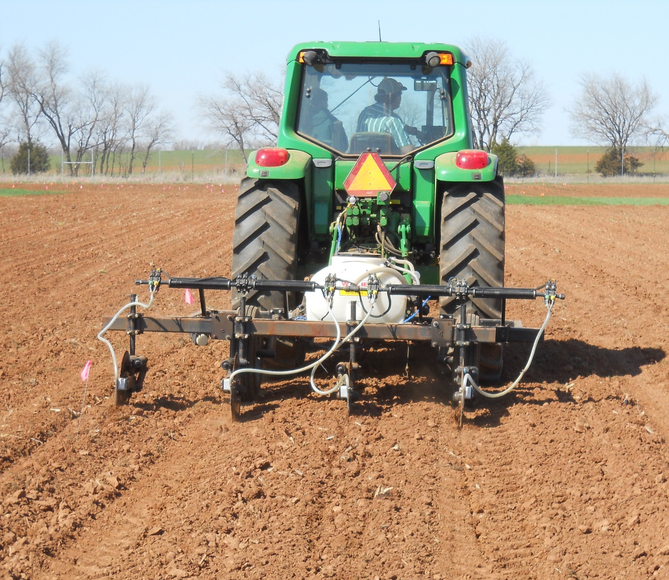
Figure 1. Preplant N applicator applying UAN (28-0-0) with coulters shifted for 38 cm distance away from the maize row.

