REPORT 6
- Recovering plants on the trial site. Using some wire and wood stakes, plants have been place vertical.
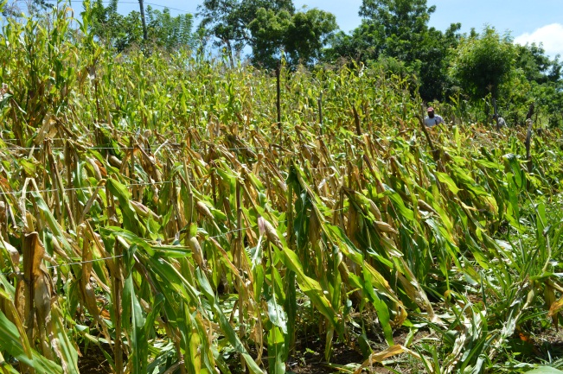
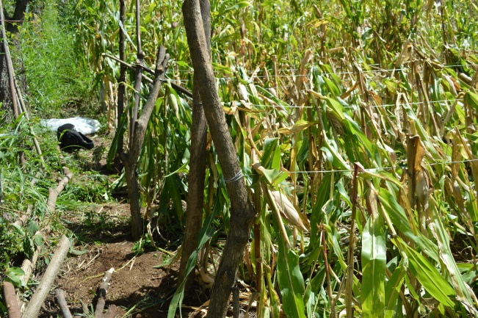

- Pictures of GS placing Urea and planting beans.

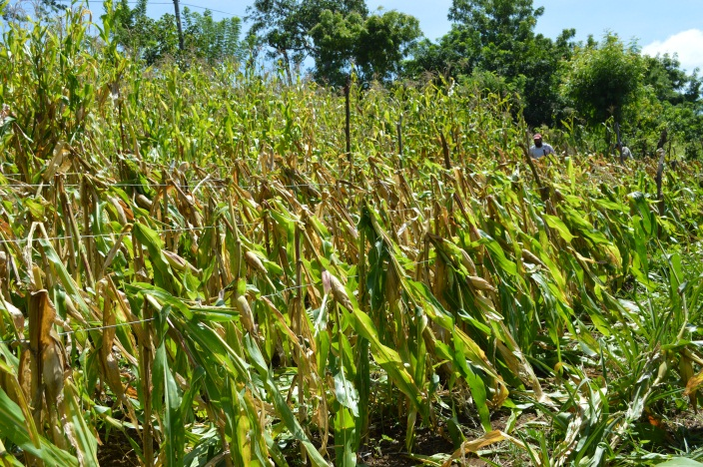
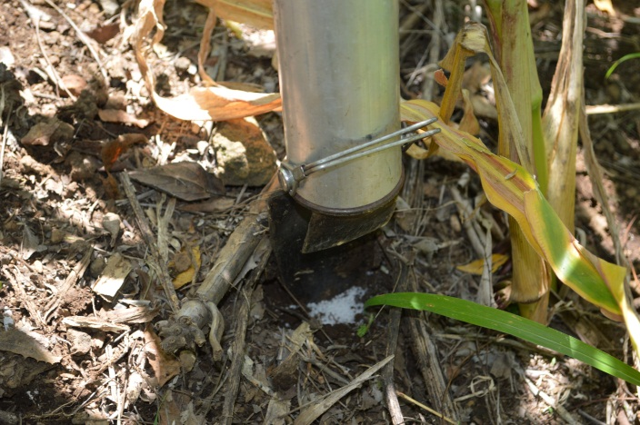

- I believe that the issue of the GS for using urea should be more revised. Why? Because the advantage of placing urea under the soil, can be useful on these days where rain is coming so erratic and it seems this trend will continue in future years.
Using the GS are less chances for loosing fertilizer on the surface, especially Ammonium Sulfate. However, I have a question, when I used the GS with Urea I measured 1.5-1.6 grams in the field. One of the guys that were there, told me later that the discharge was 2 .4 grams, he measured it using a small scale built with a syringe. Moved for the query, I did some measurements again and certainly I obtained higher weights (as you can see on the pictures). The urea I used was coming from a new bag. Do you have some suggestions?

