Changes in Response Indices as a Function of Time in Winter Wheat

B. Chung, K. Girma, Daryl B. Arnall, W.R. Raun, and J.B. Solie

Department of Plant and Soil Sciences, Oklahoma State University, Stillwater, OK 74078.

Contribution from the Oklahoma Agric. Exp. Sta.

Correspondence: William R. Raun, 044 North Ag Hall, Department of Plant and Soil Sciences, Oklahoma State University, OK 74078; Telephone: (405) 744 6418; Fax: (405) 774 5269; E-mail: bill.raun@okstate.edu

Running Title: Changes in Response Indices as a Function of Time

Changes in Response Indices as a Function of Time in Winter Wheat

Abstract
Nitrogen responsiveness of crops can change with time since it is strongly influenced by in-season environmental conditions. This study was conducted to determine the relationship of N responsiveness using a response index (RI) as a function of time at five locations (Efaw, Stillwater, Lake Carl Blackwell, Perkins and Lahoma, Oklahoma) over a 3-yr period. Subplots of 4 m² were established at each experimental site that employed a randomized complete block design. Normalized Difference Vegetation Index (NDVI) readings were taken using Greenseeker (NTech Industries, Inc., Ukiah, CA) handheld sensor at various growth stages. The N responsiveness (RI_{NDVI}) was determined as the ratio of NDVI readings from a non-N limiting strip and the farmer practice. Then, RI was plotted against days where growing degree days (GDD= (T_{min}+T_{max})/2–4.4°C) were > zero (DGDD>0). At all sites, RI_{NDVI} increased with advancing stage of growth. Excluding Perkins 2005 and Stillwater 2006, the relationship between RI_{NDVI} and DGDD>0 was positive and highly correlated. When the number of days from planting to sensing where DGDD>0 was less than 60, it is unlikely that a reliable estimate of RI_{NDVI} could be obtained since values were all small (close to 1.0), consistent with limited growth at the early stages of growth. Averaged over years and sites for all growth stages, the correlation of RI_{NDVI} and RI_{Harvest} was positive and increased up to the Feekes 9 growth stage. Our results further suggested that once RI_{NDVI} is collected, it should be adjusted using the Eq. RI_{NDVIadj} = RI_{NDVI} x [1.87/(DGDD>0 * 0.00997) + 0.5876].
Keywords: winter wheat, Normalized Difference Vegetation Index, Response Index,
Abbreviation: GDD, growing degree days; DGGD>0, the number of days where GDD> 0

Introduction

Supplying fertilizer N when crop response is expected can improve grain production and reduce the risk of applying too much N (Lukina et al., 2001; Flower et al., 2004). This has become more important today since N is the main nutrient needed for growth and development of plant tissues and yield (Chung et al., 1999; Thomason et al., 2002).
Worldwide fertilizer N consumption was 85,529,551 Mg in 1999 (NUEweb, 2007) and 60% of this consumed fertilizer N was used for cereal production (NUEweb, 2007). Nitrogen use efficiency for cereal crop production has remained low, near 33% (Raun and Johnson, 1999). An increase in cereal NUE of 1% was estimated to be worth $235 million in 1999 for the world (Raun and Johnson, 1999) and that would be significantly higher today. A large amount of N fertilizer that is applied can remain in the soil after harvest and can be hazardous (Chen et al., 2004; Embelton et al., 1986). The presence of excess N fertilizer in the soil-plant system, which is the primary source of NO₃-N accumulation in the soil (Vyn et al., 1999), can lead to high NO₃-N concentrations in perched groundwater (Huggins and Pan, 1993; Raun et al., 2002; Spruill et al., 1996). Often NO₃-N concentration in surface waters exceeds 10 mg L⁻¹, which is the USEPA’s maximum contaminant level (MCL) for drinking water (Huggins and Pan, 1993; Jaynes et al., 1999; Mitchell et al., 2000). Thus, it is important to develop techniques that will improve N management to increase efficiency (Lukina et al., 2001; Flower et al., 2004; Washmon et al., 2002).
Nitrogen use efficiency (NUE) of winter wheat (Triticum aestivum L.) was improved by more than 15% when N rate recommendations were based on midseason predictions of yield potential (YP₀) and RI compared to conventional N rate recommendations (Raun et al., 2002). This indicated that applied fertilizer N loss in the soil-plant system can be minimized using a sensor based N approach which uses remotely sensed reflectance characteristics of vegetation.
R
Remote sensing is inexpensive method to estimate N status of larger areas, and can be used to monitor N status in the field (Filella et al., 1995). It is important to note that there is an effect of soil background on reflectance if plant coverage densities are less than 50% (Heilman and Kress, 1987). Work by Huete et al. (1985) showed that soil background affects canopy reflectance, especially at low vegetation densities. However, Lukina et al. (2000) found that soil irradiance was not an important factor when plant coverage densities were more than 40%. Thus, the spectral radiance of wheat changes with plant biomass, percent vegetation coverage, and posture and structure of the plants (Lukina et al., 2000).
The NDVI (Rouse et al., 1973) is a widely used spectral vegetation index and has been utilized to determine crop yield potentials using simple regression equations (Raun et al., 2001; Teal et al., 2006). The equation established between in-season estimated yield (INSEY) and actual yield was used to compute predicted yield potential from early season NDVI readings. The sensor based system that was initially developed at Oklahoma State University, measured spectral reflectance using an integrated sensor with photodiode-based sensors and interference filters. Spectral reflectance measurements were originally determined passively using upward and downward looking photodiode sensors that collect readings in red and near infrared bandwidths (Stone et al., 1996). The active (self-illuminated reflectance) GreenSeeker hand held optical sensor measures crop reflectance and calculates the NDVI in both the red (650 ± 10nm) and NIR (770 ± 15nm) bandwidths in an area of 60 x 10 cm when the sensor is held approximately a distance of 60 cm to 100 cm above the crop canopy.
Nitrogen requirements of winter wheat have been estimated by early season estimates of N uptake and potential yield (Lukina et al., 2001; Raun et al., 2002). Plant N uptake can be determined using GreenSeeker sensor and that is related to NDVI measured at Feekes physiological growth stages 4 (leaf sheaths lengthen) to 6 (first node of stem visible) (Lukina et al., 2001; Large,1954; Stone et al., 1996; Solie et al., 1999).
$\begin{matrix}\text{NDVI}= & \begin{aligned}\underline{ρ\text{NIR}−ρ\text{RED}} \\ ρ\text{NIR}+ρ\text{RED}\end{aligned}\end{matrix}$

As a further refinement, the index in-season estimated yield (INSEY) was developed to predict potential grain yield using NDVI measurements (between Feekes 4 and 6) and subsequently divided by DGDD>0. Topdress fertilizer N rates were estimated by determining the difference between the amount of grain N uptake and early season plant N uptake (Lukina et al., 2001), and then dividing by and expected efficiency factor.
The RI as proposed by several authors has predicted actual crop response to applied N thus improving NUE in cereal production within a given year (Johnson and Raun, 2003; Johnson et al., 2000; Raun et al., 2002; Mullen et al., 2003). The RI estimated in-season (RI_{NDVI}) was used to predict the RI at harvest (RI_{Harvest}) at Feekes physiological growth stages 5 (leaf sheaths strongly erect), 9 (legule of flag leaf visible), and 10.5 (heading complete) by Mullen et al. (2003). The RI_{Harvest} is calculated using the following Eq. (Mullen et al., 2003):
$\text{RI}\text{Harvest}= _{\text{Mean Yield of the Check Treatment}}^{\underline{\text{Highest Mean Yield N Treatment}}}$ [1]
Crop N response can be estimated by RI_{NDVI} using the Eq. (Mullen et al., 2003):
$\text{RI}\text{NDVI}= _{\text{Mean NDVI Check Treatment}}^{\underline{\text{Highest Mean NDVI N Treatment}}}$ [2]
In-season estimated yield (INSEY) and RI_{NDVI} combined were used to estimate fertilizer rates to optimize in-season fertilizer application (Mullen et al., 2003). The objectives of this study were to determine the relationship of N responsiveness, RI_{NDVI} and RI_{Harvest}, and to determine how RI_{NDVI} changes as a function of time over several sites and years in winter wheat.

Materials and Methods
Five locations in Oklahoma (Efaw, Lahoma, Lake Carl Blackwell (LCB), Perkins and Stillwater) were used in a three-yr (2004-2006) study to evaluate changes in RI_{NDVI} over time. Soil at Efaw is classified as Norge loam (fine mixed, thermic Udertic Paleustoll; at Lahoma Grant silt loam (fine-silty, mixed, thermic Udic Argiustoll); at LCB Pulaski fine sandy loam (coarse-loamy, mixed, nonacid, thermic, Typic Ustifluvent); at Perkins Teller sandy loam (fine, mixed, thermic Udic Argiustoll); and at Stillwater Easpur loam fine-loamy (mixed, superactive, thermic Fluventic Haplustoll).
At each site, main plots ranged in size from 3.1 x 9.1 m to 6.1 x 15.2 m. Subplots (2.0 x 2.0 m) were then established within the main plots at five existing long-term experiments, each of which employed a randomized complete block experimental design. Year of establishment and fertilizer rates are reported in Table 1 . While these long-term trials have diverse treatment structures with multiple nutrients, only those treatments that received preplant N applications were selected for evaluation (preplant N rates and established applications are reported by location in Table 1). Unless indicated, constant P and K rates were applied for all N treatments evaluated, and were also included in the 0-N checks. Source of nitrogen at all locations was ammonium nitrate (38-0-0) in 2004 and 2005 and urea (46-0-0) in 2006. Phosphorus and K source were triple superphosphate (0-46-0) and Potassium Chloride (0-0-60).
Hard red winter wheat varieties were planted in the fall at all study sites (varieties, seeding rates, and planting dates are reported in Table 2). Composite soil samples were taken from the entire site, 0-30 cm deep, air-dried, processed and analyzed for pH, NH₄-N, NO₃-N, available P and K and reported in Table 3. Rainfall for winter wheat growing season for the three-yr period is reported in Fig. 1.
Normalized difference vegetation index measurements, that are known to provide accurate estimates of plant biomass, were collected using a GreenSeeker Hand Held Optical Sensor from the entire 2.0 x 2.0 m subplot area at each site. The operation of the hand-held Greenseeker is documented elsewhere (Freeman et al., 2007; Martin et al., 2007). Each plot was sensed in 3 strips in order to obtain an average NDVI from the entire plot at various stages of growth for potential yield and response to N. The average NDVI from the N treated and average NDVI from the check (0 N) were used to compute RI_{NDVI} as defined in Eq. 2. Normalized Difference Vegetation Index were measured at Feekes 2 (beginning of tillering),3 (tillers formed),4,5,6,7 (second node visible),8 (flag leaf visible) ,9 and 10 (boot stage) with corresponding DGDD>0 of 63, 73, 88, 102, 113, 122, 134, 138, and 158, in that order.
A Massey Ferguson 8XP combine was used for harvesting wheat grain from the entire subplot at all sites. Grain weights and percent moisture were recorded using a Harvest Master yield-monitoring computer and sub-samples were taken for total N analysis. Sub-samples were dried in a forced air oven at 66˚C, ground to pass a 140 mesh sieve (0.10 mm), and analyzed for total N content using a Carlo-Erba NA 1500 dry combustion analyzer (Schepers et al., 1989). Data were analyzed using analysis of variance procedures within SAS V.9.0 (SAS Institute, 2002). The general linear model procedure was used for analysis of variance of RI at each sensing for the five study sites, and simple correlation was used to evaluate the relationships between RI_{Harvest}, RI_{NDVI} and DGDD>0. A linear plateau model of RI_{NDVI} on DGDD>0 was developed using the NLIN procedure in SAS. The squared correlation coefficients of RI_{Harvest} vs. RI_{NDVI} from growth stages Feekes 2 to Feekes 10 (combined over site-year) were plotted against DGDD>0. To assess the nature of this relationship, a prediction equation was developed using the best-fit model tool in Excel.

Results and Discussion
The relationship between RI_{NDVI} vs. DGDD>0 for Lake Carl Blackwell, Perkins, and Stillwater (all years included for each site) are illustrated in Fig. 2, 3 and 4, respectively. In general, similar increases in RI_{NDVI} with advancing stage of growth were observed at all locations. The exceptions were noted at Perkins in 2005 and Stillwater in 2006 where severe moisture stress was encountered throughout the season thus, limiting any kind of observable response to applied N (Fig. 4 and 5, respectively).
For Lake Carl Blackwell, the increase in RI_{NDVI} as a function of DGDD>0 was very similar for 2004 and 2006 (Fig. 2). No data for 2005 was collected at this site. Similarly, this relationship was consistent for 2004 and 2006 at Perkins (Fig. 3). At Stillwater, this relationship was significantly different for 2006 when compared to 2004 and 2005. This was likely due to limited rainfall received over the winter months restricted both growth and the potential for N response. However, it should be noted that excluding this year and location, the linear increase in RI_{NDVI} was somewhat consistent over locations.
In 2006, severe moisture stress was encountered throughout the growing season (Fig. 1). In fact, no moisture was received for 120 d, and as a result, response to fertilizer N was not affected due to the complete lack of responsiveness when compared to the other sites.
The relationship between RI_{NDVI} and DGDD>0 determined between Feekes growth stages 3 (tillers formed, leaves often twisted spirally) and 9 (last leaf visible, but still rolled up, ear beginning to swell) (Large, 1954) combined over sites and years is illustrated in Fig. 5. Data for Stillwater in 2006 was not included for the over site equation generated between DGDD>0 and RI_{NDVI.} Similarly, limited response was noted at Perkins in 2005, largely because this is an extremely sandy soil that dries out rapidly, and as a result, limited or no response was observed. Even though early season differences in N response have been seen at this site, late season N responsiveness has in general been thwarted because of the very limited moisture holding capacity, and thus, limited resiliency to conditions where reduced rainfall is encountered.
Thus excluding Perkins 2005 and Stillwater 2006, it was found that the relationship between RI_{NDVI} and DGDD>0 was highly significant (r² = 0.47, p < 0.001, n=102, Fig.5). The linear relationship with a significant positive slope clearly indicated that RI increases with advancing stage of growth. The positive relationship suggests that RI could theoretically be adjusted upwards or downwards based on the known DGDD>0. When DGDD>0 is less than 60, the reliability of obtaining an accurate estimate of RI decreased. Observed RI_{NDVI} values were all small early on (close to 1.0), which is consistent with limited growth expected at these early stages of growth (Fig. 5). However, with this in mind, it is not uncommon for farmers to push the envelope whereby they are interested in topdressing with fertilizer N earlier in the winter. Thus, it is important to understand the mathematical relationship between time (estimated with DGDD>0) and estimated RI.
The basic premise of this work is that early season N responsiveness can be determined using RI_{NDVI}, and this can be accomplished in time to be used to prescribe midseason, environment-specific N rates that are known to be more efficient (Mullen et al., 2003). Furthermore, in-season fertilizer can help increase NUE and yield. Applying N prior to Feekes 6, even when severe N stress is encountered, ensures that maximum yields can still be produced. Early season N application at planting is less effective in increasing grain yields than late season N applications (Wuest and Cassman, 1992). Alternatively, N applications later in the season can produce maximum yields without preplant N application. Delayed fertilization like topdress N applications in midseason, resulted in maximum yields without preplant N application at Lake Carl Blackwell in 2003, and Covington, Lake Carl Blackwell and Tipton in 2004 (Morris et al., 2006).

Sembiring (1998) reported average N uptake of winter wheat at Feekes 5 to be 60 kg ha⁻¹ while only 30 kg ha⁻¹ N was removed by the Feekes 4 growth stage. Garabet et al. (1998) stated that N uptake at stem elongation in a 3-yr study ranged from 30 to 65 kg ha⁻¹. The low demand for N during the early growth stages of winter wheat (Feekes 3 and Feekes 4) helps explain the lack of finding a relationship between RI_{NDVI} and RI_{HARVEST} at those stages. Early in the growth cycle, the soil system has the capability to supply the crop with adequate levels of N. For every 1% organic matter in the soil, 23 to 46 kg N ha⁻¹ can be available for plant uptake (Zhang and Raun, 2006; Girma et al., 2007), depending on the environmental conditions which dictate N mineralization. Even without accounting for residual soil N from the previous crop year, the N level in the soil is often sufficient to prevent deficiencies until Feekes 5. However, by the time the plant approaches stem elongation, the level of N removed by the crop is much greater and the ability to detect differences in the farmer practice and the N-rich strip is improved. Differences in the two plots that develop (high and low N fertility) at early stages are small, and therefore the RI_{NDVI} determined at these stages can underestimate RI_{Harvest}.
As was noted, even though we attempted to detect early season N responsiveness (RI_{NDVI} vs. RI_{Harvest}) this was virtually undetectable at Feekes growth stages 3-4 (r² < 0.06, P>0.1, n=24). The coefficient of simple determination for the relationship between RI_{NDVI} and RI_{Harvest} was less than 0.2 up to Feekes 4. The relationship was improved starting from Feekes 5 (r²= 0.52, p<0.01, n= 32) and 9 (r²= 0.56, p<0.05, n= 30).
Averaged over years and sites for all growth stages, the correlation of RI_{NDVI} and RI_{Harvest} was found to increase with advancing stage of growth up to Feekes 9 (Fig. 6). This was expected since the demand for added N (or lack thereof) should be more pronounced as the growth cycle continues, especially in those environments where N stress is expected. Considering that the response was consistent for most of the sites included in this work, results presented in Fig. 5 offer the opportunity to adjust RI_{NDVI} based on the known days from planting to sensing where GDD>0. Once RI_{NDVI} is determined, it should be adjusted using the Eq.:
[3]
If DGDD>0 is less than 128
Where: DGDD>0 as defined above
RI_{NDVI.adj} – adjusted RI_{NDVI}
This essentially uses the linear relationship from the linear-plateau model but using an inverse function where the numerator represents the plateau. This in turn weights RI upwards at low DGDD>0 and to a lesser extent when DGDD>0 approach the plateau (x = 128) where theoretically there should no longer be an adjustment. In the past, RI determinations midseason have been adjusted upwards as per the work of Hodgen et al. (2005), however, this approach was not sensitive to the time when RI was determined. The approach presented here is what we believe is a needed improvement to RI values that are known to be affected by the number of days from planting to sensing where GDD>0.

Conclusions
Based on the three years of data collected in this winter wheat study conducted at five locations across Oklahoma, it was found that estimated RI_{NDVI} increases with advancing stage of growth. This was observed at all locations except Stillwater in 2006 and Perkins in 2005 due to severe moisture stress that was encountered during these seasons. According to these results, the RI could be adjusted based on known DGDD>0. When DGDD>0 was <60, a reliable estimate of N responsiveness using RI_{NDVI} was not considered possible. The relationship between RI_{NDVI} and RI_{Harvest} was inconsistent at Feekes growth stages 2, 3 and 4. Beyond this point, the correlation of RI_{NDVI} and RI_{Harvest} increased with advancing stage of growth up to Feekes 7, and subsequently stabilized. This study shows that RI_{NDVI} can be used to estimate crop N responsiveness and that could be used to optimize in-season fertilizer N rate recommendations that will ultimately lead to increased NUE and yield, and reduce the risk of over application of nutrients to the environment. Our results suggest that once RI_{NDVI} is collected, it should be adjusted using Eq. 3. The RI_{NDVI.adj} Eq. can be used to get better nitrogen rate.

References

Chen, Q., X. Li, D. Horlacher, and H.P. Liebig. 2004. Effect of different nitrogen rates on open-field vegetable growth and nitrogen utilization in the north China plain. Commun. Soil Sci. Plant Anal. 35: 1725-1740.

Chung, R., H. Chen., and P. Wu. 1999. Effect of split applications of nitrogen fertilizer on the growth and nitrogen composition of Chinese mustard. Commun. Soil Sci. Plant Anal. 30: 307-316.

Embelton, T.W., M. Matsumura, L.H. Stolzy, D.A. Devitt, W.W. Jones, R. El Motaium, and L.L. Summers. 1986. Citrus nitrogen fertilizer management, groundwater pollution, soil salinity, and nitrogen balance. Applied Agricultural Research 1: 57-64.

Filella, I., L. Serrano, J. Serra, and J. Penuelas. 1995. Evaluating wheat nitrogen status with canopy reflectance indices and discriminant analysis. Crop Sci. 35: 1400-1405.

Flowers, M., R. Weisz, R. Heiniger, D. Osmond and C. Crozier. 2004. In-season optimization and site-specific nitrogen management for soft red winter wheat. Agron. J. 96: 124-134.

Freeman, K.W., K. Girma, D.B. Arnall, R.W. Mullen, K.L. Martin, R.K. Teal, and W.R. Raun. 2007. By-plant prediction of corn forage biomass and nitrogen uptake at various growth stages using remote sensing and plant height. Agron. J. 99: 530- 536.
Garabet, S., J. Ryan, and M. Wood. 1998. Nitrogen and water effects on wheat yield in a Mediterranean-type climate: II. Fertilizer-use efficiency with labeled nitrogen. Field Crops Res. 58:213–221.

Girma, K., S.L. Holtz, D.B. Arnall, B.S. Tubaña, and W.R. Raun. 2007. The Magruder Plots: Untangling the puzzle. Agron. J. 99: 1191-1198.

Heilman, J.L., and M.R. Kress. 1987. Effect of vegetation on spectral irradiance at the soil surface. Agron. J. 79: 765-768.
Hodgen, P.J., W.R. Raun, G.V. Johnson, R.K. Teal, K.W. Freeman, K.B. Brixey, K.L. Martin, J.B. Solie, M.L. Stone. 2005. Relationship between response indices measured in-season and at harvest in winter wheat. J. Plant Nutr. 28: 221 – 235.

Huete, A.R., R.D. Jackson, and D.F. Post. 1985. Spectral response of a plant canopy with different soil backgrounds. Remote Sens. Environ. 17: 37-57.

Huggins, D.R., and Pan W.L. 1993. Nitrogen use efficiency component analysis: An evaluation of cropping system differences in productivity. Agron. J. 85: 898-905.

Jaynes, D.B., J.L. Hatfield, and D.W. Meek. 1999. Water quality in Walnut Creek watershed: Herbicides and nitrate in surface waters. J. Environ. Qual. 28: 45-59.

Johnson, G.V., and W.R. Raun. 2003. Nitrogen response index as a guide to fertilizer management. J. Plant Nutr. 26: 249-262.

Johnson, G.V., W.R. Raun, and R.W. Mullen. 2000. Nitrogen use efficiency as influenced by crop response index. Pl291. In Agronomy abstracts. ASA, CSSA, and SSSA, Madison, WI.

Large, E.C. 1954. Growth stages in cereals: Illustration of Feekes scale. Plant Pathol. 3: 128-129.

Lukina, E.C., K.W. Freeman, K.J. Wynn, W.E. Thomason, R.W. Mullen, A.R. Klatt, G.V. Johnson, R.L. Elliott, M.L. Stone, J.B. Solie, and W.R. Raun. 2001. Nitrogen fertilization optimization algorithm based on in-season estimates of yield and plant nitrogen uptake. J. Plant Nutr. 24: 885-898.

Lukina, E.V., W.R. Raun, M.L. Stone, J.B. Solie, G.V. Johnson, H.L. Lees, J.M. LaRuffa, and S.B. Phillips. 2000. Effect of row spacing growth stage, and nitrogen rate on spectral irradiance in winter wheat. J. Plant Nutr. 23: 103-122.
Martin, K.L., K. Girma, K.W. Freeman, R.K. Teal, B. Tubaña, D.B. Arnall, B. Chung, O. Walsh, J.B. Solie, M.L. Stone, and W.R. Raun. 2007. Expression of variability in corn as influenced by growth stage using optical sensor measurements. Agron. J. 99: 384-389.

Mitchell, J.K., G.F. Mclsaac, S.E. Walker, and M.C. Hirschi. 2000. Nitrate in river and subsurface drainage flows from an east-central Illinois watershed. Trans. ASAE 43: 337-342.

Morris, K.B., K.L. Martin, K.W. Freeman, R.K. Teal, D.B. Arnall, K. Desta, W.R. Raun, and J.B. Solie. 2006. Midseason recovery to nitrogen stress in winter wheat. J. Plant Nutr. 29: 727-745.

Mullen, R.W., K.W. Freeman, W.R. Raun, G.V. Johnson, M.L. Stone, and J.B. Solie. 2003. Identifying an in-season response index and the potential to increase wheat yield with nitrogen. Agron. J. 95: 347-351.
NUEweb. 2007. Facts and figures concerning nitrogen use efficiency (NUE): Precision sensing solutions for improved NUE in corn and wheat production systems. Available at: http://www.nue.okstate.edu/NUE_Facts.htm (Accessed on 26 De., 2007), Department of Plant and Soil Sciences, Oklhoma State University, Stillwater, OK.

Raun, W.R., G.V. Johnson, M.L. Stone, J.B. Solie, E.V. Lukina, W.E. Thomason, and J.S. Schepers. 2001. In-season prediction of potential grain yield in winter wheat using canopy reflectance. Agron. J. 93: 131-138.

Raun, W.R., and G.V. Johnson. 1999. Improving nitrogen use efficiency for cereal production. Agron. J. 91: 357-363.

Raun, W.R., J.B. Solie, G.V. Johnson, M.L. Stone, R.W. Mullen, K.W. Freeman, W.E. Thomason, and E.V. Lukina. 2002. Improving nitrogen use efficiency in cereal grain production with optical sensing and variable rate application. Agron. J. 94: 815-820.

Rouse, J.W., Jr., R.H. Has, J.A. Schell, and D.W. Deering. 1973. Monitoring vegetation systems in the Great Plains with ERTS. ERTS Symp. 3rd, Washington, DC. 10-14 Dec. 1972. NASA SP-351. Vol. I:309-317. NASA, Washington, DC.

SAS Institute. 2002. The SAS system for windows. Version 8.0. Cary, NC: SAS Institute.

Schepers, J.S., D.D. Francis, and M. T. Thomposon. 1989. Simultaneous determination of total C, total N, and 15N on soil and plant material. Commun. Soil Sci. Plant Anal. 20: 949-959.

Sembiring, H., W.R. Raun, G.V. Johnson, M.L. Stone, J.B. Solie, and S.B. Phillips. 1998. Detection of nitrogen and phosphorus nutrient status in bermudagrass using spectral radiance. J. Plant Nutr. 21: 1189-1206.

Solie, J.B., W.R. Raun, and M.L. Stone. 1999. Submeter spatial variability of selected soil and bermudagrass production variables. Soil. Sci. Soc. Am. J. 63:1724-1733.

Spruill, T.B., J.L. Eimers, and A.E. Morey. 1996. Nitrate-nitrogen concentrations in shallow ground water of the Coastal Plain of the Albemarle-Pamlico Drainage Study Unit, North Carolina and Virginia. U.S. Geol. Surv. Fact Sheet FS-241-96. USGS, Reston, VA.

Stone, M.L., J.B. Solie, W.R. Raun, R.W. Whitney, S.L. Taylor, and J.D. Ringer. 1996. Use of spectral radiance for correcting in-season fertilizer nitrogen deficiencies in winter wheat. Trans. ASAE 39: 1623-1631.

Teal, R.K., B. Tubana, K. Girma, K.W. Freeman, D.B. Arnall, O. Walsh, and W.R. Raun. 2006. In-season prediction of corn grain yield potential using normalized difference vegetation index. Agron. J. 98: 1488-1494.

Thomason, W.E., W.R. Raun, G.V. Johnson, K.W. Freeman, K.J. Wynn, and R.W. Mullen. 2002. Production system techniques to increase nitrogen use efficiency in winter wheat. J. Plant Nutr. 25: 2261-2283.

Vyn, T.J., K.J. Janovicek, M.H. Miller, and E.G. Beauchamp. 1999. Spring soil nitrate accumulation and corn yield response to preceding small grain N fertilization and cover crops. Agron. J. 91: 17-24.

Washmon, C.N., J.B. Solie, W.R. Raun, and D.D. Itenfisu. 2002. Within field variability in wheat at grain yield over nine years in Oklahoma. J. Plant Nutr. 25: 2655-2662.

Wuest, S.B., and K.G. Cassman. 1992. Fertilizer-nitrogen use efficiency of irrigated wheat: II. Partitioning efficiency of preplant vs. late-season application. Agron. J. 84: 689-694.

Zhang, H., and W.R. Raun. 2006. Oklahoma Soil Fertility Handbook. Oklahoma State University, Stillwater, OK 74078.

Fig. 1. Total monthly rain fall (mm) during crop growing season at (September to June) at Lahoma, Lake Carl Blackwell, Perkins and Stillwater, 2003-2006.

Fig. 2. RI_{NDVI} plotted as a function of days where GDD>0, Lake Carl Blackwell 2004 (p<0.001) and 2006 (p<0.001).

Fig. 3. RI_{NDVI} plotted as a function of days where growing degree days >0 (DGDD>0), Perkins, 2004 (p> 0.1), 2005 (p> 0.1) and 2006 (p< 0.001).

Fig. 4. RI_{NDVI} plotted as a function of days where growing degree days > 0 (DGDD>0), Stillwater, 2004 (p> 0.1), 2005 (p< 0.01) and 2006 (p>0.1).

Fig. 5. RI_{NDVI} plotted as a function of days where growing degree days > 0 (DGDD>0) at all locations, 2004–2006 (p<0.01), excluding Perkins, 2005 and Stillwater, 2006.

Fig. 6. Coefficient of simple determination (r²) of RI_{NDVI} vs. RI_{Harvest}, plotted as a function of days where growing degree days > 0 (DGDD>0) at all locations, 2004–2006.

Table 1. Preplant nitrogen rates and the year each study was established.

Location | Preplant N rate, kg ha⁻¹ | Year established
Stillwater | 0†, 0, 44.8, 89.6, 134.4 | 1969
Perkins | 0, 56, 112, 168 | 1996
Efaw | 0, 44.8, 89.6, 179.2, 268.8, 537.6 | 1993
LCB | 0, 50.4, 100.8 | 2002
Lahoma | 0†, 0, 22.4, 44.8, 67.2, 89.6, 112 | 1970
LCB: Lake Carl Blackwell

Stillwater – fixed P and K rate of 29 and 37 kg ha⁻¹, respectively, applied to all treatments
Perkins – fixed P rate of 29 kg ha⁻¹ applied to all treatments
Efaw – no P or K needed
LCB – no P or K needed
Lahoma – constant P and K rates of 19 and 56 kg ha⁻¹ applied to all treatments

† no P or K applied

Table 2. Winter wheat variety, seeding rate and planting date at study sites in Oklahoma, 2003-2005.

Location | Winter wheat Varieties | Seeding rate  kg ha⁻¹ | Planting date
Stillwater  Stillwater  Stillwater | Custer  2174  Endurance | 89.7  100.9  94.1 | 10/6/2003  10/21/2004  10/7/2005
Perkins  Perkins  Perkins | Jagger  Jagger  Jagger | 89.7  100.9  89.7 | 9/26/2003  9/26/2004  10/11/2005
Efaw  Efaw  Efaw | Custer  2174  Endurance | 89.7  95.3  89.7 | 10/21/2003  10/17/2004  10/11/2005
LCB  LCB | Jagalene  2174 | 112.1  89.7 | 10/8/2003  10/24/2005
Lahoma  Lahoma  Lahoma | Custer  Custer  Overley | 87.4  89.7  75.8 | 10/15/2003  9/29/2004  10/15/2005
LCB: Lake Carl Blackwell

Table 3. Soil chemical properties determined prior to experiment from initial surface soil samples (0-30 cm) at five locations, Oklahoma.

 | pH | NH₄-N | NO₃-N | P | K
 | pH | mg kg⁻¹
Stillwater | 5.8 | 21.6 | 7.0 | 25.8 | 143.1
Efaw | 6.3 | 11.0 | 31.5 | 34.3 | 234.8
LCB | 5.9 | 15.6 | 6.8 | 24.3 | 97.0
Perkins | 6.2 | 9.2 | 8.1 | 14.5 | 117.6
Lahoma | 6.1 | 9.2 | 8.2 | 74.9 | 405.2
LCB: Lake Carl Blackwell
pH – 1:1 soil:water; K and P – Mehlich III; NH₄-N and NO₃-N – 2M KCI

Changes in Response Indices as a Function of Time in Winter Wheat: Fig1

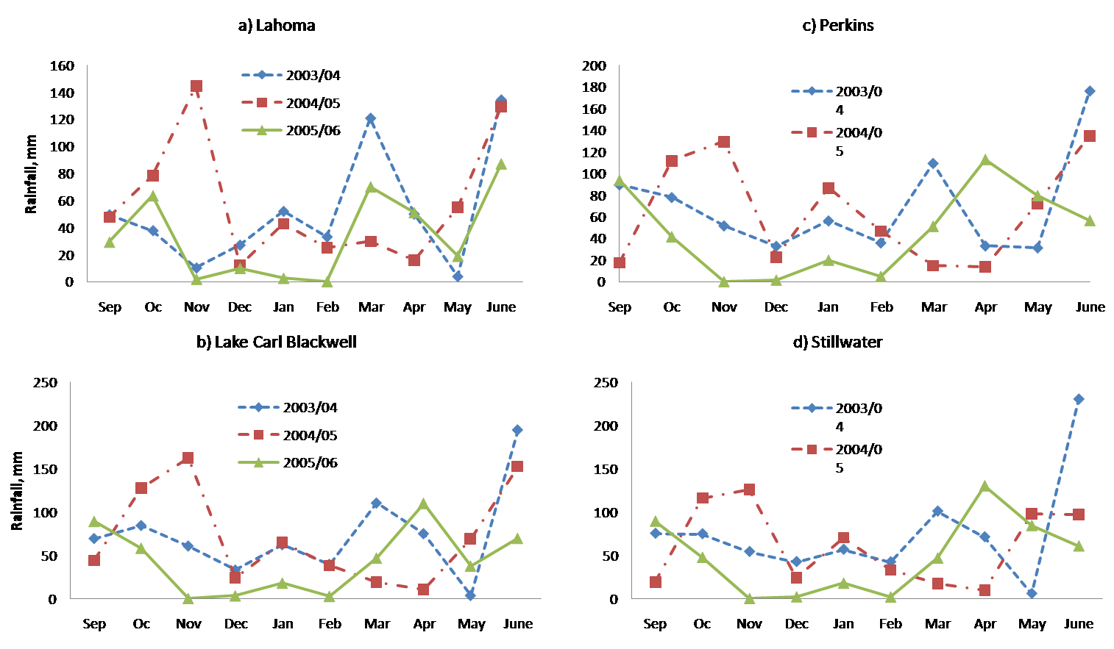

Changes in Response Indices as a Function of Time in Winter Whea: Fig2

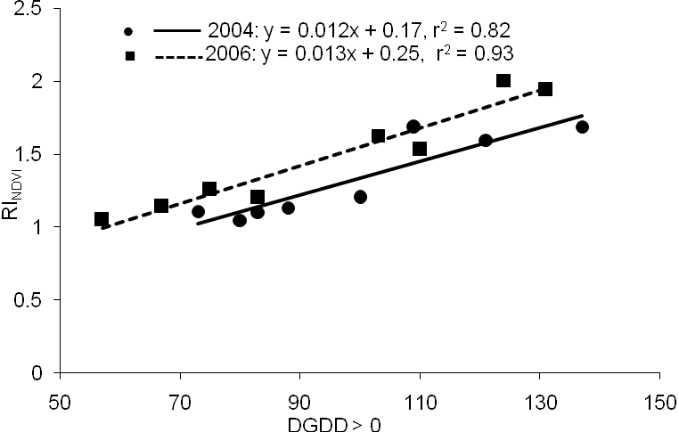

Changes in Response Indices as a Function of Time in Winter Wheat: Fig3

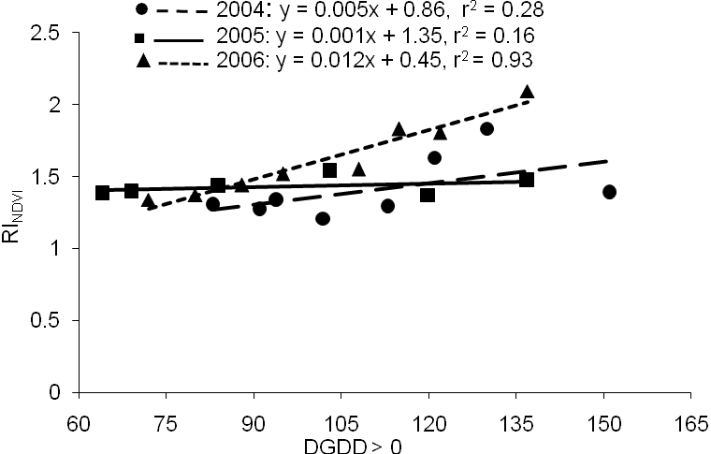

Changes in Response Indices as a Function of Time in Winter Wheat: Fig4

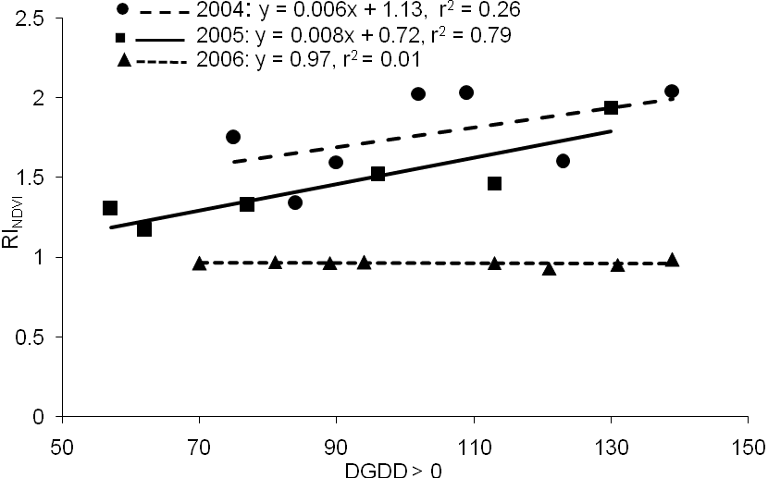

Changes in Response Indices as a Function of Time in Winter Wheat: Fig5

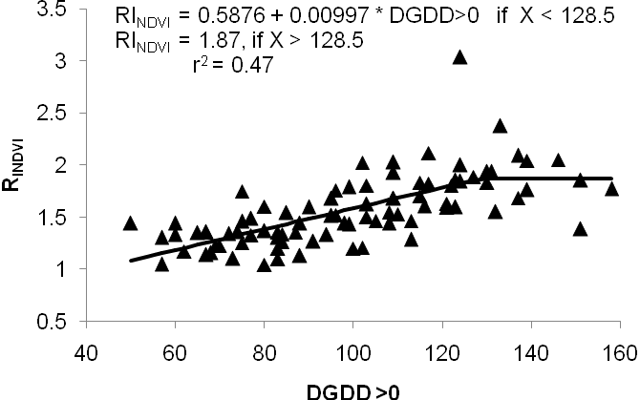

R²

Changes in Response Indices as a Function of Time in Winter Wheat: Fig6

