Ramp Calibration Strip Technology for Determining Mid-Season N Rates in Corn and Wheat

ABSTRACT
Methodologies currently available for making mid-season fertilizer nitrogen (N) recommendations in corn (Zea mays L.) and wheat (Triticum aestivum L.) are not consistent from one region to the next. The use of preplant soil testing, yield goals, economic optimums, chlorophyll meters, and optical sensor-based yield prediction models have all to some extent been limited regionally. The objective of this paper is to introduce an applied approach for applying preplant N fertilizer in automated gradients used for determining midseason N rates based on plant response. This approach assumes that mid-season biomass estimated using normalized difference vegetation index (NDVI) sensor readings is directly related to wheat and corn grain yield, and that delaying applied N till mid-season (Feekes 5 in winter wheat and 8 leaf stage in corn) can result in near maximum yields. The ramped calibration strip (RCS) applicator applies 16 different incremental N rates (3 to 6 m intervals), over 45 to 90 m (number of rates, intervals, and distances can be adjusted depending on the crop and other conditions). Because the RCS is superimposed on the farmer preplant N practice, producers can examine plant responsiveness over the range of rates to determine the optimum topdress N rate. Whether determined visually or with active reflectance based sensors, the point where mid-season visual growth differences no longer exist is the topdress N rate. Recording distance is required as you walk the RCS since distance is associated with an incremental N rate within the ramp. This approach assumes that maximum or near maximum yields from mid-season N applications can be achieved, and yield potentials are not severely restricted by moderate or severe early season N stress. Where adequate but not excessive preplant N is available, the ramp interpolated rate provides an applied method to determine how much mid-season N should be applied to achieve the maximum yields based on growth response evidenced within the RCS.

Introduction
The need to improve N use efficiency (NUE) both in large and small scale operations has become increasingly acute with increased fertilizer N prices and added scrutiny associated with adverse affects on our environment from excess N applied in cereal production. Similar to that encountered in other regions of the world, Lobell et al., 2004 showed that for wheat farmers in Ciudad Obregon, Mexico, N fertilizer represented the single largest cost of production. Lobell et al. (2004) further noted that anything that can be done to match N supply to spatial and temporal variations in crop demand could assist in achieving greater crop yields and improved agricultural sustainability. While seemingly straightforward, Pang and Letey (2000) also noted the difficulty in matching the time of mineral N availability with N uptake in crop production. The approach presented here provides a mid-season visual estimation of how much additional fertilizer N is needed, while accounting for the amount of N mineralized from planting to the time of inspection.
Soil and tissue testing
Over time, there have been improvements in mid-season soil testing procedures like the pre-sidedress nitrate test (PSNT) developed by Bundy and Andraski (1995); however, adoption has been localized. Similarly, methods that predict N mineralization from soil organic matter have shown promise (Cabrera and Kissel, 1988), as have methods aimed at quantifying amino sugar N which has been used to determine preplant fertilizer N response (Mulvaney et al., 2001). However, both of these approaches are restricted by their inability to account for within-season temporal variability in the rate of N mineralization that alters the amount of N available to the crop. Other researchers have noted that temporal variability influences the amount of N supplied by soil organic matter which is in turn affected by rainfall, soil temperature, and other environmental factors that control demand for mid-season fertilizer N (Raun et al., 2005).
Yield goals
Yield goals continue to be used as a method for generating preplant N rates for cereal crop production. This is in general 33 kg N ha⁻¹ per 1 Mg of wheat (Triticum aestivum L.) and 20 kg N ha⁻¹ for every 1 Mg of corn (Zea mays L), but like soil testing methods, they fail to account for in-season temporal variability that controls yield levels and the demand for in-season N fertilizer. Accurate mid-season prediction of corn (Teal et al., 2006) and wheat (Raun et al., 2002) grain yield potential has been demonstrated using in-season optical sensor measurements of reflectance expressed as the normalized difference vegetation index (NDVI), and accounting for either cumulative growing degree days or days from planting to sensing, respectively. These yield prediction equations have been used to calculate mid-season fertilizer N rates by estimating differences in grain N uptake between farmer practices and non-N limiting strips placed in each farmer field (Raun et al., 2002). This approach is very similar to that of using preplant yield goals, with the difference being the use of in-season sensor measurements to account for temporal variability occurring between planting and topdressing.
Leaf color charts
Leaf color charts (LCC) printed on plastic were first developed in Japan (Furuya 1987). The most widely distributed LCC in Asia was developed through collaboration between International Rice Research Institute and the Philippine Rice Research Institute (IRRI 1999). Witt et al. (2005) found that leaf color charts enabled farmers to estimate plant N demand in real time (midseason) to improve the efficiency of fertilizer and to increase rice yields. The advantages associated with the use and implementation of LCC’s was their affordability and ease of instruction in their use to farmers.
Calibration stamps
Work by Raun et al. (2005) developed calibration stamps that were to be applied preplant or soon thereafter and superimposed on top of the farmer fertilization practice. The calibration stamps consisted of an automated system capable of delivering a range of fixed N rates as urea ammonium nitrate (280 g N kg⁻¹) within continuous 9-1 m² cells arranged in a 3 by 3-m array. The minimum N rate for mid-season applications was determined by choosing the cell with the lowest N rate where no visual differences were observed between it and the highest rate. Calibration stamps applied preplant or soon after planting assisted in providing visual interpretation of net N mineralization + atmospheric N deposition occurring from planting to the time midseason N was applied, and improved the determination of optimum topdress N rates (Raun et al., 2005). While farmers appreciated this approach, they expressed the need for larger areas to better interpolate the ideal mid-season fertilizer N rate.
Ramp Calibration Strips (RCS)
Because farmers were so receptive to the use of a visual method to determine mid-season N application rates, the authors developed the ramped calibration strip (RCS). The RCS consists of a continuously changing or stepped application rate of N fertilizer applied in a 2-m or wider band across a portion of a farmer’s field. The length of the ramp varied as did the number of N application rates. Crop response along the ramp was proportional to the N rate until growth reached a plateau. The minimum N rate required to reach that plateau could be determined visually or with greater precision by an optical reflectance sensor. Also, the RCS approach will reveal when and if mid-season N is needed, thus reducing producer costs and protecting ground and surface water quality.
The objective of this work is to report on the agronomic and engineering utility of using the ramp calibration strip, and to delineate the materials and methods needed to establish and evaluate an RCS.

Materials and Methods
This RCS approach is an expansion of the calibration stamp technology developed to determine N topdress rates for cereal crops (Raun et al., 2005). The RCS is based on the concept of visually evaluating plots with incremental rates of preplant N to identify the minimum N rate required for maximum biomass production. The lowest preplant N rate that results in maximum midseason forage production (determined visibly or using an active hand-held NDVI sensor) provides an estimate of the amount of additional N needed to achieve optimum grain yield. Assuming that maximum or near maximum yields can still be achieved from mid-season applied N, producers can evaluate the RCS in-season to determine the optimum rate, prior to applying additional N. In order to accomplish this, a sprayer was designed to automatically apply UAN liquid fertilizer. It should be noted that engineering design for this kind of applicator could be extended to granular sources, and various other nutrients other than N.
Urea ammonium nitrate fertilizer was metered through TeeJet StreamJet nozzles. Nozzles were positioned 0.6 m above the ground and spaced 0.6 m apart along the boom. Nozzle sizes were selected based on desired rates and an application speed of 8 km h⁻¹ with an operating pressure of 207 kPa. The number of rates, distances between rate changes, and actual rates applied within the RCS can be adjusted upward or downward using selected nozzle tips and programming as deemed necessary for selected crops.
Texas Industrial Remcor solenoid valves with integrated standard agricultural nozzle bodies were attached directly to a 1.9-cm schedule 40 stainless steel pipe, which served as a wet boom. All fertilizer handling components of the system were compatible with UAN solution.
A 12V programmable logic controller (PLC) was used to control the sprayer. The PLC can use either radar or a proximity sensor to determine distance traveled. In both cases, pulses from the sensor were input to the PLC and used to drive three counters in the PLC. The counters were each set to provide output after the desired amount of wheel rotation. Outputs from the PLC were used to directly drive relays to power the solenoid valves that actuated the nozzles. A momentary switch was provided as an input to the PLC to trigger the timing sequence. When engaged, the aforementioned spray sequence was initiated to produce the N rate sequence shown in Figure 1. The resulting system is illustrated on the applicator in Figure 2. The system applied a series of ramps (rate array) when the trigger was depressed.
The original ramp applicators were equipped with four sets of nozzles selected to apply 1X, 2X, 4X, and 8X rates. The PLC turned on combinations of these nozzles to apply applications rates of 0, 15, 29, 44, 58, 73, 87, 102, 116, 131, 146, 160, 175, 190, 205, and 220 kg ha⁻¹. The application rates can be altered by changing a combination of nozzle size, spray system pressure, and applicator speed.
The programmable logic controller is set up to accommodate any combination of nozzles and has been used to apply as few as 8 rates when the ramp area is limited. The controller program permits the operator to select any desired length over which each application rate is applied. In 2006, the standard length used was 3 m for each ramp step.
The maximum desired application rate where a fertilizer response can be obtained can be estimated visually or calculated from measurements of NDVI. Farmers can observe the point where the crop growth reaches a plateau. They can then calculate an N rate by dividing the distance from the start of the 0-N rate to that point by the total ramp length multiplied by the maximum application rate (Figure 1). Oklahoma State University researchers have written a program, Ramp Analyzer 1.12 (www.nue.okstate.edu), for MicrosoftTM Windows CE based PDA’s to fit a linear plateau function to NDVI measurements from the ramp. This program calculates the N rate required to reach that plateau if the fertilizer was applied at the normal topdress time, from measurements taken over the entire ramp. This program also calculates the crop yield potential with and without additional fertilizer, the fertilizer response index with additional N fertilizer, and the fertilizer application rate using the sensor based N rate calculator (SBNRC) algorithm developed at Okalahoma State University (Raun et al., 2002; Raun et al., 2005). More than 21 variations of the algorithm have been developed for different crops and regions and are available through the web based SBNRC (http://www.soiltesting.okstate.edu/SBNRC/SBNRC.php). These crop and region specific algorithms were developed by researchers at their respective locations.
There are a number of individuals and companies interested in building variants of the ramp applicator. Instructions for constructing the Oklahoma State University version of the ramp applicator are available on our website (www.nue.okstate.edu). Information on several farmer built ramp applicator designs, and names and addresses of companies building the ramp applicators are also included on this site (www.nue.okstate.edu/Index_RI.htm). In the fall of 2007, combined with our extension efforts and that of the private sector, over 2000 ramp calibration strips were applied in winter wheat farmer fields. The same farmers that chased one of our local fertilizer dealers out of the field in 2006, were paying him for the same service in 2007. The RCS units developed privately vary greatly (rates, width, and length) as is reported on the web site above. At present we do not have a recommendation for optimum widths, lengths, and/or number of rates within the RCS. Current configuration of the OSU applicator (3 m ramp steps, 4-5 m wide) was a tradeoff, long enough where differences due to rates could be visualized, but not too long where ramp steps were masked by field variability. We currently recommend placing and RCS in at least 2 locations in each field. More critical to this process is simply getting producers to apply an RCS, and to incorporate this temporally dependent tool in their mid-season N fertilizer decision.
Discussion
The concept of using the RCS to determine the optimum topdress N rate is illustrated in Figure 1. By stopping at the point (recording distance in m) where there are no longer visible changes in plant growth or differences in NDVI as measured by the sensor (secondary y-axis), you can plot or mentally visualize a linear-plateau function. The point where the transition curve reaches the plateau is the recommended topdress N rate. For the field in Figure 1, the recommended topdress N rate would have been around 140 kg N ha⁻¹. This is because the RCS is applied on-top of the farmer practice (whatever that may be) and the point where vegetative growth was maximized beyond that seen for the farmer practice would be the peak in the NDVI curve, and that was associated with the corresponding 140 kg N ha⁻¹ rate. Assuming that we can "catch up" and/or achieve maximum yields from the mid-season N application, and assuming that yield potentials were not severely restricted by early season N stress, the RCS interpolated rate is how much you would need to apply on the rest of the field to achieve the same "visible" or NDVI recorded response. In practice, farmers adjust mid-season N rates based on their experience. However, the RCS application rate provides them with a reasonable maximum target that accounts for temporal variability.
Since the ramp constitutes one observation within a field, recommended practice calls for establishing more than one ramp as illustrated for wheat (2nd ramp in the background of Figure 3) and corn (2nd ramp to the side in Figure 4). Earlier experience with the N Rich Strip (Mullen et al., 2003) showed that measurements of the area with the greatest response to additional N should be used to calculate the topdress N application rate, without regard for the previous management, soil type, etc. Similarly, we recommend that the ramp with the greatest visual biomass response or measured NDVI should be used to estimate topdress N application rate.
Two RCS examples, one for wheat (Figure 5) and corn (Figure 6) illustrate mid-season NDVI readings (Feekes 5 in wheat and 8 leaf stage in corn, respectively) and corresponding grain yield collected from the same plots. For winter wheat, NDVI readings at Feekes 5, peaked just above 100 kg N/ha, while very similar results were observed for final grain yield (Figure 5). The rainfed corn RCS example included showed that the 8 leaf stage NDVI readings peaked just above 150 kg N/ha, while grain yield values showed a very similar trend (Figure 6).
There has been significant debate on the relationship of the timing of topdress N application and the ability to maximize grain yield. Morris et al., (2006) demonstrated that even when early season N stress was present (0-N preplant) in winter wheat, N applied topdress at the Feekes 5 (Large, 1954) growth stage resulted in maximum or near maximum yields at 4 of 6 site-year combinations when compared to other treatments receiving both preplant and topdress N. Scharf et al. (2002) found little or no evidence of irreversible corn grain yield loss when N applications were delayed as late as stage V11, even when N stress was highly visible. Results from Gehl et al. (2005) disagreed somewhat in finding that split applications of 185 kg N ha^{–1} were sufficient to achieve maximum corn grain yields, but where the sidedress N was applied much earlier (between V6 and V10). Varvel et al. (1997) reported that maximum grain yields in corn were attained when early season sufficiency indexes ranged between 90 and 100% up to the V8 growth stage, but if the sufficiency index fell below 90% at V8, maximum yields could not be achieved, a result of early season N deficiency. In general, if sidedress N is applied at or before V8 and Feekes 5 for corn and wheat, respectively, early season N stress will not result in lost yield potential.
For corn, UAN is commonly sidedressed in surface dribble bands, or sub-surface bands. For center-pivots, mid-season UAN is applied with the water as a fertigation treatment, and is highly efficient. In this regard, preplant application of the RCS approach in corn should likely take place via knife applications, whereby employing this method would apply more immediately applicable results, and that would more accurately integrate the visible N demand. Knife RCS applicators would also better simulate the conditions for mineralization, immobilization, leaching, and volatilization losses for what is the most common N application in the corn belt.
In corn, it could be argued that this methodology is flawed, because you don't know whether or not this recommended mid-season N rate will "run out" later in the season. This is to a certain extent correct, but if the farmer wants to avoid that potential "risk", the topdress N rate can be increased by whatever amount he/she deems appropriate. However, the RCS offers a visual tool for estimating the mid-season N rate. Ample data exist from multiple-year corn and wheat experiments documenting years where the check plot that had not received any fertilizer N for several years, somehow produced near maximum yields (Bundy, 2003; Bundy, 2006; Johnson and Raun, 2003; Meisinger et al., 1985; Olson et al., 1986; Olson, 1980). For the cited examples where the check plot (0-N) produced near maximum yields, an RCS would have visibly illustrated limited differences between the 0-N segment and plots in the RCS receiving N. As a result, this in-season observation would have recognized limited or no demand for added fertilizer N. In light of the frequency at which no or limited N response has been encountered in field trials, an RCS approach would be useful. If the check plots with no fertilizer N looked as good as the fertilized plots, where was their N coming from? Over the years, we have observed that warm wet winters (winter wheat) and warm wet springs and early summers (corn) are conducive to increasing the amount of N mineralized from soil organic matter, and N deposition in the rainfall. There are years where the demand for fertilizer N is limited (and highly dependent on the environment), and other years when it is cool and dry and the demand for fertilizer N is greater. Midseason evaluation of the RCS provides an estimate of how much N the environment delivered.
For those farmers/producers interested in using active NDVI sensors for determining their midseason N rates, they can mark the start and end of the RCS (preplant or soon after planting), and collect sensor data using handheld NDVI sensors walking at a constant speed over the length of the ramp. Using the Ramp Analyzer 1.12 program (available on the www.nue.okstate.edu downloads page) producers can measure NDVI with the GreenSeekerTM sensor over the entire RCS and with the program, read the sensor data file, and the optimum N rate will be computed accordingly (identifies where NDVI peaks within the RCS). We recommend the use of the sensors simply because our eyes are not as sensitive in picking up these differences, however, walking the RCS is a viable method of visually inspecting N response.
Furthermore, the RCS approach is expected to provide improved guidance for N management in other crops like cotton. The decision to use harvest aids (defoliation, boll opening, re-growth inhibition) could be clarified if an RCS were available in each field. The RCS could lead to identification of more appropriate N rates and less ‘rank’ growth which could result in lower rates of harvest aids or even no application. Cotton producers are aware that the demands for N differ from one year to the next, but they currently do not employ a tool like the RCS that serves as a visual guide to decipher mid-season N rates and/or the demand for other materials that are highly dependent on N nutrition.
The RCS approach is consistent with the demand for other mobile nutrients. Crop response to chloride and sulfur has also been found to be highly variable depending on the environment (Engel et al., 1994; Freeman et al., 2006; Girma et al., 2005). In-season evaluation of chloride and sulfur ramps could assist in determining when these micronutrients are needed in cereal production systems and in time to accommodate foliar applications that would alleviate the deficiency. Other approaches of using the RCS could be applied in corn, where early-season N deficiencies are more difficult to determine, but that are more apparent later in the season (Sripada 2006). Because early season evaluation of the corn plant will not always reveal N stress, a winter wheat RCS planted and fertilized after corn harvest (3 to 6 m wide, 45 – 90 m in length) could be useful. The winter wheat RCS evaluated the ensuing spring once corn was at the V8 growth stage could visually integrate how much N was mineralized from soil organic matter and N deposition in rainfall. The size of the mineralized N pool or total inorganic N available may not show up visually in a corn RCS, because the demand and N removal at V8 can be small in colder northern climates. The winter wheat RCS assists in this regard, by having been in the field from corn harvest, all the way to V8 the ensuing season when midseason N decisions can be made, and using a crop where the potential for N responsiveness will be evident (Mullen et al., 2003). In a sense, the winter wheat RCS could serve as visual proxy for N mineralization potential.
Producer adoption, and private sector enthusiasm over this approach has been encouraging. However, there are many facets of this approach that have yet to be investigated including, but not excluded to number of ramp steps, number of RCS per field, averaging RCS data, range of rates needed for specific crops, and regression methods used to interpret the RCS.
Applied methodologies that integrate farmer intuition, and farmer input within the decision making process, could assist in increasing adoption. While the RCS approach may be limited in deciphering exact maximum N rates in high yielding environments, it provides a visual mid-season alternative for N fertilization, in opposition to applying all N preplant in crop production systems that are known to be inefficient.

References
Bundy, L.G., and T.W. Andraski. 1995. Soil yield potential effects on performance of soil nitrate tests. J. Prod. Agric. 8:561-568.
Bundy, L.G. 2003. Long-term nitrogen fertilization effects on corn yields and soil properties. In Proc. 33rd North Central Extension-Industry Soil Fert. Conf., Des Moines, IA, 19-20 November 2003. 19:145-150.
Bundy, L.G. 2006. How can we improve nitrogen use efficiency? Proc. Wis. Fert. Aglime and Pest Mgmt. Conf. 45:54-60.
Cabrera, M.L., and D.E. Kissel. 1988. Evaluation of a method to predict nitrogen mineralized from soil organic matter under field conditions. Soil Sci. Soc. Am. J. 52:1027–1031

Engel, R.E., J. Eckhoff, J., and R.K. Berg. 1994. Grain yield, kernel weight, and disease responses of winter wheat cultivars to chloride fertilization. Agron. J. 86:891-896.

Freeman, K.W., K. Girma, J. Mosali, R,K. Teal, K.L. Martin, and W.R. Raun. 2006. Response of winter wheat to chloride fertilization in sandy loam soils. Commun. Soil Sci. Plant Anal. 37:1947-1955.

Furuya S. 1987. Growth diagnosis of rice plants by means of leaf color. Jpn. Agric. Res. Q. 20, 147-153.
Gehl, R.J. J.P. Schmidt, L.D. Maddux, and W. B. Gordon. 2005. Corn yield response to nitrogen rate and timing in sandy irrigated soils. Agron. J. 97:1230-1238.
Girma, K., J. Mosali, K.W. Freeman, W.R. Raun, K.L. Martin, and W.E. Thomason. 2005. Forage and grain yield response to applied sulfur in winter wheat as influenced by source and rate. J. Plant Nutr. 28:1541-1553.
IRRI. 1999. Use of leaf color chart (LCC) for N management in rice. CREMNET Technology Brief No. 2. Los Baños, Philippines: International Rice Research Institute (IRRI). p 1-4.
Johnson, G.V., and W.R. Raun. 2003. Nitrogen response index as a guide to fertilizer management. J. Plant Nutr. 26:249-262.
Large, EC. 1954. Growth Stages in Cereals. Plant Pathol. 3:128-129.
Lobell, D. B., J. I. Ortiz-Monasterio, and G.P. Asner. 2004. Relative importance of soil and climate variability for nitrogen management in irrigated wheat. Field Crops Res. 87:155-165.
Meisinger, J.J., V.A. Bandel, G. Stanford, and J.O. Legg. 1985. Nitrogen utilization of corn under minimal tillage and moldboard plow tillage. I. Four-year results using labeled N fertilizer on an Atlantic coastal plain soil. Agron. J. 77:602-611.
Morris, K.B., K.L. Martin, K.W. Freeman, R.K. Teal, D.B. Arnall, K. Desta, W.R. Raun, and J.B. Solie. Mid-season recovery to nitrogen stress in winter wheat. 2006. J. Plant Nutr. 29:727-745.
Mullen, R.W., Kyle W. Freeman, William R. Raun, G.V. Johnson, M.L. Stone, and J.B. Solie. 2003. Identifying an in-season response index and the potential to increase wheat yield with nitrogen. Agron. J. 95:347-351.
Mulvaney, R.L., S. A. Khan, R. G. Hoeft, and H. M. Brown. 2001. A soil organic nitrogen fraction that reduces the need for nitrogen fertilization. Soil Sci. Soc. Am. J. 65:1164-1172
Olson, R. A., W. R. Raun, Yang Shou Chun and J. Skopp. 1986. Nitrogen management and interseeding effects on irrigated corn and sorghum and on soil strength. Agron. J. 78:856-862.
Olson, R.V. 1980. Fate of tagged nitrogen fertilizer applied to irrigated corn. Soil Sci. Soc. Amer. J. 44:614-517.
Pang, X.P., and J. Letey. 2000. Organic farming: challenge of timing nitrogen availability to crop nitrogen requirements. Soil Sci. Soc. Am. J. 64:247-253.
Raun, W.R., J.B. Solie, M.L. Stone, K.L. Martin, K.W. Freeman. And D.L. Zavodny. 2005. Automated calibration stamp technology for improved in-season nitrogen fertilization. Agron. J. 97:338-342.

Raun, W.R., J.B. Solie, G.V. Johnson, M.L. Stone, R.W. Mullen, K.W. Freeman, W.E. Thomason, and E.V. Lukina. 2002. Improving nitrogen use efficiency in cereal grain production with optical sensing and variable rate application. Agron. J. 94:815-820.
Scharf, P.C., W.J. Wiebold, and J.A. Lory. 2002. Corn yield response to nitrogen fertilizer timing and deficiency level. Agron. J. 94:435-441.
Sripada, R. P., R.W. Heiniger, Jeffrey G. White, and Alan D. Meijer. 2006. Aerial color infrared photography for determining early in-season nitrogen requirements in corn. Agron. J. 98: 968-977.

Teal, R. K., B. Tubana, K. Girma, K. W. Freeman, D. B. Arnall, O. Walsh, and W. R. Raun. 2006. In-season prediction of corn grain yield potential using normalized difference vegetation index. Agron. J. 98: 1488-1494.
Varvel, G.E., J.S. Schepers, and D.D. Francis. 1997. Ability for in-season correction of nitrogen deficiency in corn using chlorophyll meters. Soil Sci. Soc. Am. J. 61:1233-1239.

Witt, C., J.M.C.A. Pasuquin, R. Mutters, and R.J. Buresh. 2005. New leaf color chart for effective nitrogen management in rice. Better Crops 89(1):36-39.

List of Figures
Figure 1. Fertilizer N applied (y1) and theoretical NDVI values (y2) plotted against distance. Mid-season fertilizer N to be applied is determined by finding the point where NDVI was maximized, and then moving horizontally to the desired N rate.

Figure 2. View of the Ramp Calibration Strip applicator showing the boom (3 m wide) capable of delivering 15 different rates at fixed intervals using urea ammonium nitrate via fertilizer stream nozzles.

Figure 3. Ramp Calibration Strip applied preplant in winter wheat and picture taken at Feekes growth stage 5. For this RCS, rates ranged from 0 to 192 kg N ha⁻¹ in 12 kg increments, and where rates started with 15X, dropped off to 0X and then increased each 3 m back up to 15X.

Figure 4. Ramp Calibration Strip applied preplant in corn taken at the V8 growth stage. For this RCS, rates ranged from 0 to 280 kg N ha⁻¹ in 20 kg increments, and where rates started with 15X, dropped off to 0X and then increased each 3 m back up to 15X.

Figure 5. Wheat grain yield response to preplant fertilizer N and corresponding NDVI readings collected from the same plots where yield was determined, but at Feekes growth stage five, Lahoma, OK, 2006.

Figure 6. Corn grain yield response to preplant fertilizer N and corresponding NDVI readings collected from the same plots where yield was determined, but at the 8-leaf growth stage five, Efaw Experiment Station, Stillwater, OK, 2006.

Figure 1. Ramp Calibration Strip Technology for Determining Mid-Season Nitrogen Rates in Corn and Wheat

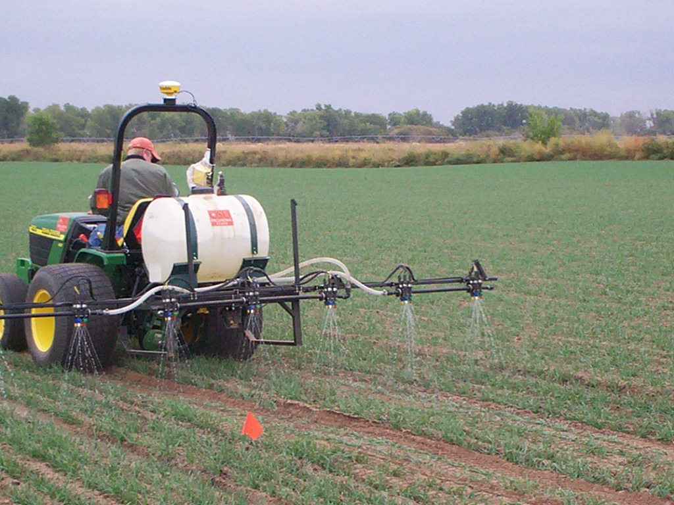

Figure 2. Ramp Calibration Strip Technology for Determining Mid-Season Nitrogen Rates in Corn and Wheat
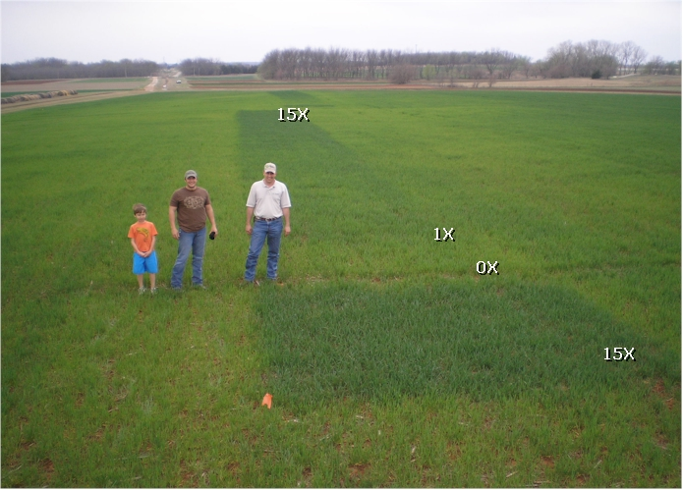Figure 3. Ramp Calibration Strip Technology for Determining Mid-Season Nitrogen Rates in Corn and Wheat

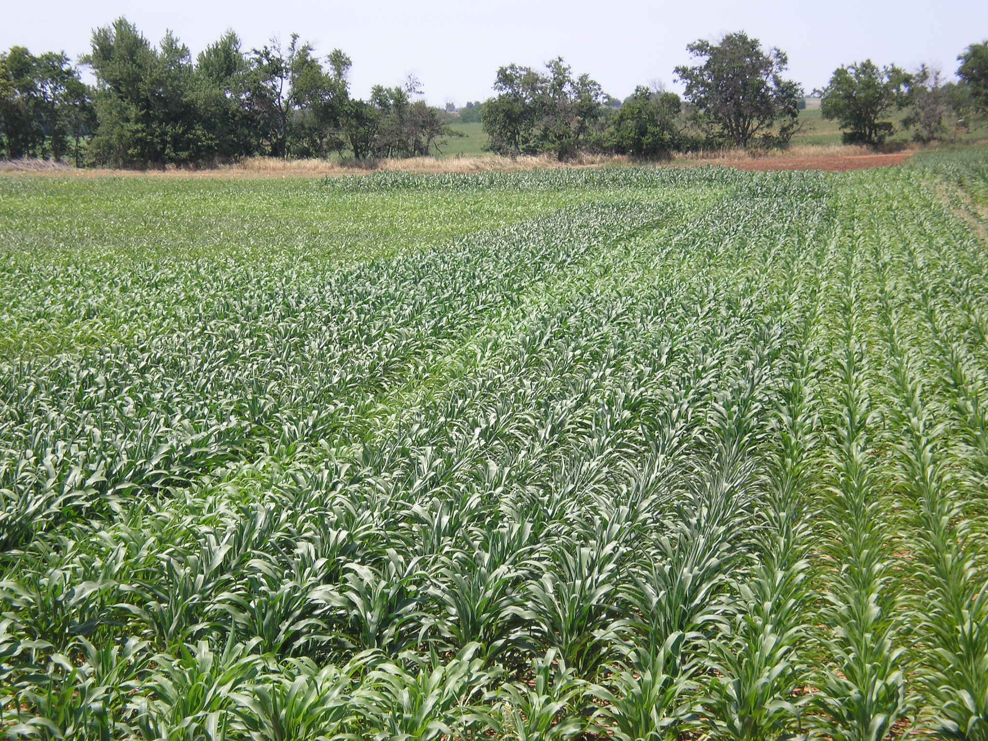
Figure 4. Ramp Calibration Strip Technology for Determining Mid-Season Nitrogen Rates in Corn and Wheat

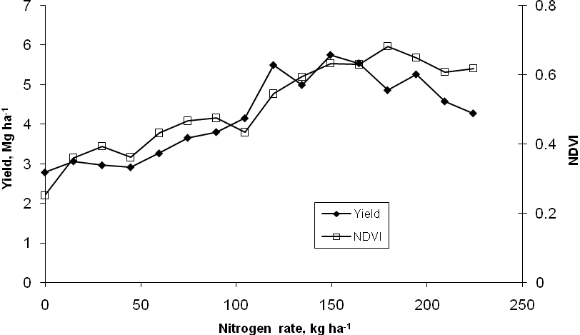
Figure 5. Ramp Calibration Strip Technology for Determining Mid-Season Nitrogen Rates in Corn and Wheat

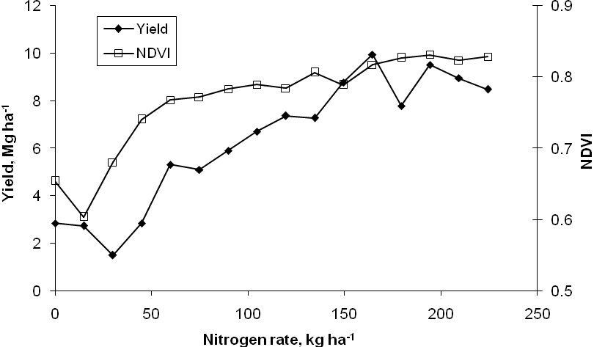
Figure 6. Ramp Calibration Strip Technology for Determining Mid-Season Nitrogen Rates in Corn and Wheat

