**Increasing Food Production on Saline Soils**

**The Problem**

* 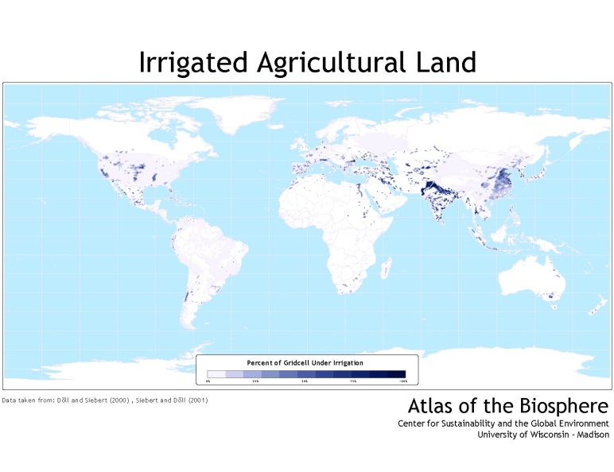Irrigated land accounts for approximately 2.8 million km2 worldwide.
* 33% of irrigated land is affected by salinity problems.
* Crop production is drastically reduced by increased soil salt concentrations, with prejudices ranging from decreased yields to complete crop failure.
* Recovering saline soils demands an enormous amount of water to leach the excessive salt to deeper portions of the profile, limited resource in arid regions.
* Worldwide population is expected to increase 35% by 2050, what would require doubled yields on existing farmland to meet food demand.

Expanding agriculture into remaining rainforests, wetlands, or grasslands, is not a viable option due to environmental and sociological impacts. Recovering saline soils is too expensive and net returns would likely be negative, rendering agriculture unfeasible. ***Now what?***

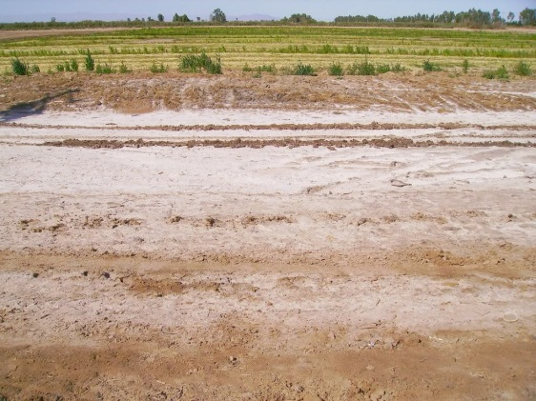**The Alternatives**

* Salt sensitivity is crop specific, and tolerance to saline soils is higher in crops such as barley, sugarbeets, and sorghum, than it is in beans, cowpeas, or maize for example.
* Modern plant breeding have created salt tolerant tomatoes by modifying plant physiological response to salt stress (Zhang and Blumwald, 2001 – bottom page figure), and wheat by back-crossing modern varieties with ancestral germplasm (Munns et al., 2011).

**The Solution**

**Figure A** wild-type tomato grown in non-saline soil; **Figure B** salt-tolerant modified tomato grown in saline soil.

**a) Relocate irrigated wheat and tomato production to saline soil areas** - these crops already present increased tolerance to high soil salt concentration, thus they can be used to bring abandoned irrigated-saline areas back to production.

**b) Develop modern lines of major crops with increased tolerance to saline soils** –resourceswill be invested inrice, maize, soybeans, and sorghum breeding and crossing with ancient germplasm seeking saline tolerance.

Munns et al., 2011. Wheat grain yield on saline soils is improved by an ancestral Na+ transporter gene. Nature Biotechnology. 30:360-364.

Zhang and Blumwald, 2001. Transgenic salt tolerant tomato plants accumulate salt in foliage but not in fruit. Nature. 19:765-768.